# JavaScript resources:

# Namaste JS Handbook link:

<https://namaste-javascript-handbook.vercel.app/docs/lecture-1>  
Tutorial link:

<https://youtu.be/ZvbzSrg0afE?si=xTAlINdSKXxxTdBs>

**Interview questions:**

1. <https://builtin.com/software-engineering-perspectives/javascript-interview-questions>
2. <https://www.interviewbit.com/javascript-interview-questions/>

 JavaScript Async Patterns to Crack Your JS Interviews  
𝟭. 𝗖𝗮𝗹𝗹𝗯𝗮𝗰𝗸𝘀 𝘃𝘀 𝗣𝗿𝗼𝗺𝗶𝘀𝗲𝘀 𝘃𝘀 𝗔𝘀𝘆𝗻𝗰/𝗔𝘄𝗮𝗶𝘁  
  
1.1. Callbacks:  
- The original way to handle async operations  
- Can lead to “callback hell” (nested, hard-to-read code)  
  
1.2. Promises:  
- Provide cleaner syntax and better error handling  
- Allow chaining of async operations via .then()  
- Handle errors with .catch()  
  
1.3. Async/Await:  
- Syntactic sugar over Promises  
- Makes async code look synchronous and easier to read  
- Simplifies error handling with try/catch blocks  
  
𝟮. 𝗘𝗿𝗿𝗼𝗿 𝗛𝗮𝗻𝗱𝗹𝗶𝗻𝗴  
  
2.1. Using Promises:  
- Attach .catch() to handle rejected promises  
  
2.2. Using Async/Await:  
- Use try/catch to catch exceptions in async functions  
  
2.3. Best Practices:  
- Always handle errors to avoid unhandled promise rejections  
- Provide user-friendly error messages or fallback logic  
  
𝟯. 𝗣𝗿𝗼𝗺𝗶𝘀𝗲 𝗖𝗵𝗮𝗶𝗻𝗶𝗻𝗴 & 𝗖𝗼𝗻𝗰𝘂𝗿𝗿𝗲𝗻𝗰𝘆  
  
3.1. Promise Chaining:  
- Execute async tasks sequentially by chaining .then() calls  
  
3.2. Promise.all:  
- Run multiple promises concurrently  
- Resolves when all promises succeed or rejects if any fail  
  
3.3. Advanced Patterns:  
- Promise.race for first-resolved promise  
- Promise.allSettled for waiting all promises regardless of success/failure  
  
3.4. Use Case:  
- Fetch multiple API endpoints simultaneously to improve performance  
  
𝟰. 𝗘𝘃𝗲𝗻𝘁 𝗟𝗼𝗼𝗽 𝗕𝗮𝘀𝗶𝗰𝘀  
  
4.1. Single-threaded JS:  
- JS runs one operation at a time but handles async via event loop  
  
4.2. Microtasks vs Macrotasks:  
- Microtasks (Promises) run before macrotasks (setTimeout, setInterval)  
- Knowing this order helps prevent bugs and understand execution flow  
  
4.3. Practical Impact:  
- Helps debug race conditions and understand UI update timing  
  
𝟱. 𝗥𝗲𝗮𝗹-𝗪𝗼𝗿𝗹𝗱 𝗘𝘅𝗮𝗺𝗽𝗹𝗲𝘀  
  
5.1. Fetching Data Asynchronously:  
- Use fetch or Axios with async/await for clean data loading  
  
5.2. Updating UI:  
- Show loading indicators during fetch  
- Display data or error messages after async operation completes  
  
5.3. Combining Multiple Data Sources:  
- Use Promise.all to fetch multiple endpoints and render combined UI data  
  
If you want to crack your frontend interview, mastering these JavaScript topics is essential.   
  
This series breaks down each topic with videos covering all important concepts you need to know.  
  
Here’s the Complete Interview Prep Series - [**https://lnkd.in/gWMcsPiH**](https://lnkd.in/gWMcsPiH)

𝟭. 𝗘𝘅𝗲𝗰𝘂𝘁𝗶𝗼𝗻 𝗖𝗼𝗻𝘁𝗲𝘅𝘁 & 𝗖𝗮𝗹𝗹 𝗦𝘁𝗮𝗰𝗸  
- Understanding how JavaScript manages function calls helps debug and optimize your code execution.  
  
𝟮. 𝗛𝗼𝗶𝘀𝘁𝗶𝗻𝗴  
- Helps avoid bugs by knowing when variables and functions are available during runtime.  
  
𝟯. 𝗜𝗜𝗙𝗘 (𝗜𝗺𝗺𝗲𝗱𝗶𝗮𝘁𝗲𝗹𝘆 𝗜𝗻𝘃𝗼𝗸𝗲𝗱 𝗙𝘂𝗻𝗰𝘁𝗶𝗼𝗻 𝗘𝘅𝗽𝗿𝗲𝘀𝘀𝗶𝗼𝗻)  
- Useful for creating isolated scopes and preventing global variable conflicts.  
  
𝟰. 𝗘𝘃𝗲𝗻𝘁 𝗟𝗼𝗼𝗽 & 𝗠𝗶𝗰𝗿𝗼𝘁𝗮𝘀𝗸𝘀 𝗤𝘂𝗲𝘂𝗲  
- Crucial for understanding how asynchronous operations are handled in JavaScript.  
  
𝟱. 𝗗𝗲𝗯𝗼𝘂𝗻𝗰𝗶𝗻𝗴 & 𝗧𝗵𝗿𝗼𝘁𝘁𝗹𝗶𝗻𝗴  
- Improves performance by controlling the frequency of event function calls, especially for user inputs.  
  
𝟲. 𝗣𝗿𝗼𝘁𝗼𝘁𝘆𝗽𝗮𝗹 𝗜𝗻𝗵𝗲𝗿𝗶𝘁𝗮𝗻𝗰𝗲  
- Key to understanding how objects share properties and methods, making JavaScript more powerful and flexible.  
  
𝟳. 𝗗𝗲𝘀𝘁𝗿𝘂𝗰𝘁𝘂𝗿𝗶𝗻𝗴 𝘄𝗶𝘁𝗵 𝗗𝗲𝗳𝗮𝘂𝗹𝘁 𝗩𝗮𝗹𝘂𝗲𝘀  
- Simplifies extracting data from objects and arrays, making your code cleaner and easier to read.  
  
𝟴. 𝗧𝘆𝗽𝗲𝗱 𝗔𝗿𝗿𝗮𝘆𝘀  
- Essential for handling binary data efficiently, such as working with large files or images in JavaScript.  
  
𝟵. 𝗠𝗲𝗺𝗼𝗶𝘇𝗮𝘁𝗶𝗼𝗻  
- Optimizes performance by saving the results of expensive function calls to prevent redundant calculations.  
  
𝟭𝟬. 𝗚𝗲𝗻𝗲𝗿𝗮𝘁𝗼𝗿𝘀 & 𝗜𝘁𝗲𝗿𝗮𝘁𝗼𝗿𝘀  
- Helps manage complex or large datasets by pausing and resuming functions, improving performance  
  
𝟭𝟭. 𝗖𝘂𝗿𝗿𝘆𝗶𝗻𝗴 & 𝗣𝗮𝗿𝘁𝗶𝗮𝗹 𝗔𝗽𝗽𝗹𝗶𝗰𝗮𝘁𝗶𝗼𝗻  
- Improves code reusability by breaking down functions into smaller, reusable units.  
  
𝟭𝟮. 𝗠𝗲𝗺𝗼𝗿𝘆 𝗠𝗮𝗻𝗮𝗴𝗲𝗺𝗲𝗻𝘁 & 𝗚𝗮𝗿𝗯𝗮𝗴𝗲 𝗖𝗼𝗹𝗹𝗲𝗰𝘁𝗶𝗼𝗻  
- Important for optimizing app performance and avoiding memory leaks by understanding how unused objects are cleaned up.  
  
𝟭𝟯. 𝗠𝗼𝗱𝘂𝗹𝗲 𝗣𝗮𝘁𝘁𝗲𝗿𝗻𝘀  
- Helps organize and maintain code in separate, reusable modules, making it easier to manage large codebases.  
  
𝟭𝟰. 𝗦𝗵𝗮𝗱𝗼𝘄 𝗗𝗢𝗠  
- Encapsulates the structure and behavior of components, promoting reusable and isolated components.  
  
𝟭𝟱. 𝗙𝘂𝗻𝗰𝘁𝗶𝗼𝗻𝗮𝗹 𝗣𝗿𝗼𝗴𝗿𝗮𝗺𝗺𝗶𝗻𝗴 𝗶𝗻 𝗝𝗮𝘃𝗮𝗦𝗰𝗿𝗶𝗽𝘁  
- Promotes cleaner, more maintainable code by using pure functions, immutability, and first-class functions.  
  
𝟭𝟲. 𝗣𝗿𝗼𝘅𝘆  
- Allows you to intercept and modify object behavior, offering dynamic control over object properties.

# Synchronous vs Asynchronous programming:

#### What Is the Difference Between Synchronous and Asynchronous Programming?

In synchronous programming, the program execution occurs sequentially, and each statement blocks the execution until it is completed. In asynchronous programming, multiple tasks can be executed concurrently, and the program doesn’t wait for a task to finish before moving to the next one.

Synchronous coding example:

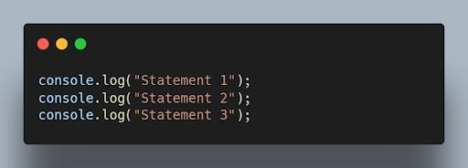JavaScript synchronous code example. | Image: Akshay Kumar

Asynchronous code example:

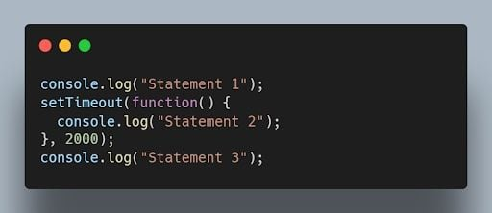A

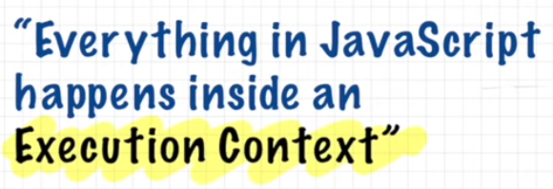

Execution Context look like:  
  
memory component:

Memory component contains variable and functions as key value pairs

Code Component:

It is the place where whole js code is executed

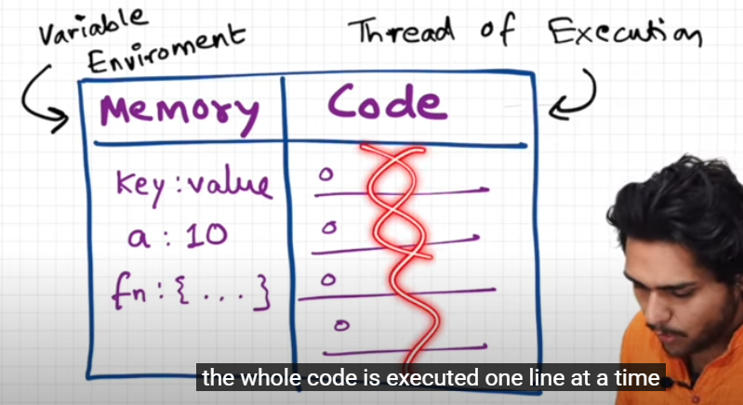

Memory component contains variable and functions as key value pairs

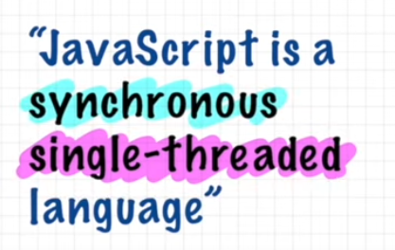  


# Synchronous single threaded:

Js can execute one command at a time and in a specific order that means it can only go to the next line once the current line has been finished executing  
  
**AJAX: Asynchronous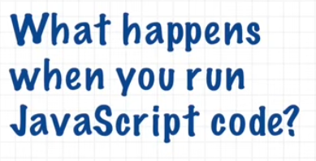 ans**: an Execution context is created  
  
Phase 1: Memory creation Phase

Js will allocate memory to all the variable and functions

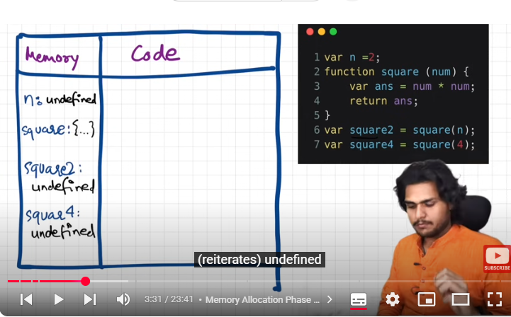  
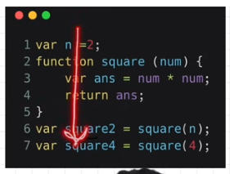  
undefined: its like a placeholder ; a special keyword in js

And in case of function the entire code in function is copied to memory as it is  
and then two var square2 and square =4 ; it allocates memory to variables and store the value undefined

## Phase 2: Code Execution Phase

The value of n in this phase will become 2  
on line number 6 **: function invoke** hua ha   
**another execution context** is created when func is invoked   
now again 2 phases   
1. Mem allocation  
2. Execution phase  
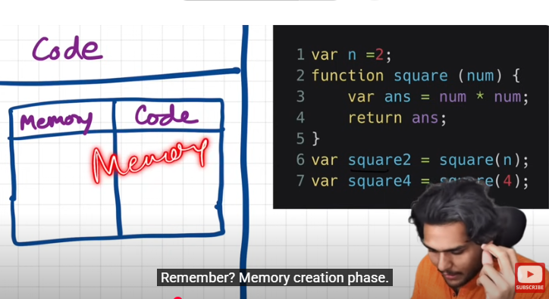

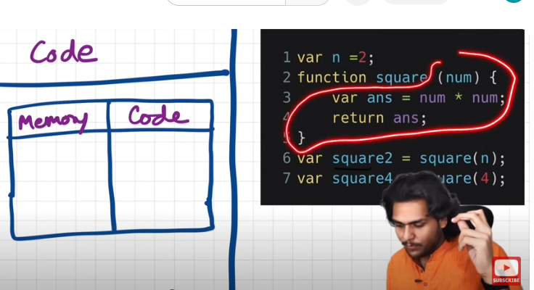  
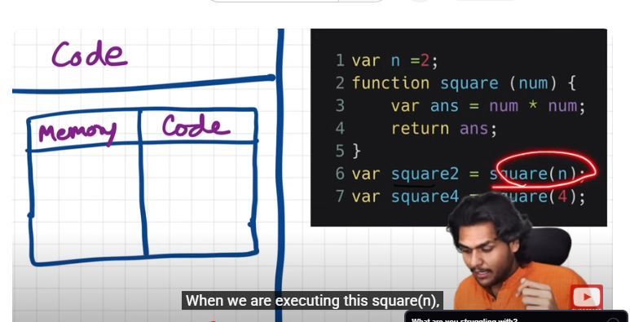  
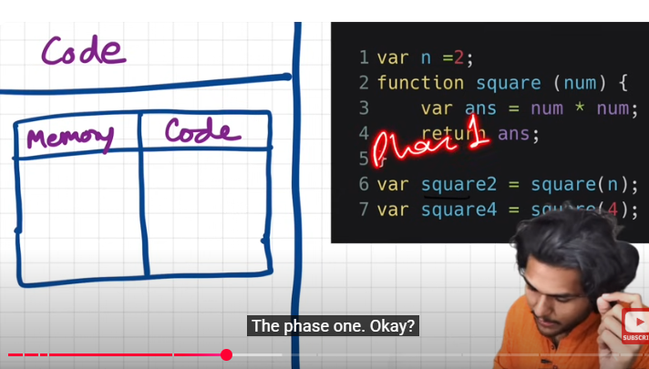

Phase 1: mem is allocated to var and func  
1. It involves parameter like num and other vriables like ans

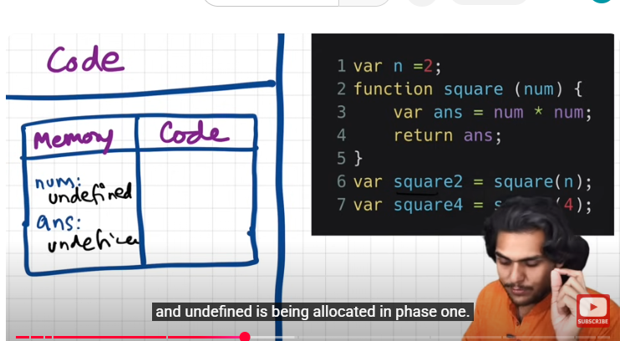

Phase 2: code execution phase

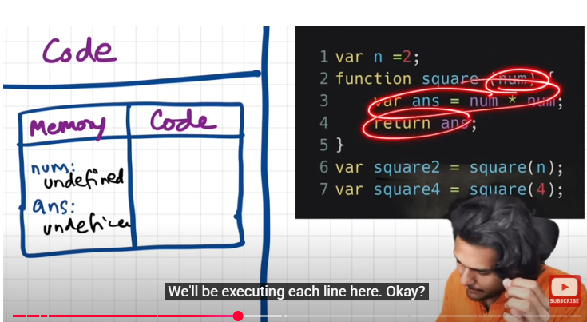

So when this function is invoked,

9:28

first of all, this value of n, over here,

9:31

which is 2, is passed to num. Okay?

9:35

so this n is passed to num.

9:38

So that means, this value 2,is passed to num.

9:43

Got it?

9:44

So let me tell you one more concept.

9:46

Num over here is known as parameter of the function,

9:50

and, n over here is the argument. Okay?

9:53

So this is the argument, and,

9:56

the value of n is 2 right now.

9:59

So, remember, over here the value of n is 2

10:03

which will come over here in place of undefined.

10:05

So let us put the value 2 in num,

10:12

and the code will then move to the next line. Okay

In line 3, it will do the calculation,

10:22

and put the value of num*num inside ans.

10:26

It's like executing the code inside this code block, okay?

10:32

num into (multiplied by) num

10:36

and whatever the value will be there, will now go to this,

10:41

and undefined will be replaced by num*num, and the value.

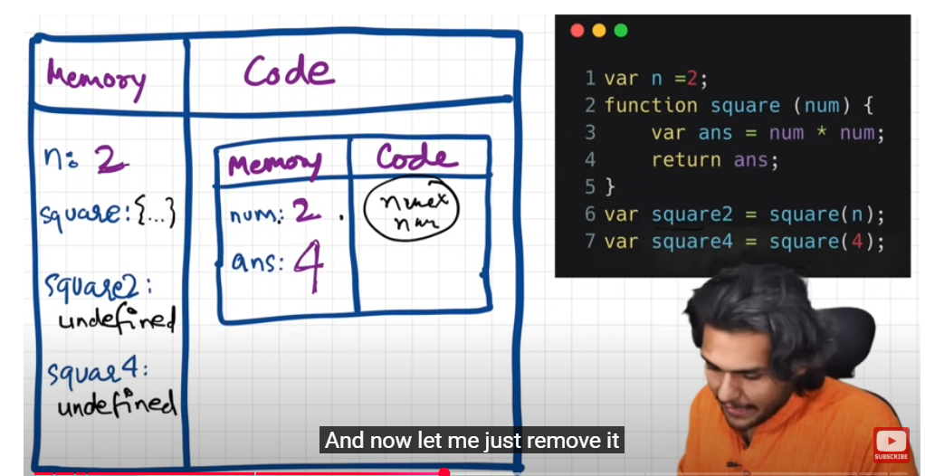

## Return statement

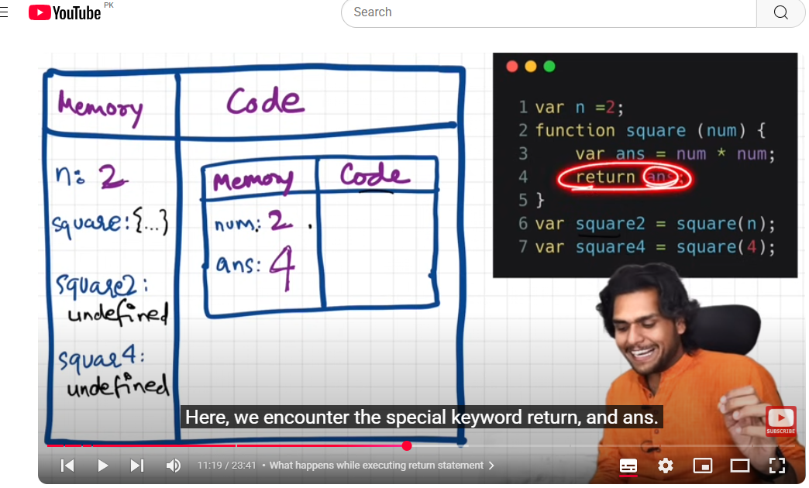  
This return keyword tells this function,

11:27

that you are done with your work now,

11:29

just return the control back to the execution context,

11:34

where the function was invoked.  
  
So return the value of ans, to the place where it was

11:55

the control, now the control goes here, to line 6 again.

11:59

How does that happen? Let me tell you.

12:03

As soon as we encounter this return statement,

12:05

we have this return of ans,

12:08

so it finds the value of ans inside this local memory.

12:12

This is known as the local memory, so local memory has 4,

12:16

So this return ans now returns the control back over here

12:20

and, okay in the line number 6,

12:23

and this value of ans, which was here 4, will now replace undefined of square2.

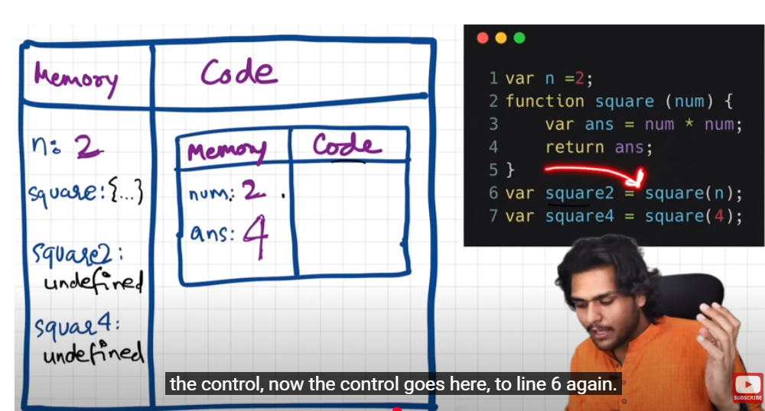

One more thing that happens when the whole function is executed,

12:48

is that, this whole execution context, for that instance of that function, will be deleted.

12:55

That means that this whole execution context will now be completely deleted.

13:01

So now there won't be the execution context as soon as we return the value

13:05

So this whole thing wll be deleted. Okay?

13:07

And the control moves to line number 6.

13:09

After this replacement, we will go to line number 7

13:13

So in line number 7 we are again invoking a function, right,

13:17

and just the difference is, we are now passing in 4 over here as an argument directly. That's it.

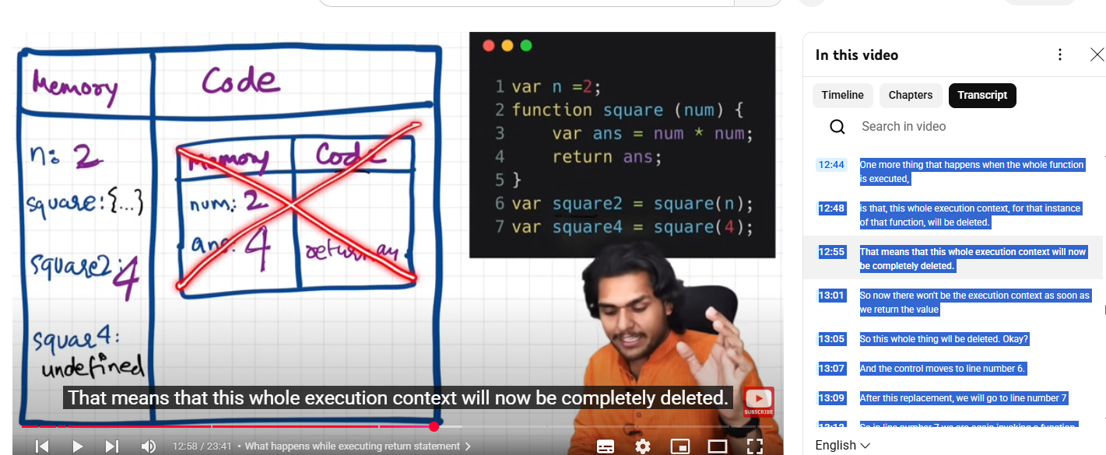  
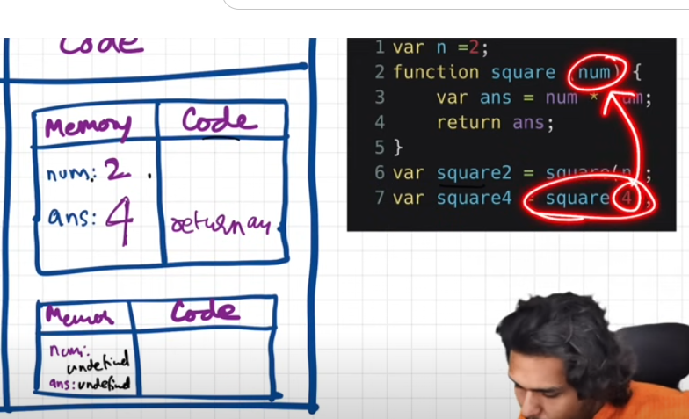  
and just the difference is, we are now passing in 4 over here as an argument directly. That's it.

13:23

Nothing will change.

13:25

Similarly, what will happen now?

13:27

As soon as this function invocation happens,

13:31

Again, a brand new execution context will be created, so let us create one, quickly and see how things are working.

13:39

So the brand new execution context is created.

13:45

Apologies for this drawing, I'm not very good at drawing (standard teacher dialogue lol)

13:48

This execution context is created,

13:52

Again it will have this memory

13:54

Again it will have a code component, remember?

13:58

And now, it will again go through those two phases.

14:01

Let's quickly do that, it will be fun.

14:03

So now it again goes back to this function here, right?

14:07

So this function. Now remember what happens?

14:10

Firstly memory is allocated to num, okay?

14:14

num will store the value undefined. Remember?

14:17

So let me zoom in.

14:19

Undefined

14:21

And, one more thing happens is, we allocate memory to ans, which is again, undefined.

14:31

Right?

14:34

Our first phase is done.

14:37

Now in the second phase,

14:40

In the code execution phase,

14:42

What will happen is, num will get this argument, from the invocation in line number 7,

14:49

num will get this value 4.

14:52

So num parameter will get the argument 4.

14:55

So here the argument is 4.

14:56

Okay?

14:58

In the code execution,this undefined will be replaced by (in the code execution phase) 4.

15:07

Right?

15:10

So it will be 4. Right?

15:12

And, what will happen after that, it will go to line number 3. Right?

15:18

So while invocation it will go to line number 3.

15:21

It will execute num*num, which is 4*4, 16

15:25

and this 16 will now replace this undefined value inside the ans. Right?

15:31

So we'll now replace this with 16. Got it?

15:36

So now it'll store 16.

15:39

The control moves to line number 4. After 3 is done.

15:44

So now, this return statement takes back the control to line number 7, where, the function was actually invoked.

15:51

Now the value 16 will replace undefined in the square4 variable. Okay?

15:57

So let us do that

16:00

Let us quickly do that. It will now get value 16 over here. Okay?

16:09

As soon as we are done with the function execution, this whole execution context is now deleted.

16:14

So this will be deleted.

16:16

So now line 7 is also executed, now there is nothing more.

16:19

So JS is done with all it's work.

16:21

So once JS is done with all it's work, now the program is finished,

16:26

The whole global execution context also deletes; goes off. Okay?

16:32

So that is how the whole code is executed.

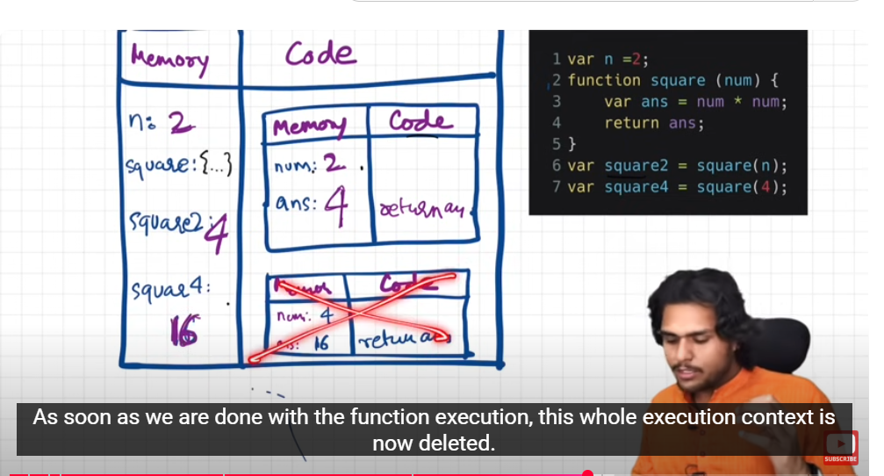  
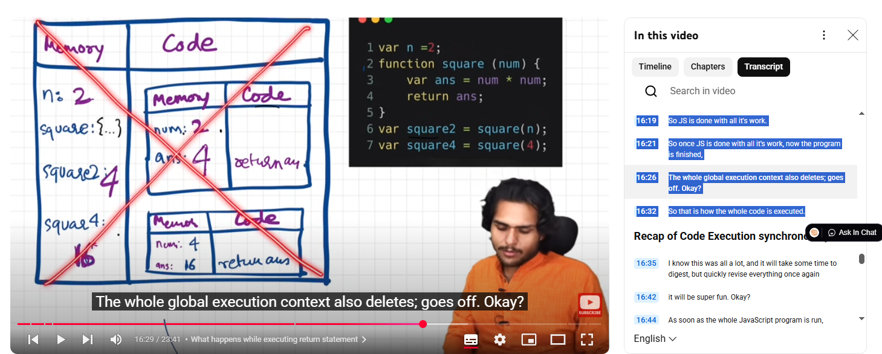  
the whole global execution context is also deleted once prog is finished

# Call Stack

At the bottom of stack; global execution context   
then as function invoked another execution context is created and put onto the slack

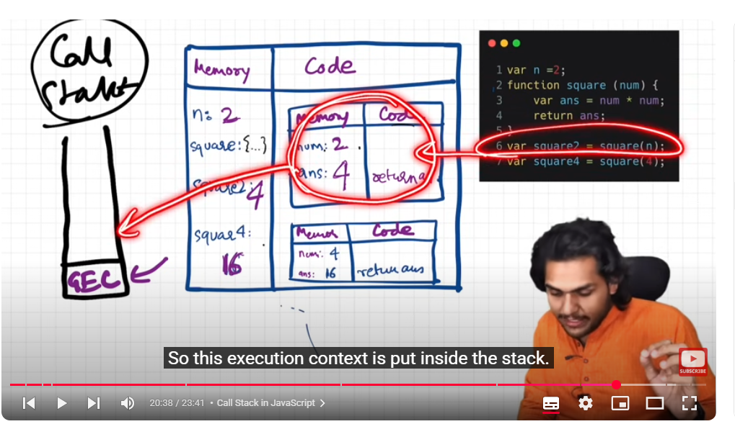

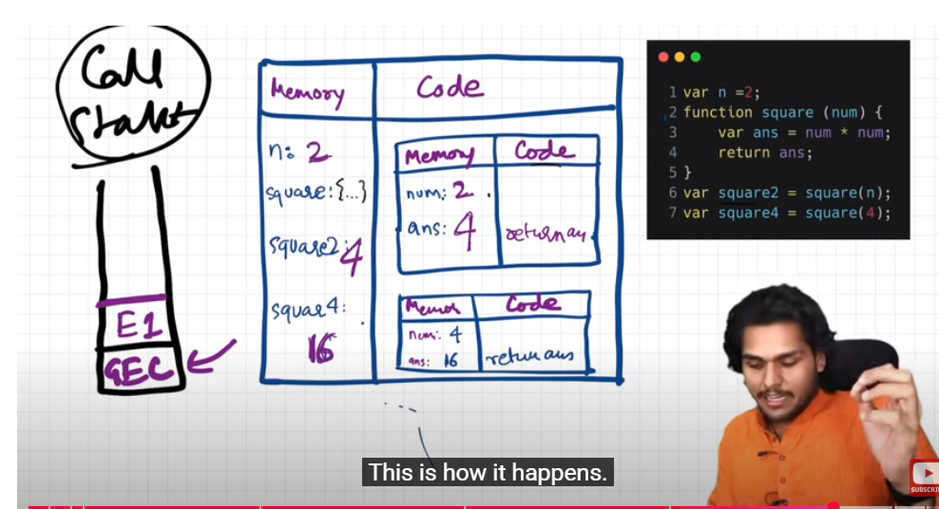  
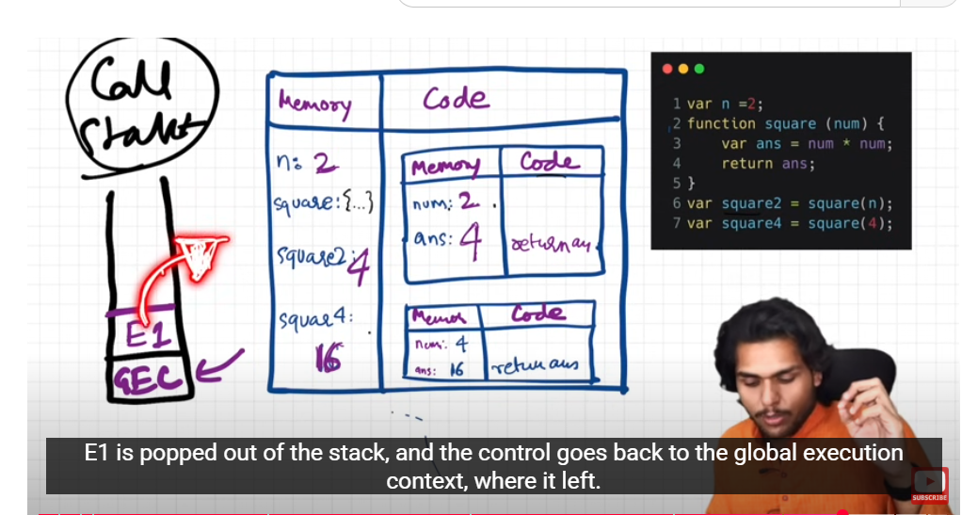  
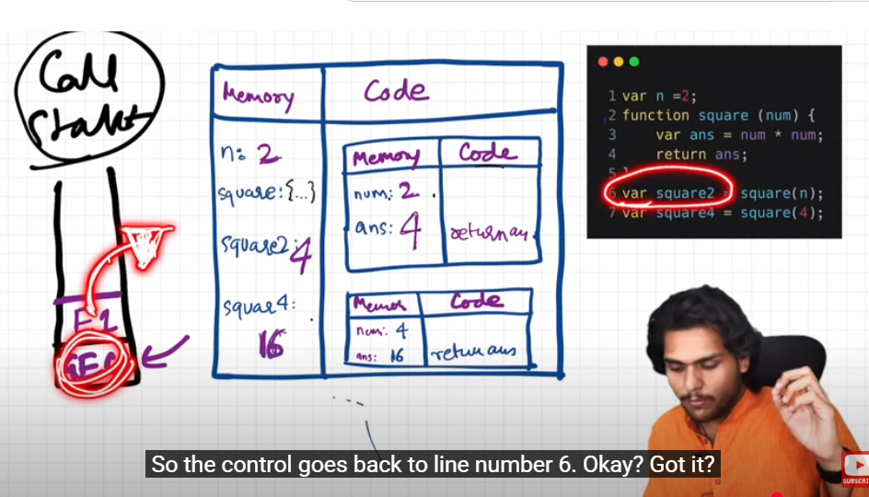

E1 : Execution context1 is popped out of stack once is executed  
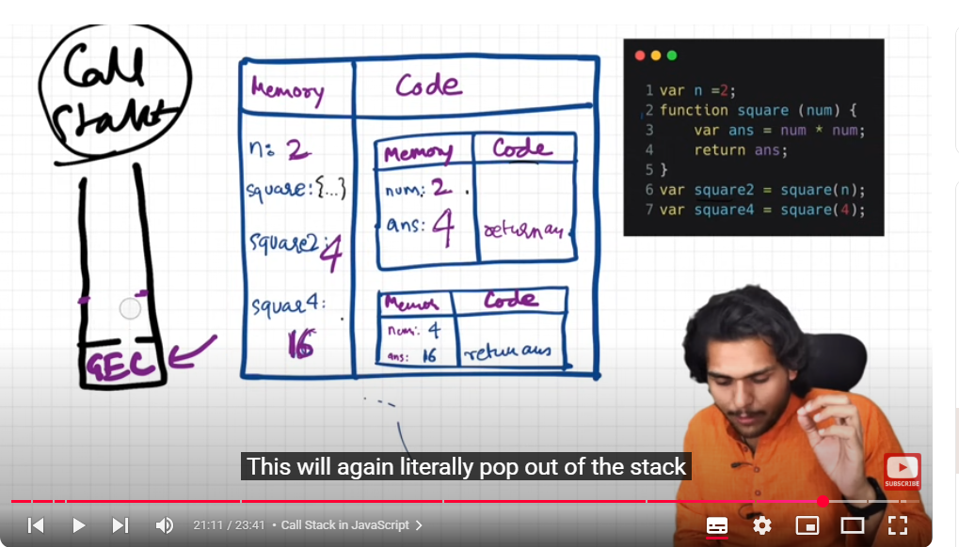

on line 7: another func is invoked another execution context is created lets say E2 and it will move to stack  
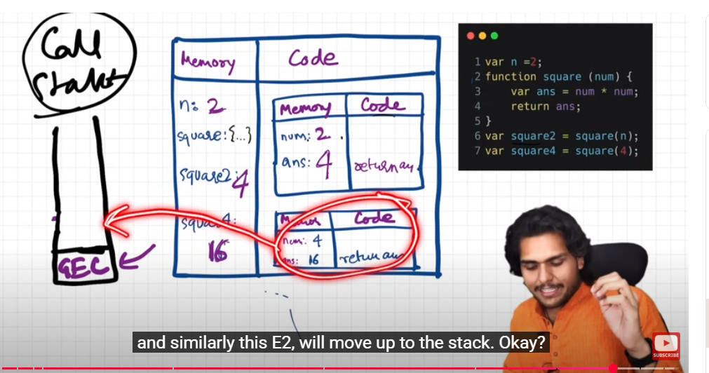  
  
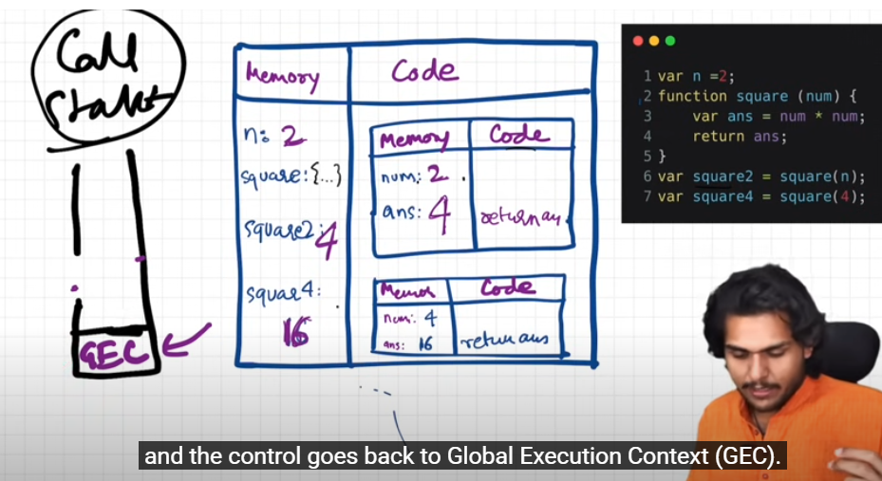  


# core concept

# call stack other names:

# Hoisting

Whenever interviewer ask about hoisting talk about execution context and its phases so that you can demonstrate that you know the whole concept behind

**Hoisting is phenomenon in js by which you can access variables and functions even before you have initialized it and you have put some value in it and you can access it without any error**

Case 1:

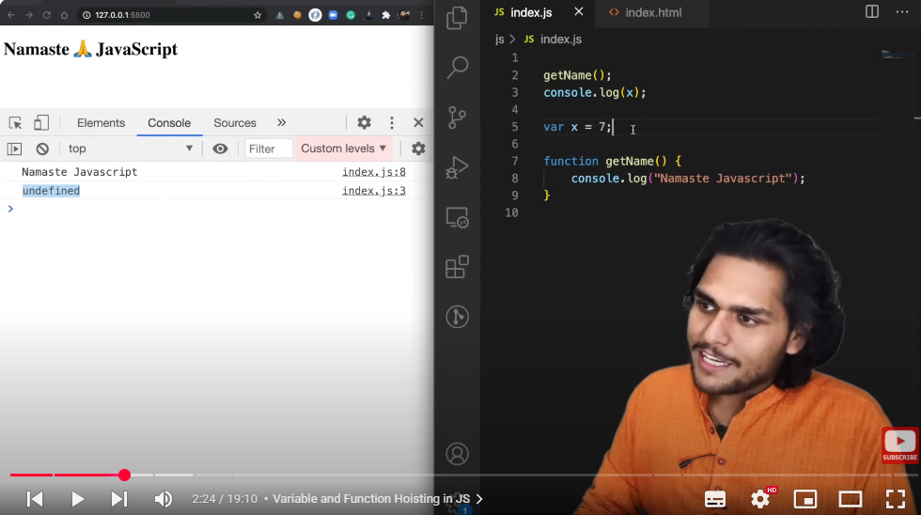

Case 2:

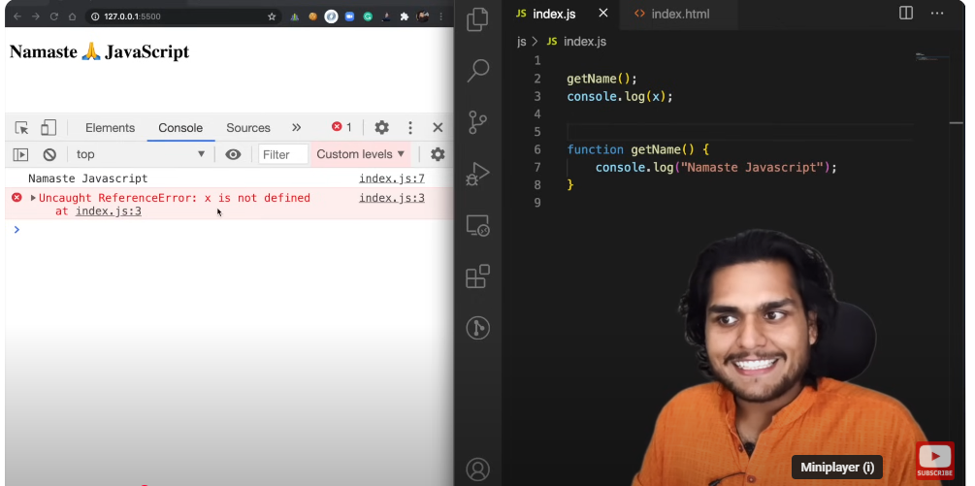

Case3:  
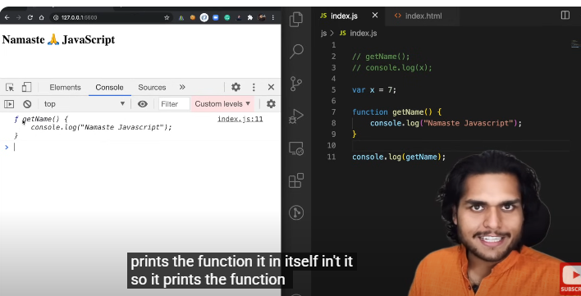

Case 4:  
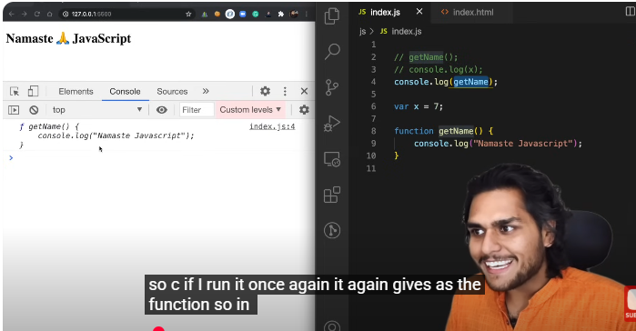  
  
all cases combined:

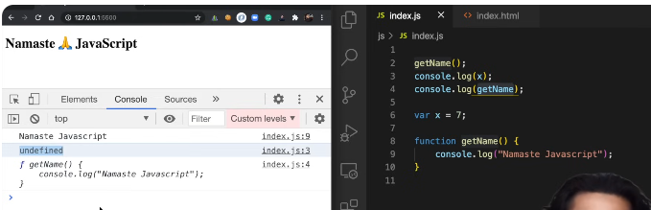

## Background:

Before execution memory is allocated to each variable and func(reference to prev video and execution context is created which has two phases :  
phase 1: memory creation  
phase2: execution)

Lets go deep inside:  
  
we put a debugger on first line ; even before execution see the global scope in console  
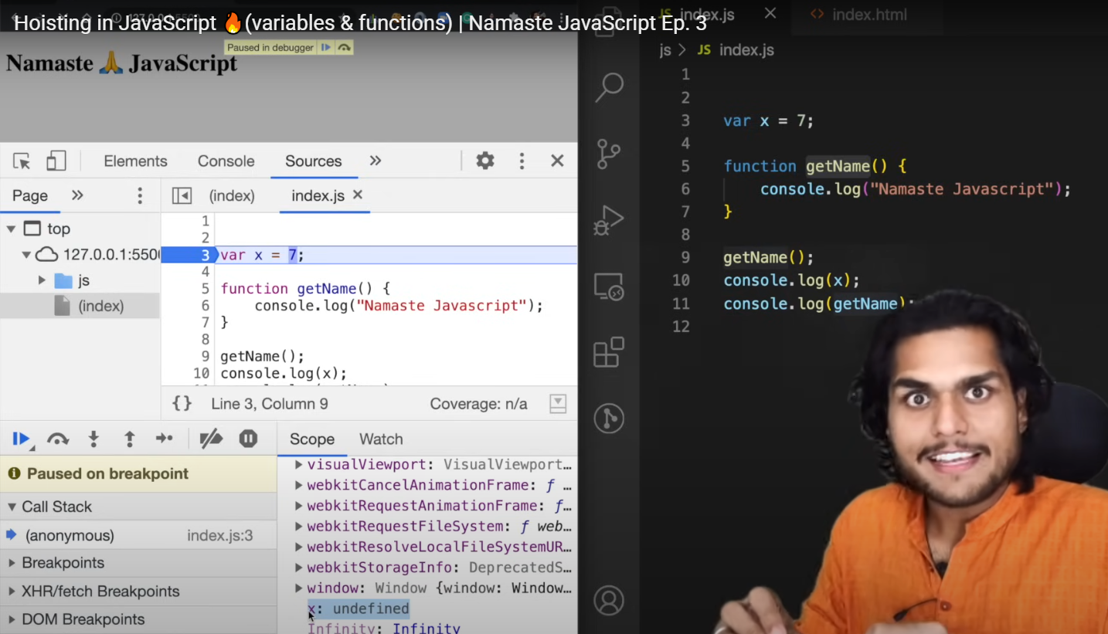

memory is allocated to x even before we have started execution and it stores a special keyword undefined for these variables.

So even before execution Js has reserved memory for x and place the special placeholder undefined to it.  
ad similarly in case of function ; whole code inside func is copied as it is to memory  
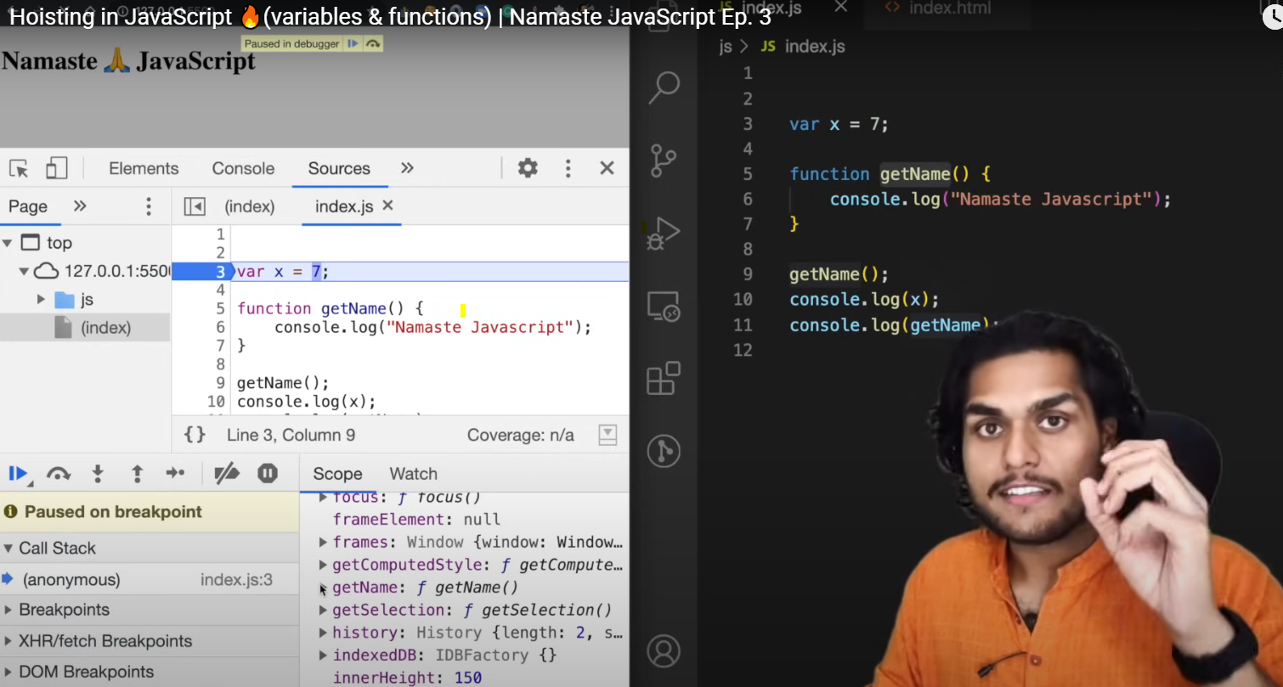  
  
now call the func and var on the top before initializing and again lets put debugger on the first line and even before this first line that is invocation of getName() is executed , we will already have these variabes and functions in memory space.  
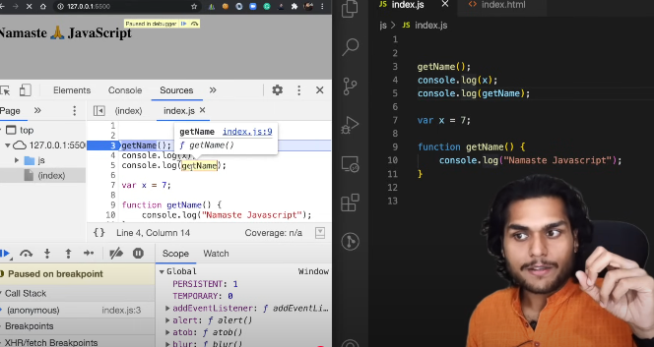  
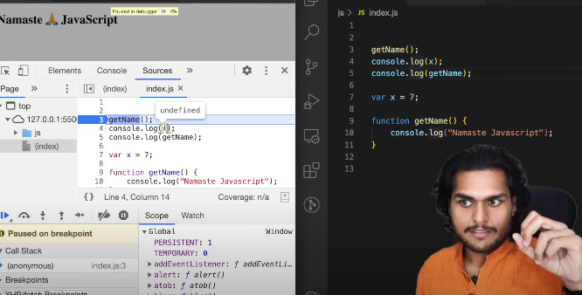  
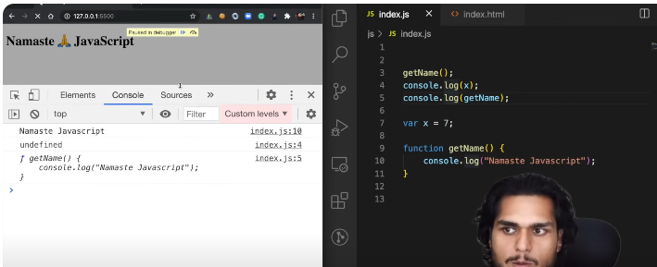

# Difference b/w not defined and undefined:

JavaScript code is executed in a different way it creates a global execution context and allocates memory to all the variables and functions even before a single line of code is executed.

Undefined 🡪 a placeholder which is placed in the memory

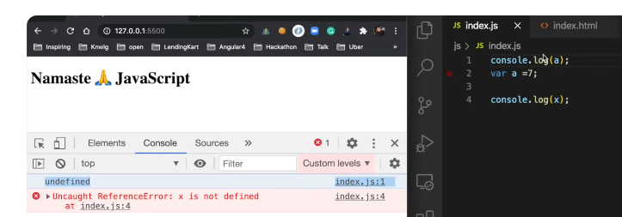

undefined was coming from the place just because JavaScript engine allocated undefined that special placeholder to a okay not like not defined not defined in something which has not been allocated memory.

## Undefined:

it is a special keyword it takes up its own memory but you can assume it to be like a placeholder which is kept for the time being until the variable is assigned some other value okay

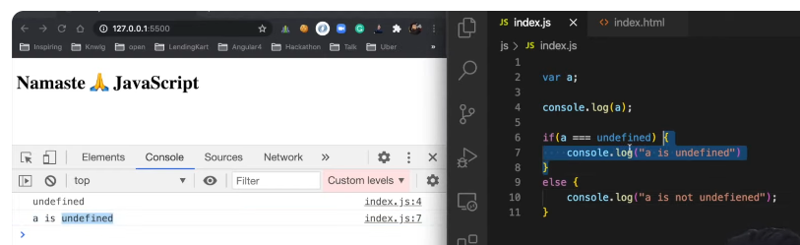

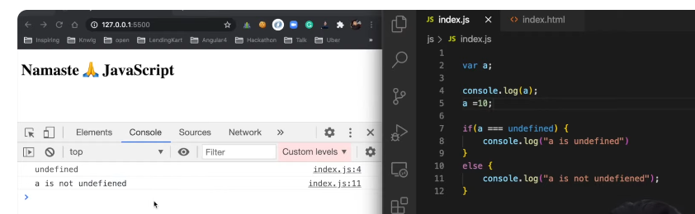

# JS is a loosely typed language

Also known as weakly typed language

so loosely typed means that it does not attaches its variables to any specific data type so suppose if i created a and put in string in it so later on in the program i can also put numbers in it i can also put Boolean in it. It is like very javascript is very flexible in this case right it is loosely typed that is known as loosely type language if it was strict type then just like other languages just like c or c plus plus if you assign a variable that if it is a string a so it will only hold string it won't hold numbers or booleans or anything else.

### Coercion

## Bad practice:



a bad thing to do in javascript okay you

should not do it

because see first of all what is

undefined so undefined is like a

placeholder which is

kept inside the variables

and it states that in the whole code

that variable

was not assigned anything right so it is

meant for a specific purpose

so it is not generally a good way to put

undefined like this

though it is a totally okay to do this

other examples of undefined

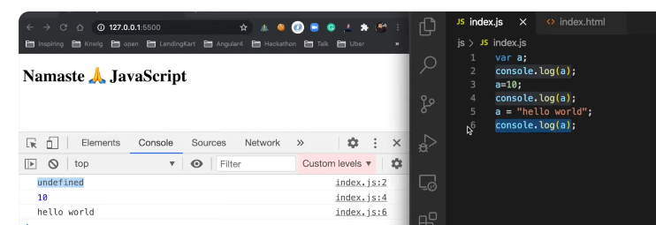

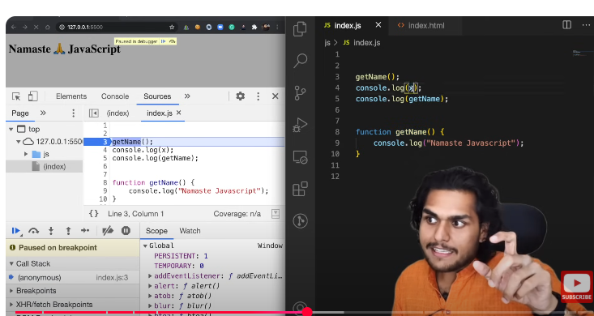

Now we have removed var x from code   
again put debugger on first line:  
as soon as it goes to firs line ; now we have not reserved memory for x; we just reserved memory for getName() 🡪 now JS will throw error : reference error : x is not defined means x was not present in memory that means x is nowhere initialize in program and you are trying to access it

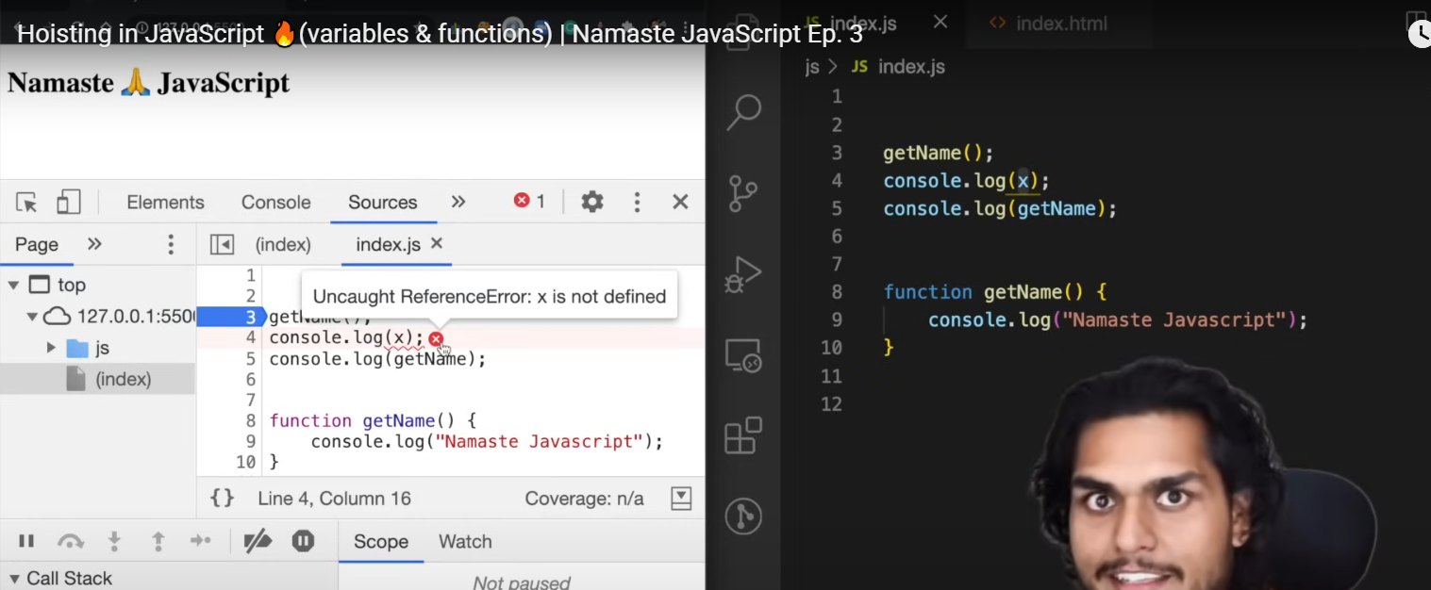

## Arrow function:

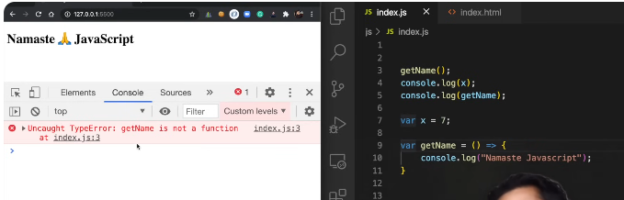

When getName() is arrow function ; it behaves just like another variable now this getName() does not behave like a function so what it will do is even before we execute this whole code ; in memory allocation phase of execution context 🡪 just like it allocates undefined to x 🡪 it will allocate undefined to gtName() let us see in global memory space now:

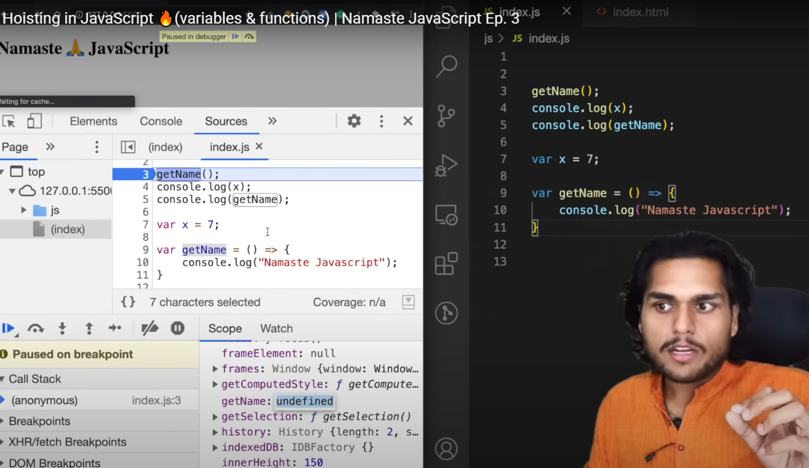  
  
getName2() syntax and see it in memory:  
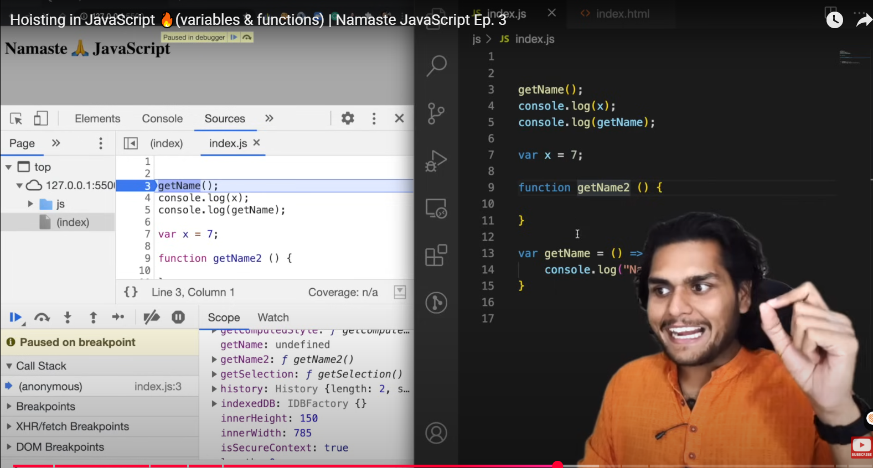  
  
one more way to define a function:  
  
getName2() is undefined again  
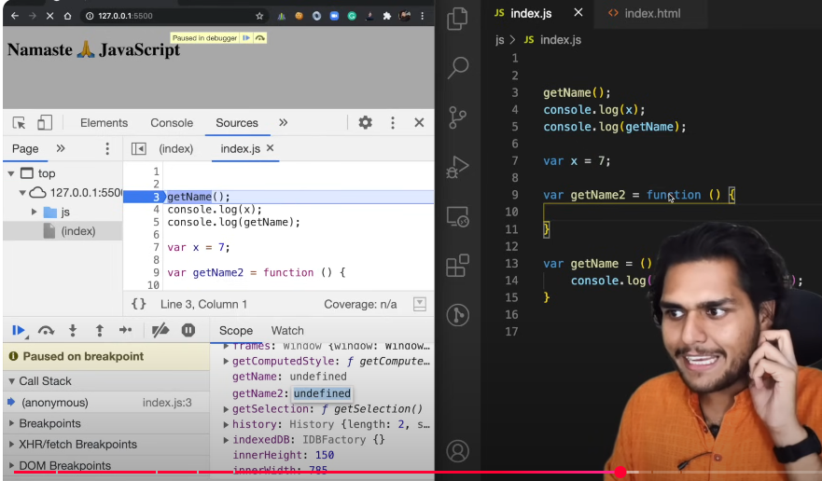

So In above two cases getName() getName2() behaves like variable and it will allocate a memory with placeholder undefined

And in case of **proper function decleration:**

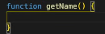  
it will copy the whole code in memory  
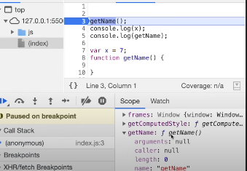  
  
Call Stack:

Let us see the practical demo of call stack that we talked about in last video how call stack is maintained jo sabse bottom pe global execution context hota then jaise jaise exeution context create hote hain function invoked hone pe wo stack me push and pop hote hain see:

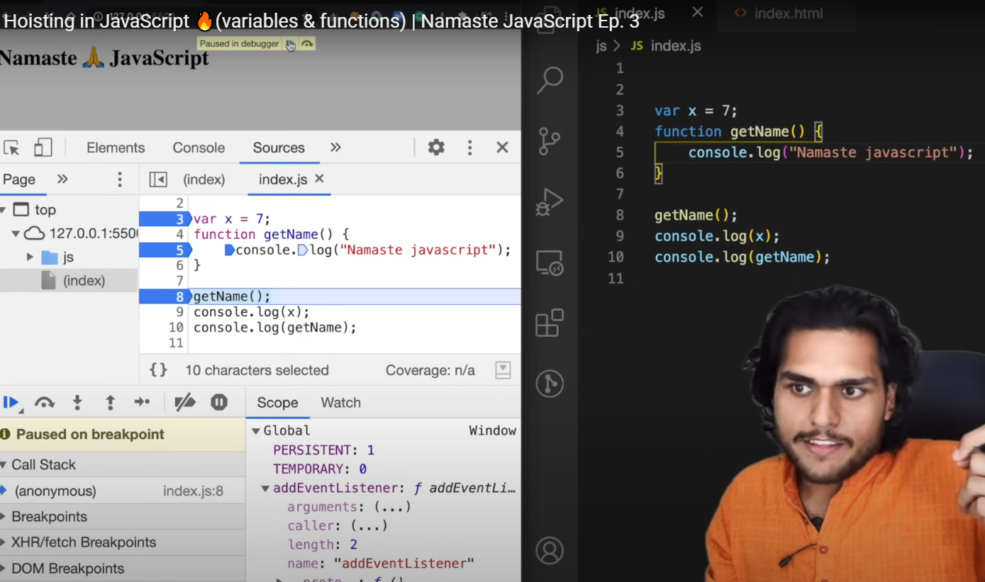  
GEC: anonymous ()pointer initially on it)  
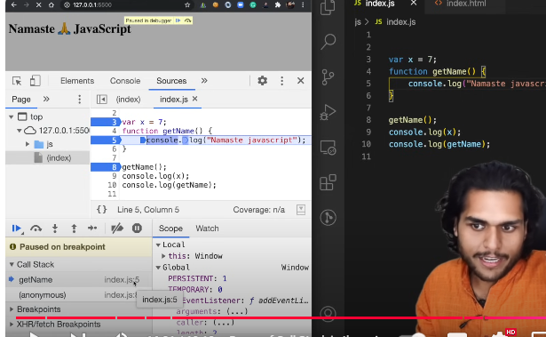  
control went to line 5 where I put debugger , execution context of getName() was created and put on call stack  
anonymous 🡪 GEC on bottom of call stack

On top of it getName() E1  
WHEN WE FINISH EXECUTING THIS FUNCTION ; that execution context will be deleted and it will be popped off stack  
  
so if I put a debugger on line 8:  
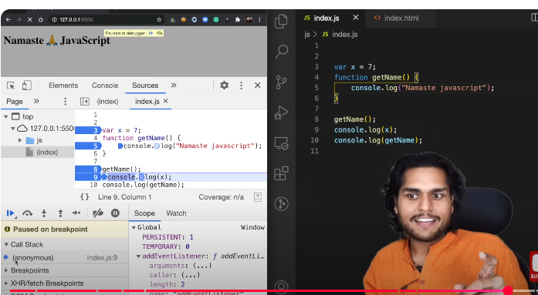

Now getName() is vanished  
control is went to line 9

Once we finished executing everything in program 🡪 call stack is empty now  
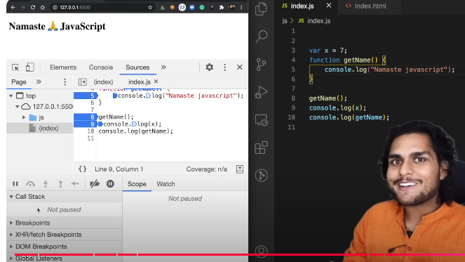

# Arrow Functions and this:

This represents current context  
user = {}  
this is current context , {} represents the context

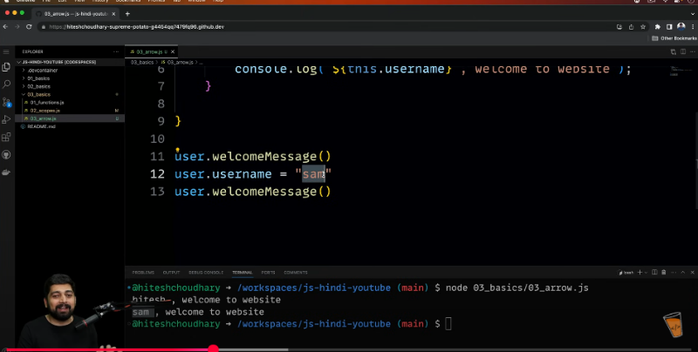

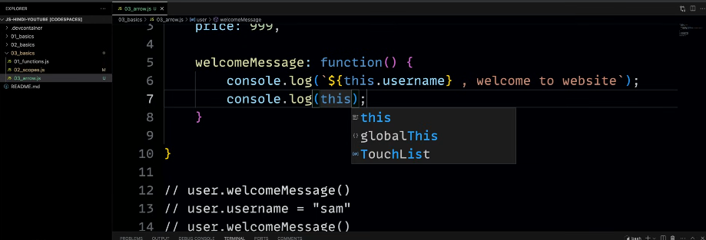

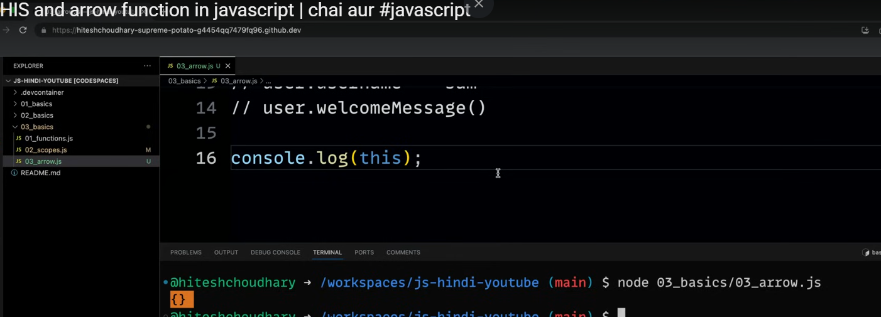

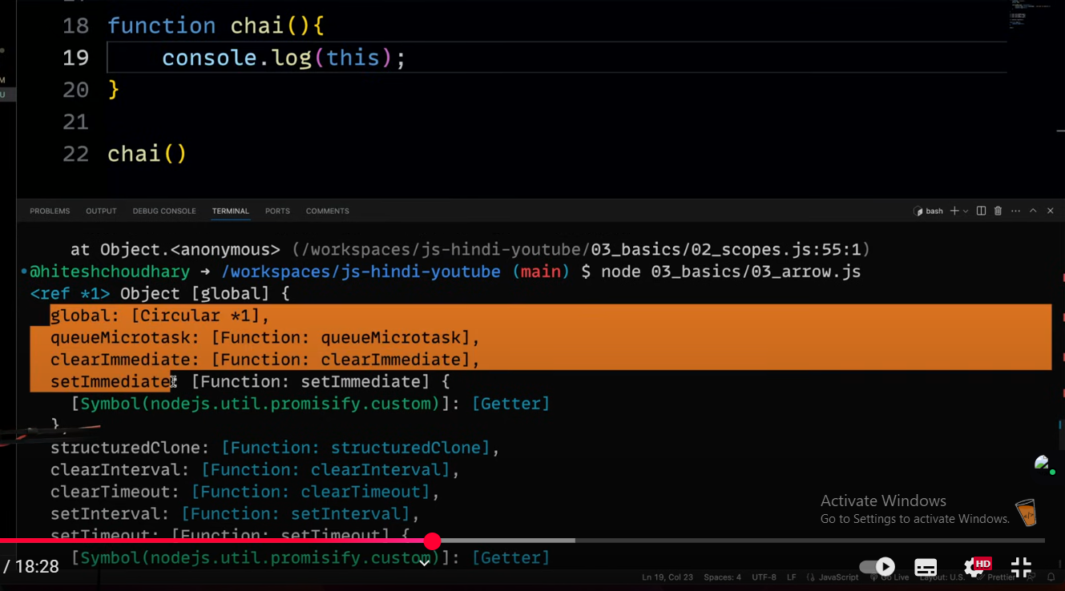  
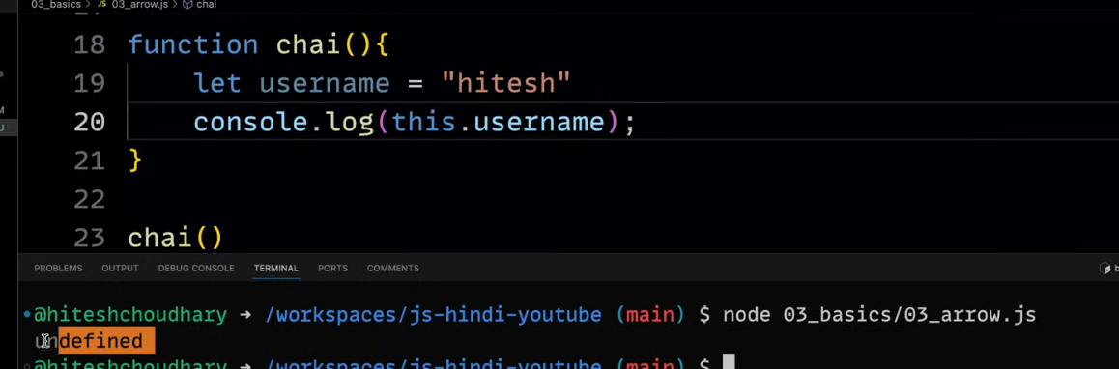  
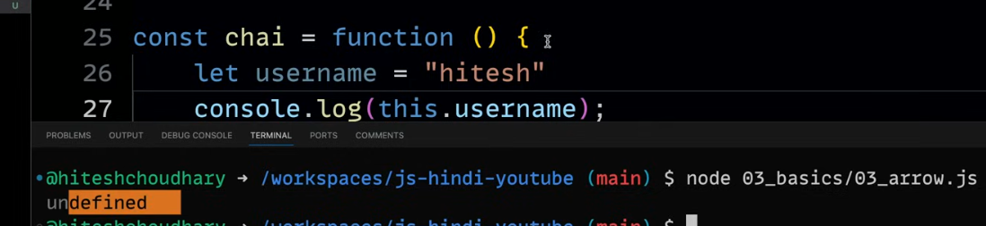  
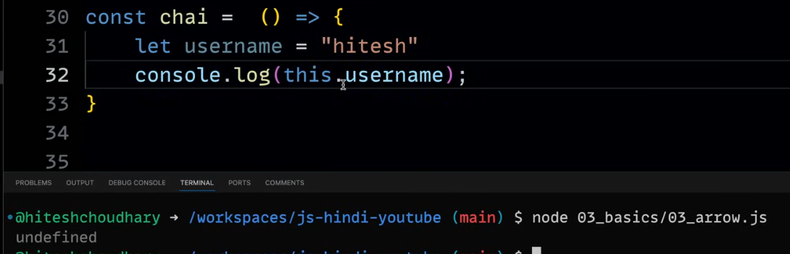

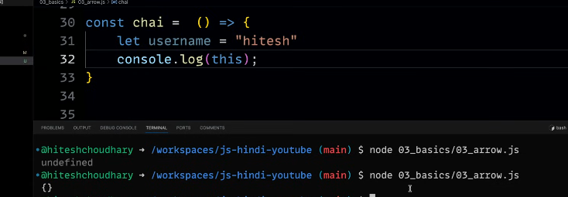

Functions :   
how function invocation behaves behind the scenes

if we have same variable names ; how our program behaves 🡪 how js is handling this scenario

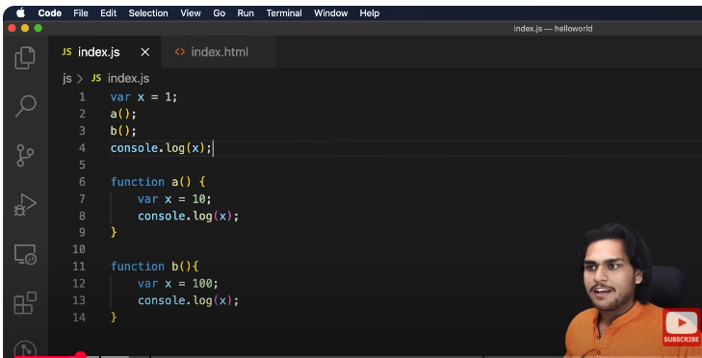

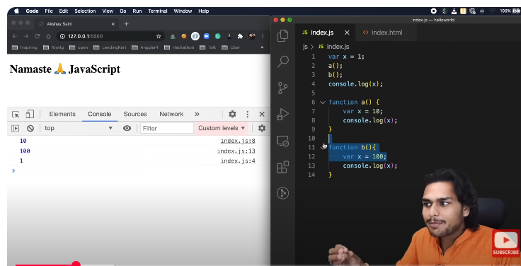

Analysis:  
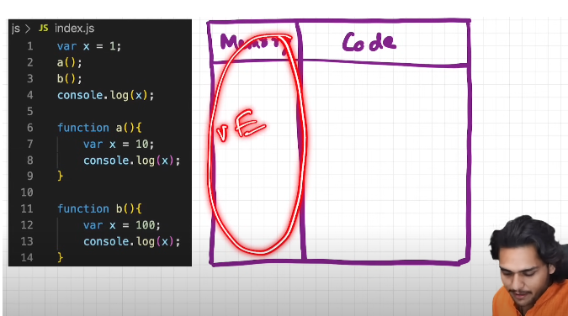

As program runs the global execution context is created   
it consists of two components  
1. Memory (also called variable environment)

2. Code

Before execution memory is allocated to all var and func  
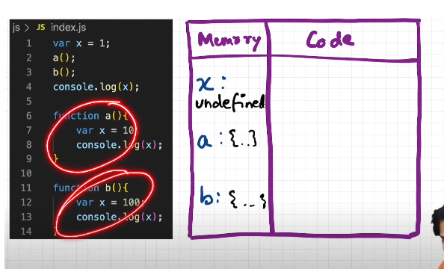

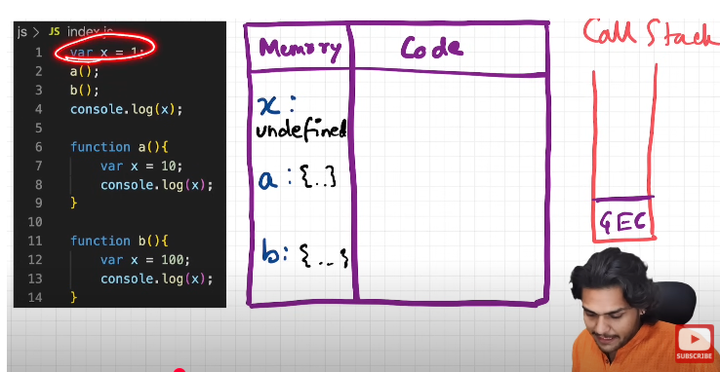

Now when we start execution:

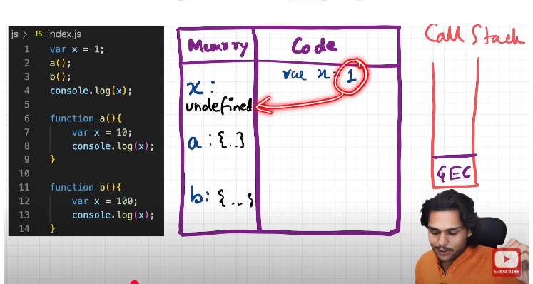

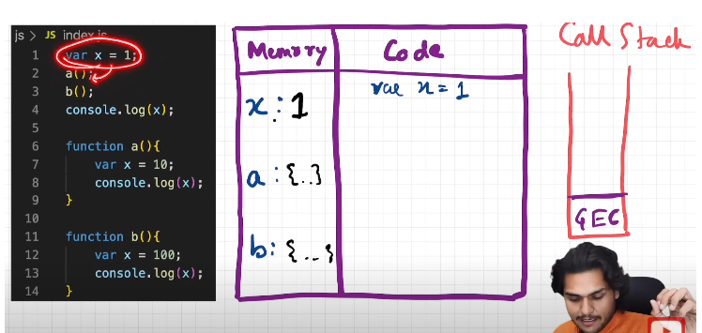

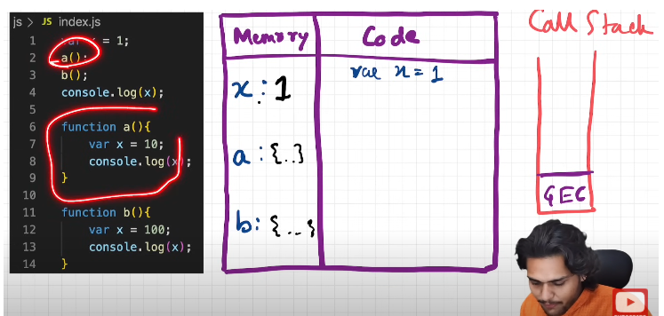

a() func is invoked:  
an execution context is created and this will put on stack

now this is separate mini environment ; now again this execution context will have two phases 1. Mem allocation   
2. Code execution  
now ;

there is no parameter in function directly go iside ; thre is variable x allocate mem to x  
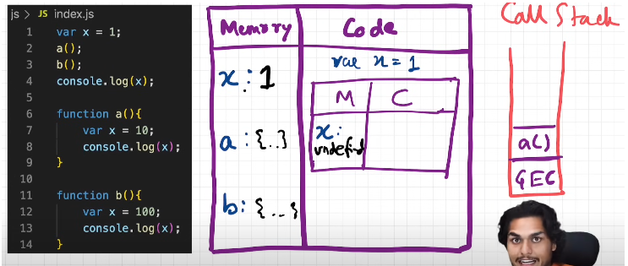

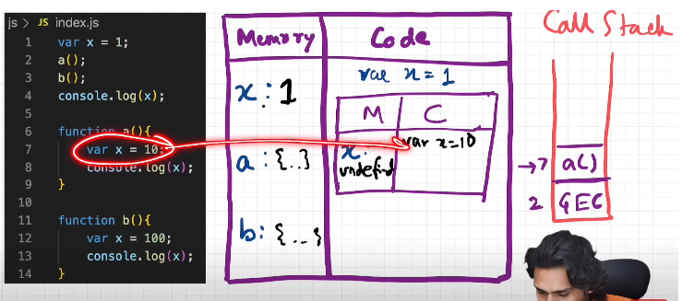

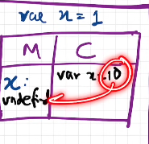

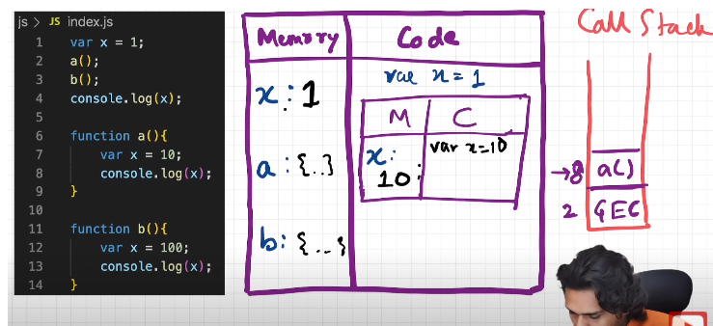

Line 8: Console log x

Javascript engine will look for value of x in local memory space that means it is limited to particular execution context  
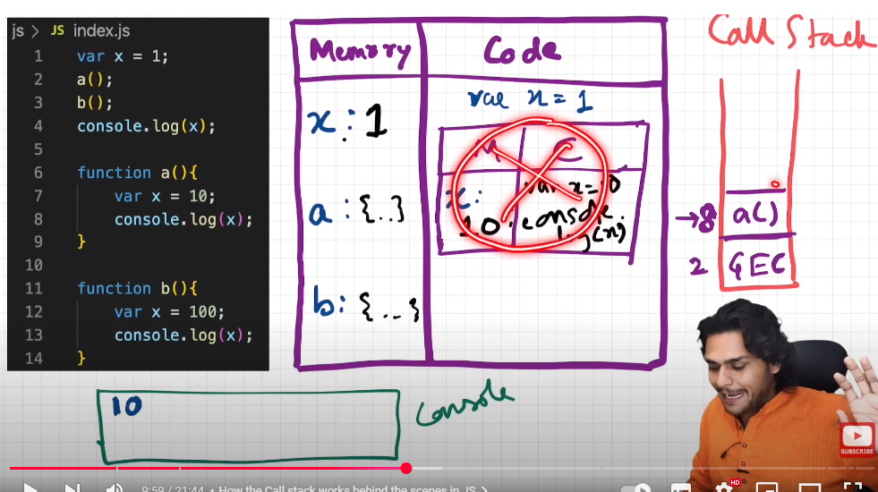

Once this func a() is executed ; execution context is deleted and popped of  
 stack

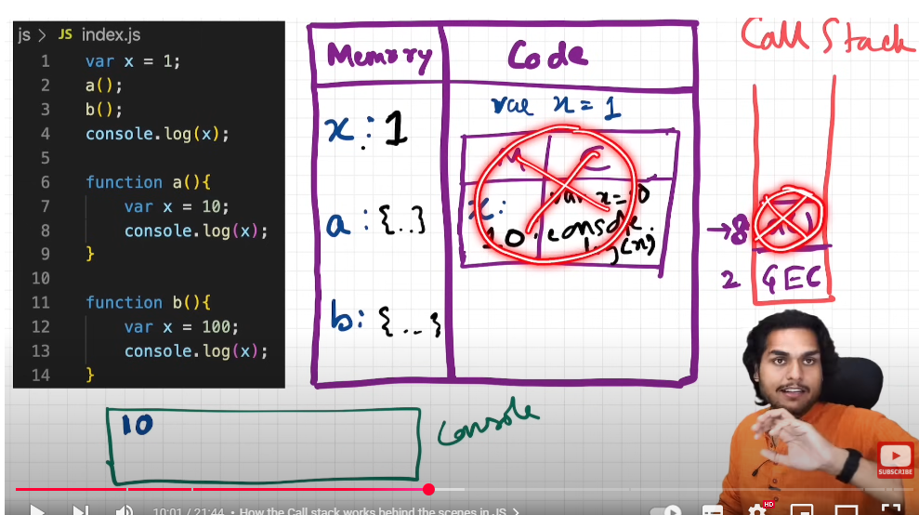

Now control goes back to GEC line 2 where we left  
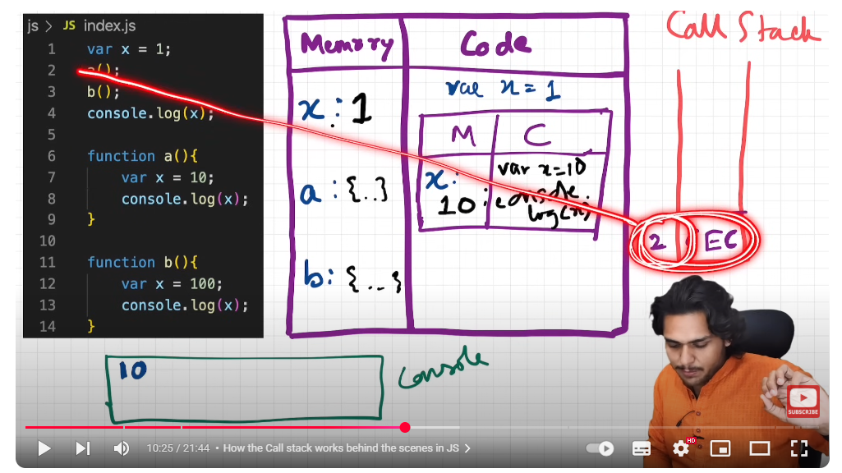

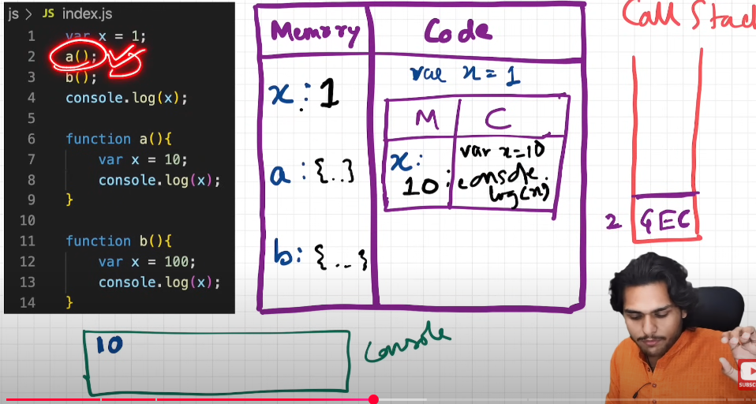

b() is invoked   
again execution context created which has two phases

phase1: mem allo 🡺 x is allocated mem with undefined placeholder

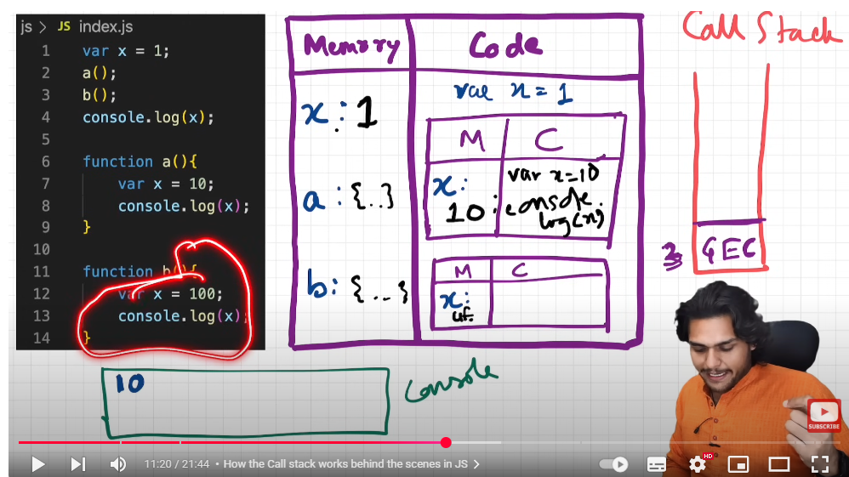

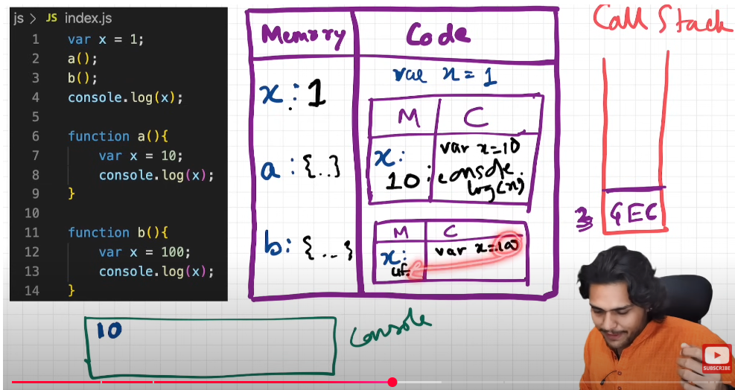

Now console log x which means JS tries to find out value of x in local memory  
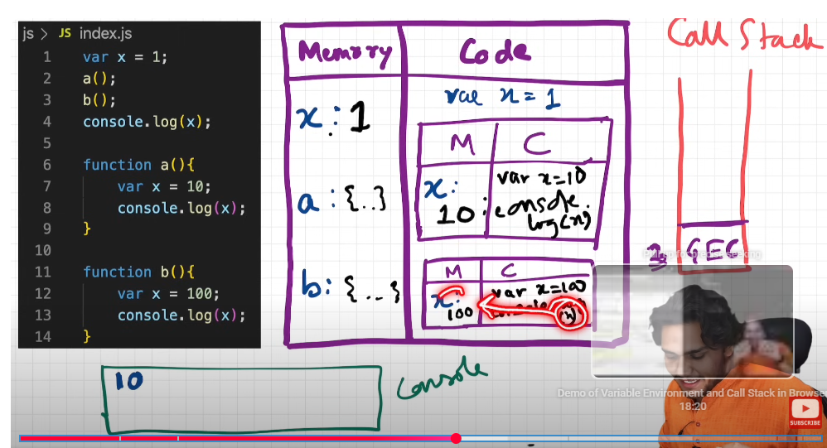  
it will find 100 and print  
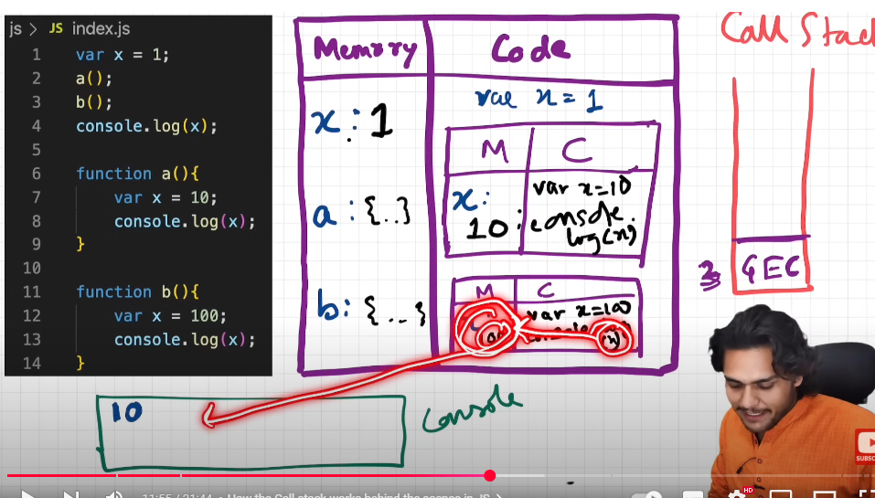

Again b() has finished execution and its context will be deleted and popped of stack.

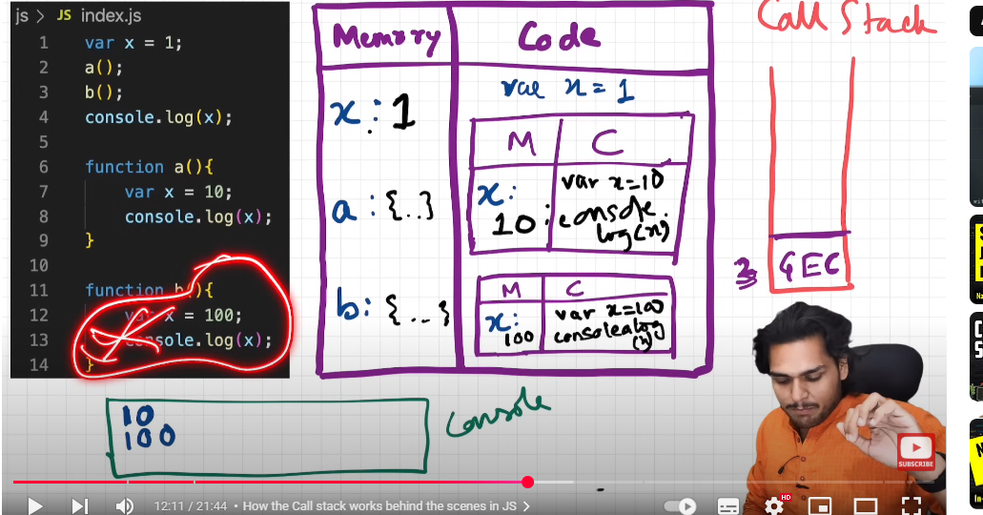

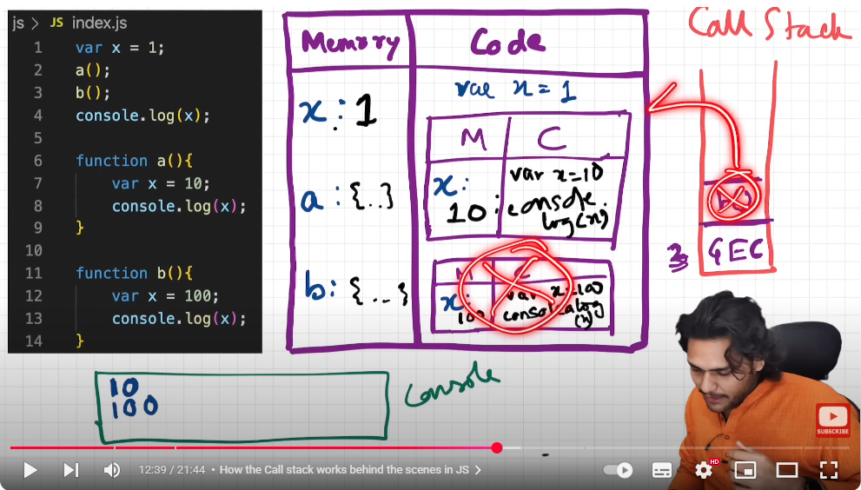

Memory space ; everything is deleted

Now control is back to GEC line 3:  
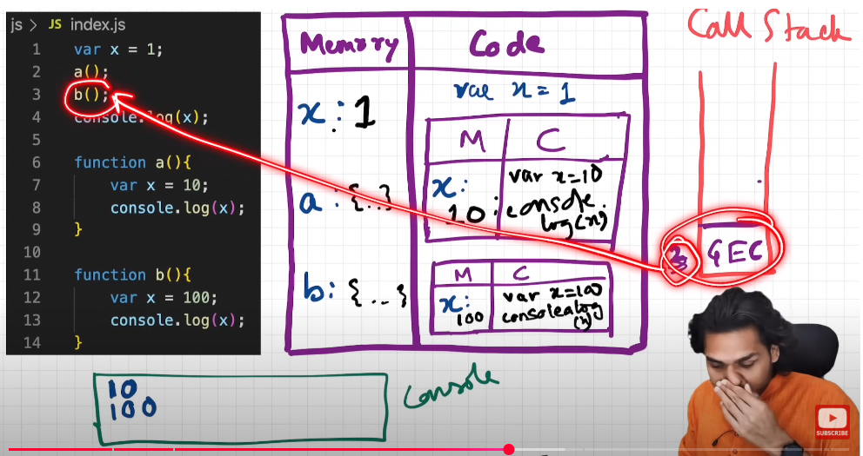

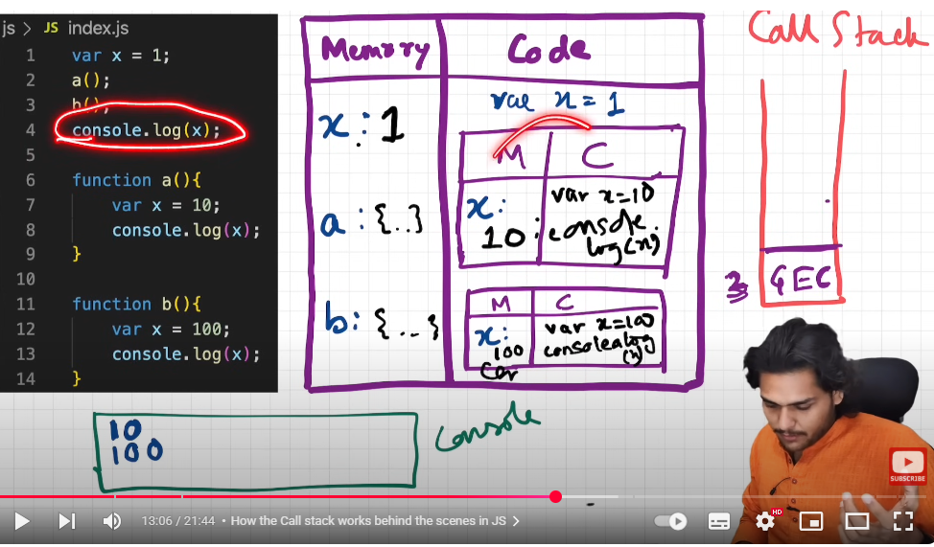

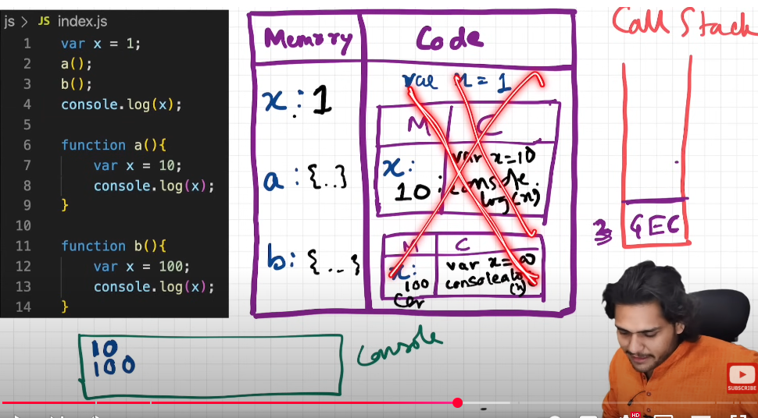

Now console log x –> it will find value of x in local memory  
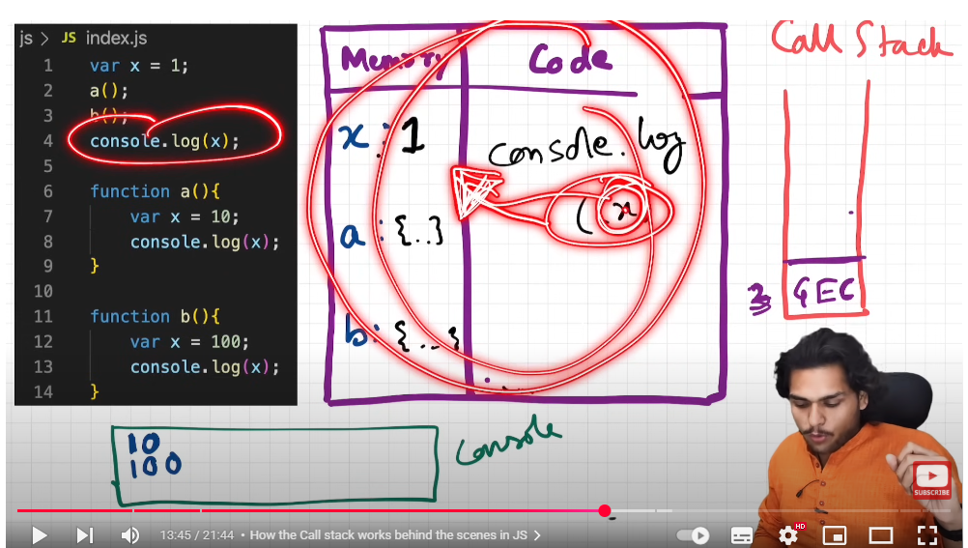

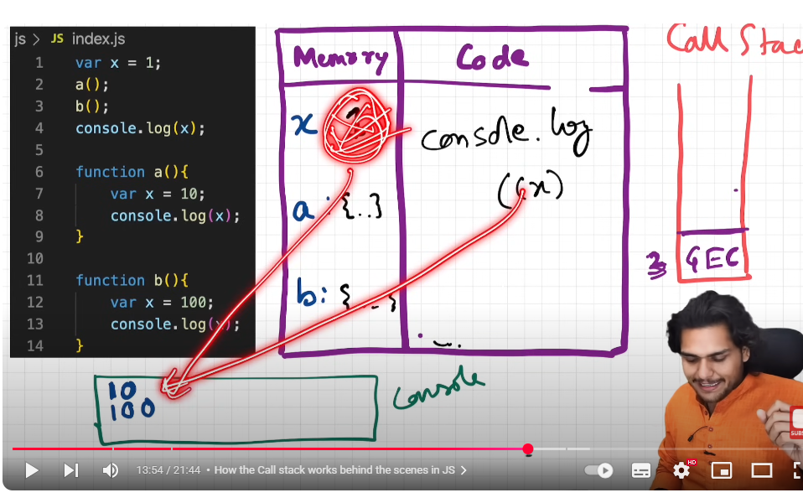

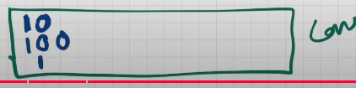

Nothing to execute further tou even whole GEC will bw deeted

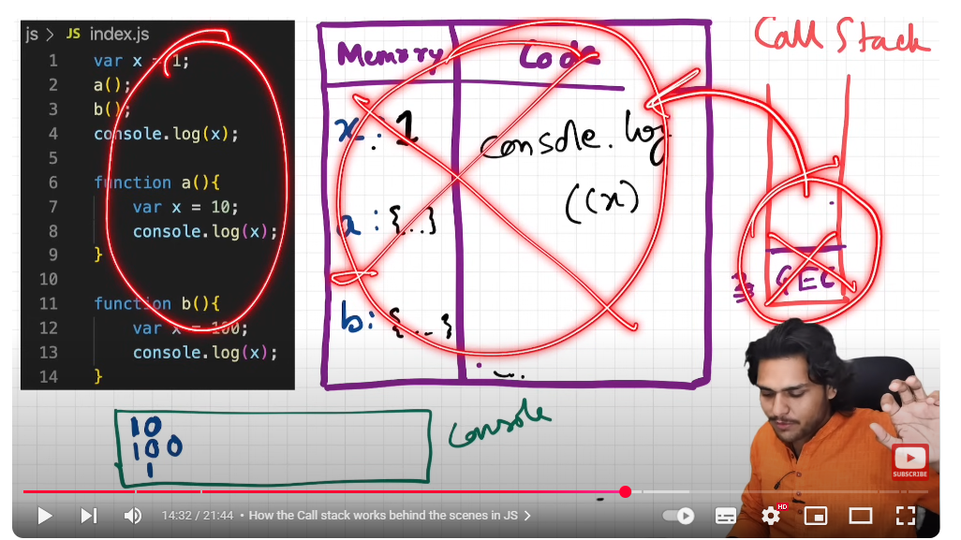

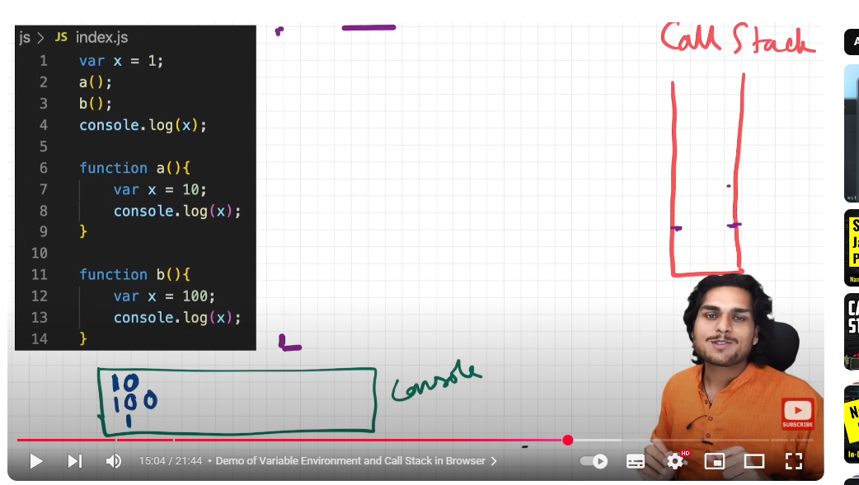

Let us see this in browser:

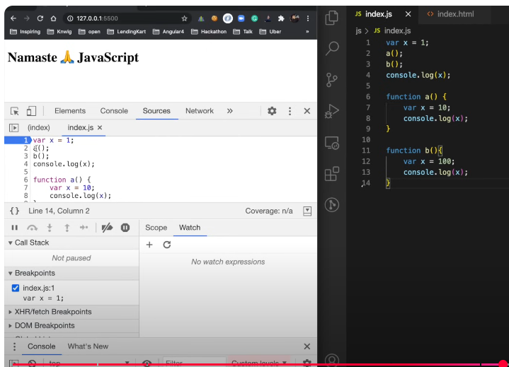

In the beginning before execution of prog call stack is empty

We put debugger on line 1:

As we run prog 🡪 GEC is created and pushed on slack

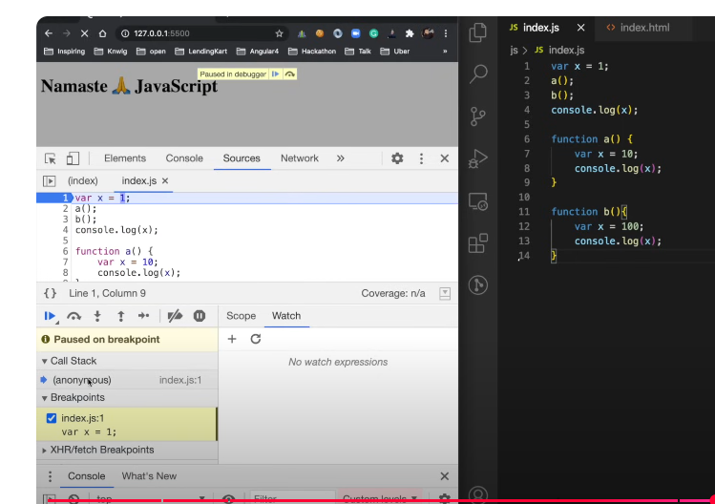

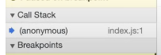

Control is on line 1   
x , a(), b() should be allocated memory in phase 1

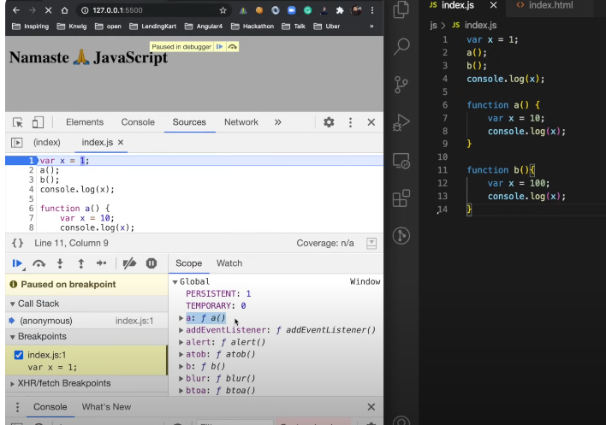

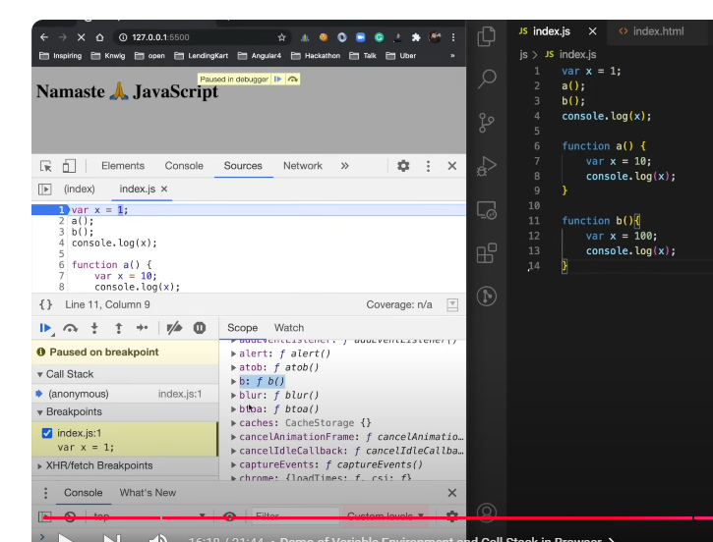

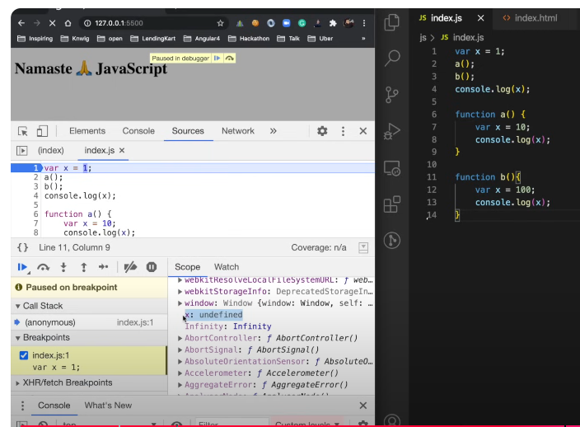

Now phase 2: execution

Line 1 executed : value of x will become 1

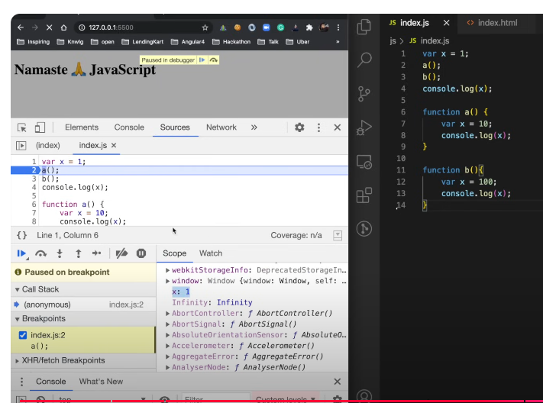

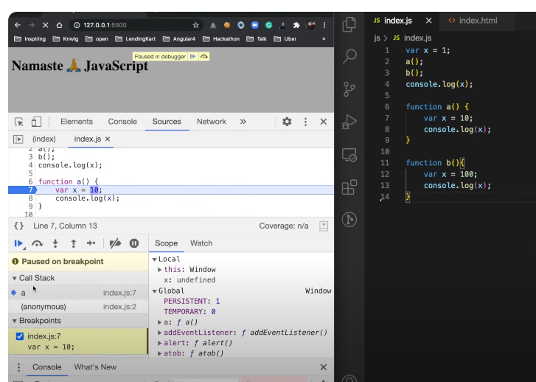

Control moves to line 7 🡪 a() execution context pushed to call stack

GEC has its own memoray space separate and

a has its own mem space

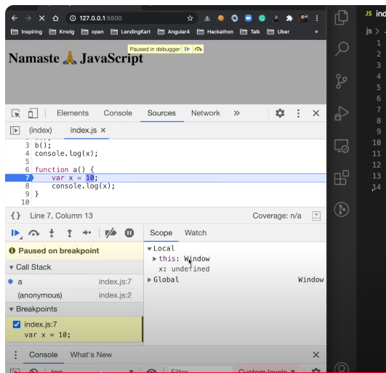

Our code hasn’t started executing in a() context so x is undefined that is phase 1 of this exection context x is allocated mem and undefined.

When second phase of this execution context comes :

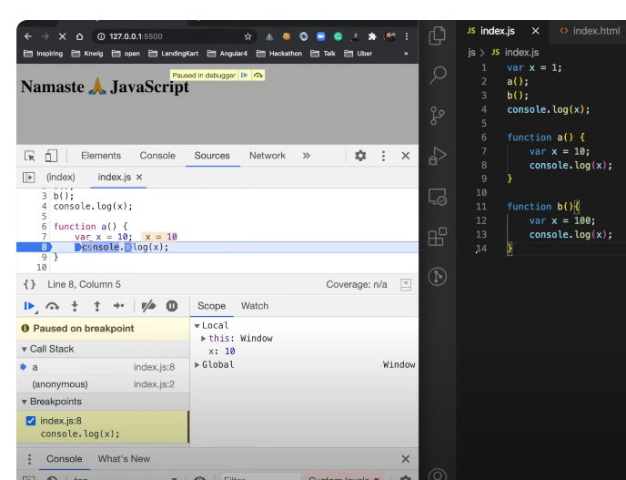

X 10 hogaya

Ab jaise hi ine 8 execute hojyegi control dubara se **line 3** pe chala jayega , ye context delete hoajyega x console hochuka hoga aur call stack se a() remove hojayega aur call tack k pointer again GEC(anonymous pe chala jaeyga)

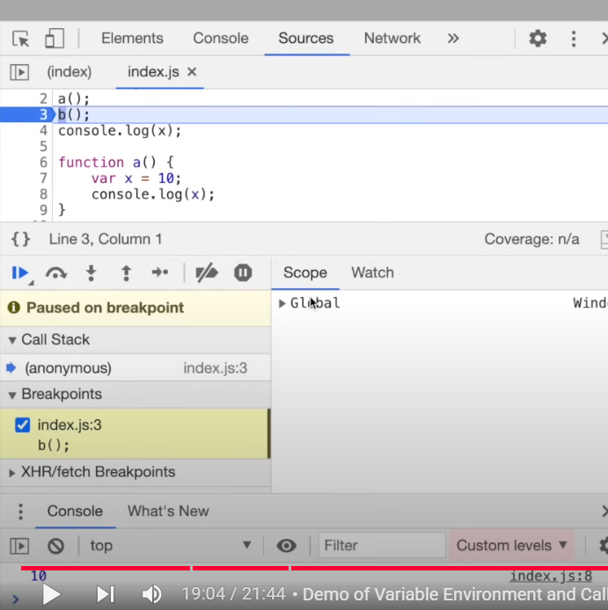

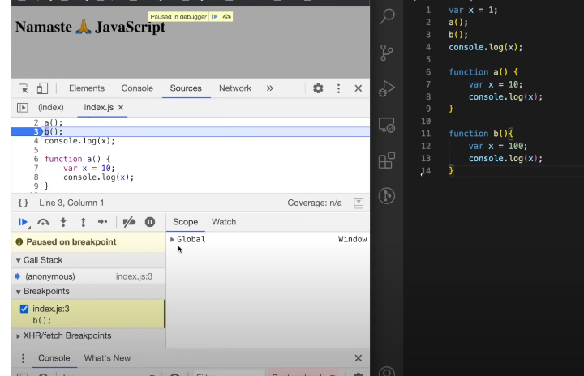

b() invoked same story repeats:

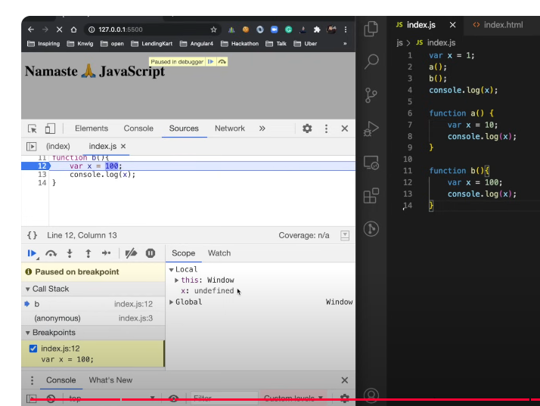

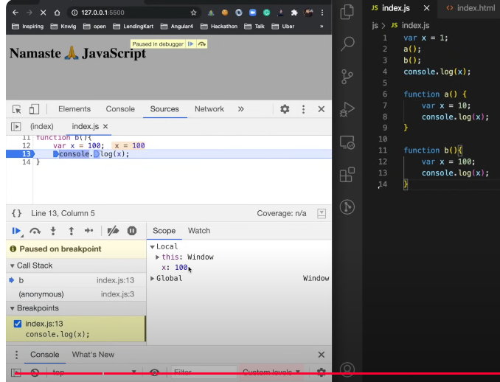

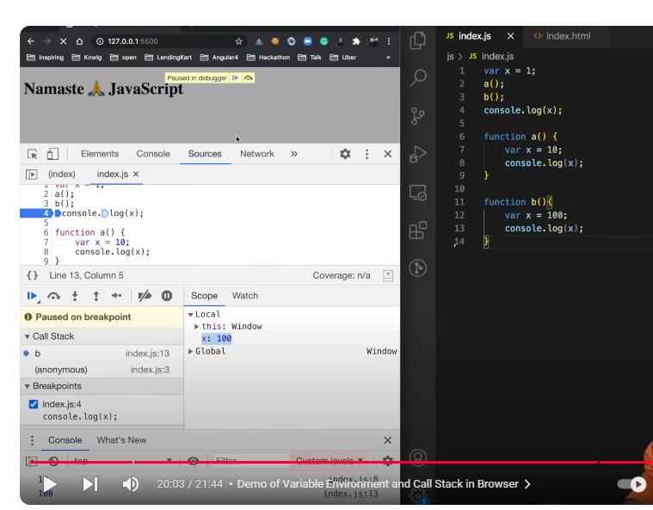

100 console pe print hogaya

Again control back to **line 4  
stack se pop hojayega b()**

**Pointer back to GEC**

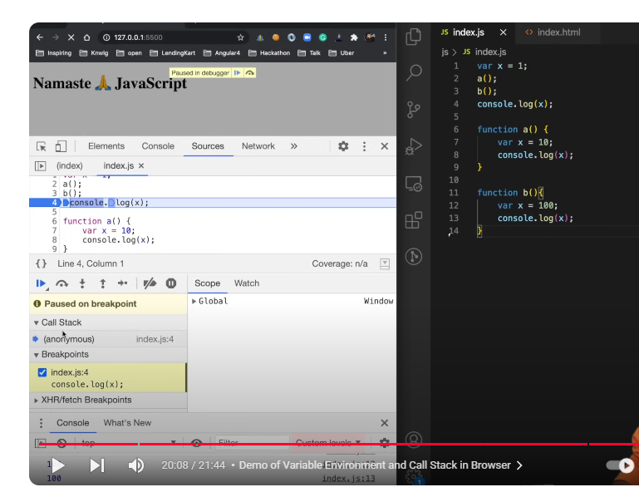

Ab jb line 4 bhi execute hojayei tou stack empty hojayega GEC bhi pop hijayega stack se

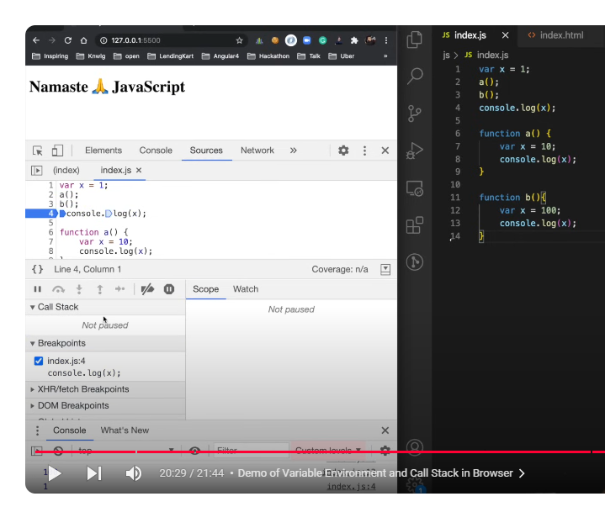

Conole 1 has been printed ; everything executed 🡪 stack empty

## Conclusion

That is how every execution context maintain its own separate space, so even if execution context is created by its function or it is global execution context or any other execution context they will have their own memory space, they will have their own virtual kind of environment where they are running separately , independent of each other

# Shortest JS Program

Empty js file

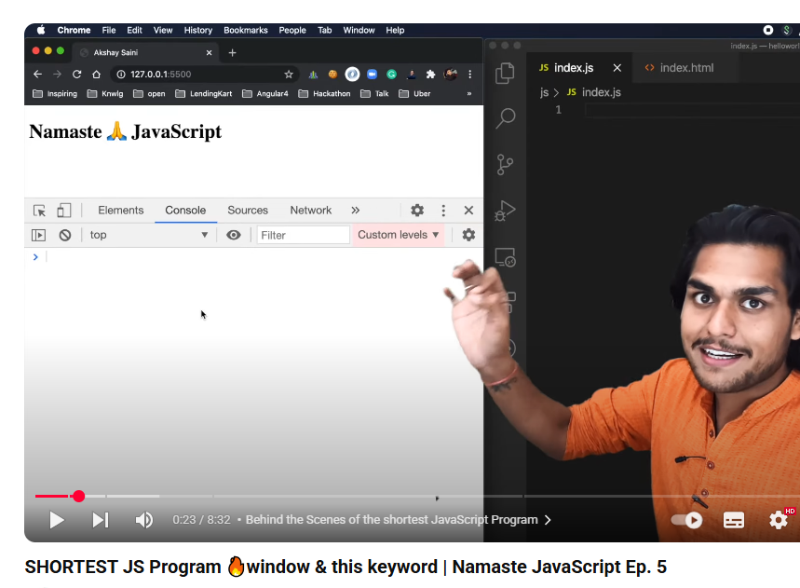

JS is till creating Global execution context and also sets up memory space, there is nothing to setup but it still doing its job

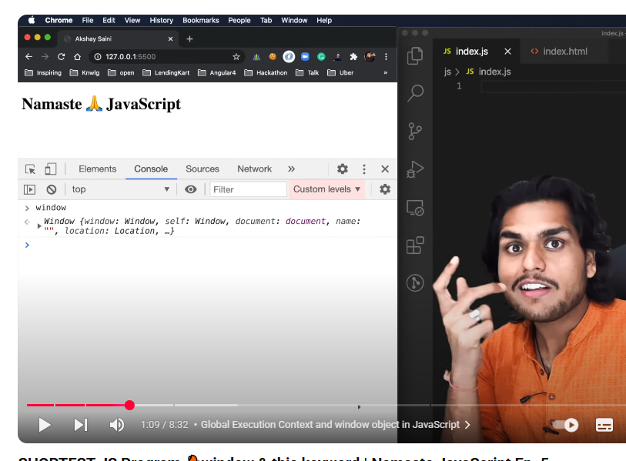

Js also creates something called **window**

It’s a big object with lots of variable and func.

These variables and functions are created by javascript engine 🡪 add into the global space 🡪 you can access all these variables and functions in your program

Javascript engine also created **this**

At global level **this** points to window object

What is window?

Window is actually a global object which is created along with the global execution context so whenever any JavaScript program runs 🡪 a global object is created, a global execution context is created and along with that **this** keyword is created

In case of browsers it is known as window’

JavaScript does not run only on browsers

JavaScript also runs on servers, JavaScript also runs on lots of other devices , where ever JS is running, there must be JavaScript engine just like **in chrome it is v8 , Mozilla , safari etc has their own engine**

**All javascript engines have responsibility to create this global object**

In case of browsers it is known as window’

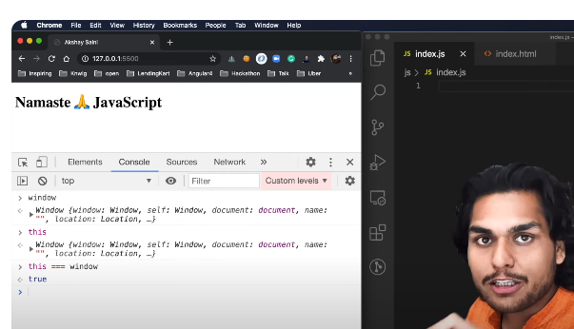

Whenever you create an execution context a this is created along with it even for the functional execution context and even for global execution context

And at global level it points to global object that is window in case of browser

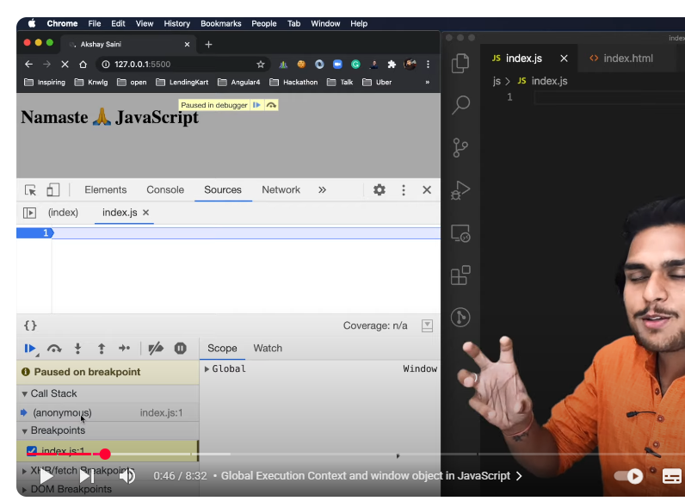

## What is global space?

Any code you write in JavaScript which is not inside a function

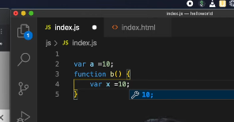

Var a is in global space

Func b is I global space

But var x is not in global space

So whenever you create any var or func in global space 🡪 these var and func get attach to that global object 🡪 it was window

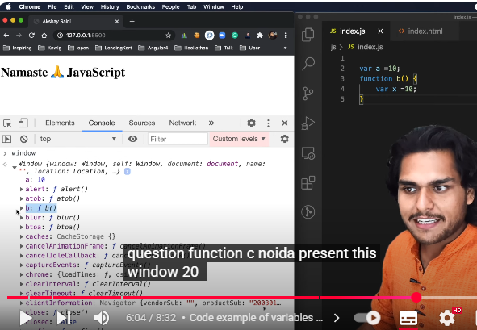’

a is in window , func b is in window , x will not be in window

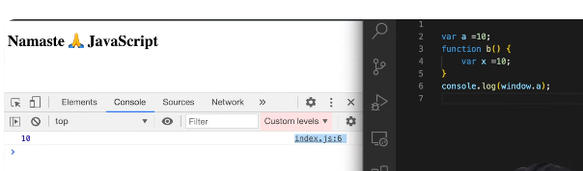

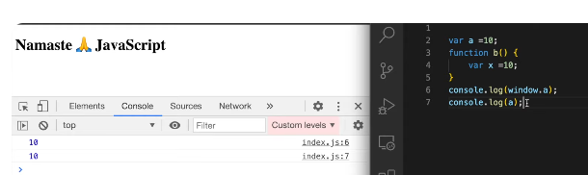

If you don’t put windows. It will automatically refer to global space

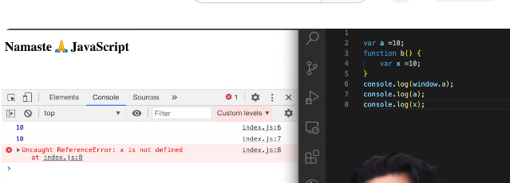

Coz when you don’t put anything in front of x it tries to find it in global space or global object and you will not find it there so it logs not defined

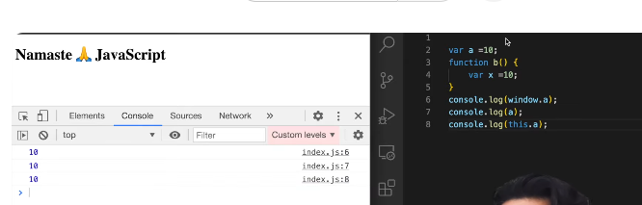

# Scope & Lexical Environment

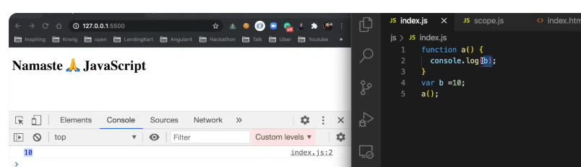

Sabse pehle jab code run hoga tou GEC create hoga and phase 1 me memory allocate hogi tou

|  |  |
| --- | --- |
| mem | code |
| b = undefined | b = 10 |
| a () {} |  |
|  |  |
| mem | code |
| b = 10 | a() |
| a () {} |  |
|  |  |

Console.log (b) = 10 o/p

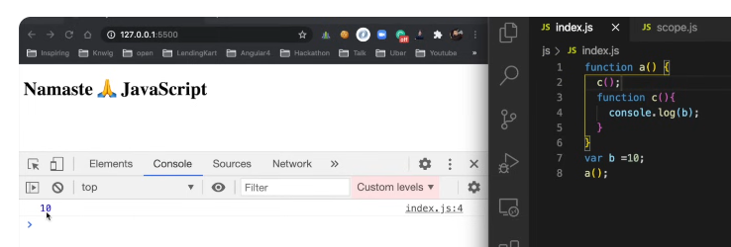

Again iski story wohi h

* pehle GEC banega
  + phase 1: mem alloc 🡪 b= undefined ; a(){} code copied
  + phase 2: code 🡪 b= 10
    - a() 🡪 another execution context created
      * phase 1: mem alloc 🡪 c(){} code copied
      * phase 2: code 🡪 console.log (b)

o/p: 10

even inside the function which is inside another function which is inside global scope I can access b

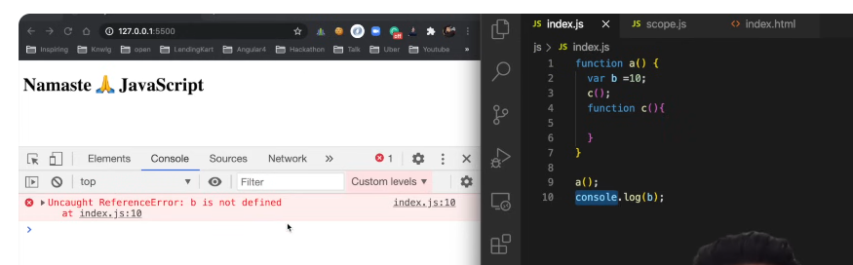

## Scope:

Where you can access a specific function or variable in a code.

Two aspects:

1. What’s the scope of var b means where you can access this variable b
2. Is b inside scope?
   1. (is b inside scope of func c)
   2. Can I access b inside c

Scope is directly dependent on lexical environment

## Lexical environment visual representation

Whenever an execution context is created 🡪 a lexical environment is also created

Lexical environment is local memory along with lexical env of its parent

Lexical mean: in hierarchy or in sequence

**Lexical scope**:   
In JavaScript, lexical scope is the concept of determining the scope of a variable based on its declaration. This means that the scope of a variable is determined by the block of code in which it is declared, not by the block of code in which it is used.  
Lexical scope in JavaScript determines the accessibility of variables based on their physical location within the code. When a variable is declared inside a function, its scope is limited to that function and any nested functions within it. This means that inner functions have access to variables declared in their outer (parent) functions, but not vice versa.

JavaScript uses lexical scoping to resolve the variable names when a function is created inside another function. It determines the function's parent scope by looking at where the function was created instead of where it was invoked.  
<https://cleverzone.medium.com/lexical-scope-in-javascript-929789101dab>

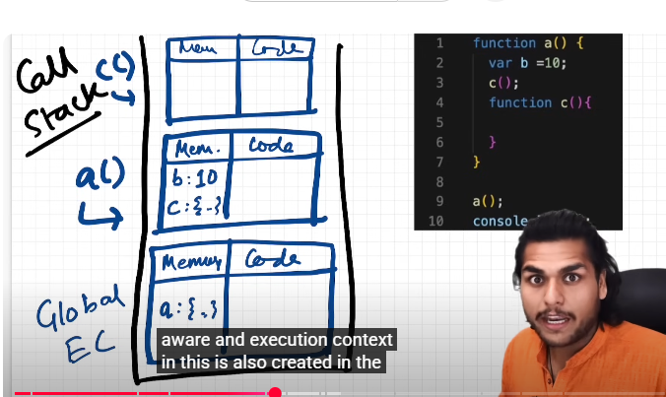

c function is lexically sitting in a function

Where that specific code is present physically inside the code ; c() function is present physically inside a()

c() is lexically inside a() and a() is lexically inside global scope

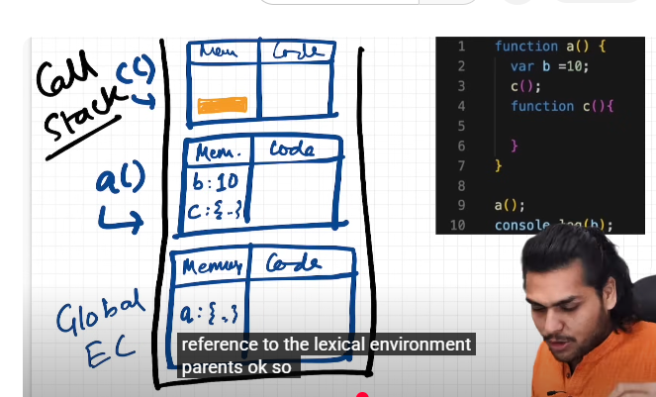

This orange thing is reference

So whenever execution context is created 🡪 you also get reference to the lexical environment of its parent 🡪 so along with memory space (along with variable and functions I this memory space you also get this orange thing 🡪 a reference to lexical environment of parent)

Lexical parent of c() is a()

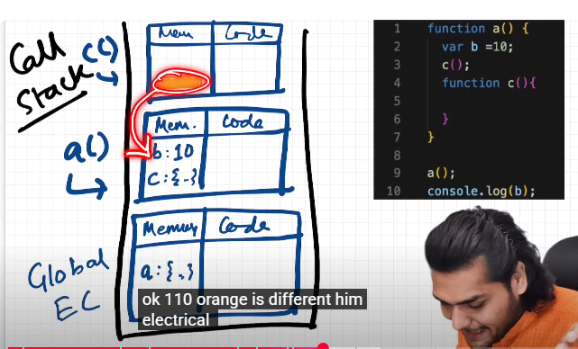

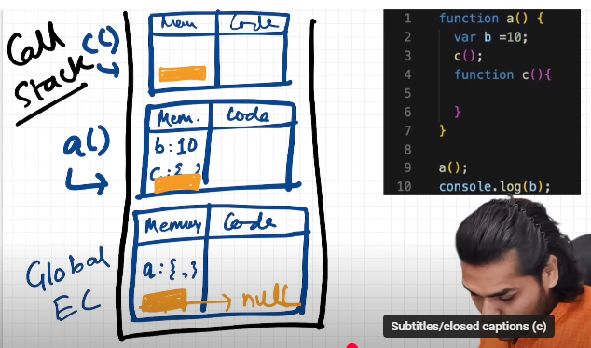

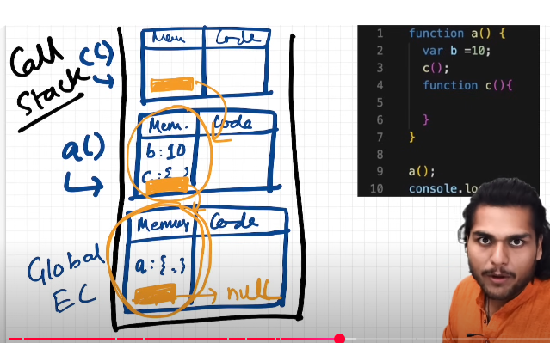

**How this works?**

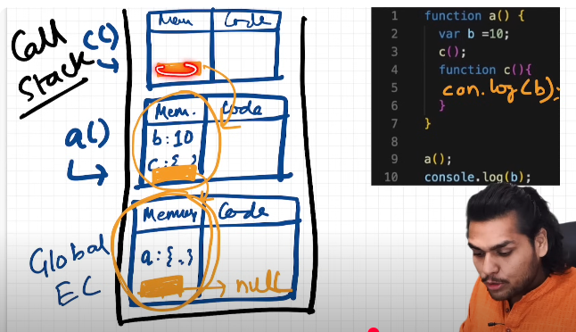

**Console log (b) 🡪** console log of b inside c

When js engine encounters this line 🡪 it tries to find out b inside local memory of c() whether b is there or not? 🡪 it won’t find 🡪 then it goes to reference (the lexical env of its parent) where it is lexically or physically present (c() is physically present n a()) 🡪 it will try to search value of b in lexical environment of a() 🡪 it found out b over here so it goes back and print b that is why you see value of b = 10 printed on console

If if had not found b in lexical env of a() then it would have again gone to lexical environment of a()’s parent i.e global execution context lexical environment

Suppose we never declared b inside our code then:

Now it would go to lexical env of global context b/c it as not in local memory of global context also

So it will endup find null

Now there are no more lexical env to search for!!!!!!!!

Program stopped and JS engine says b is not defined

This way of finding is known as

## Scope chain

So if js engine does not find something in local memory it goes to next level of scope chain again if js engine does not find something in local memory it goes to next level of scope chain this whole chain of lexical environment is known as scope chain

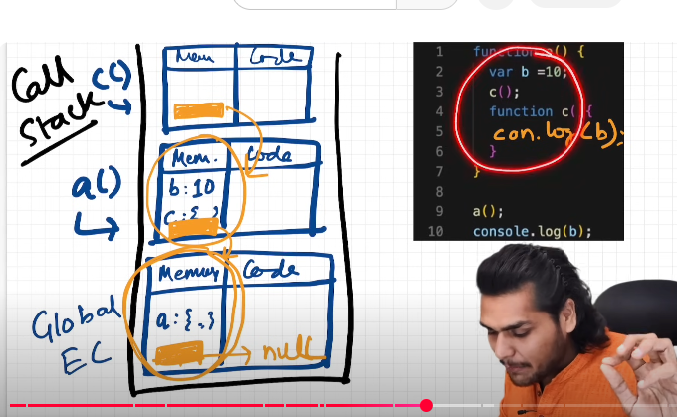

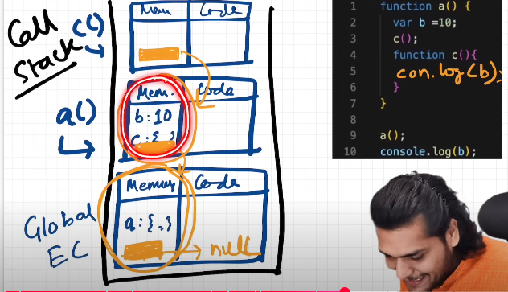

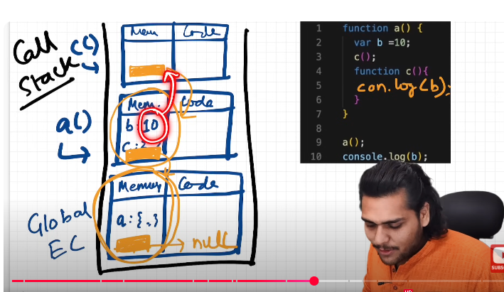

If it didn’t find b in a() then:  
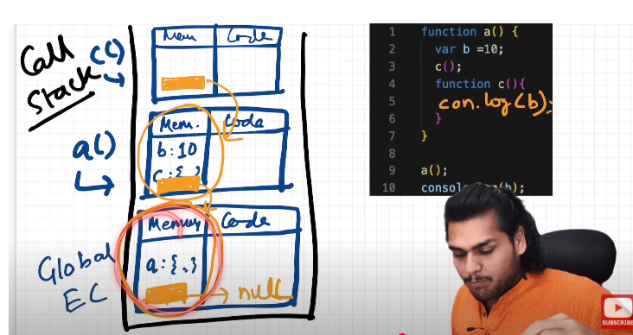

If we never declare a variable:  
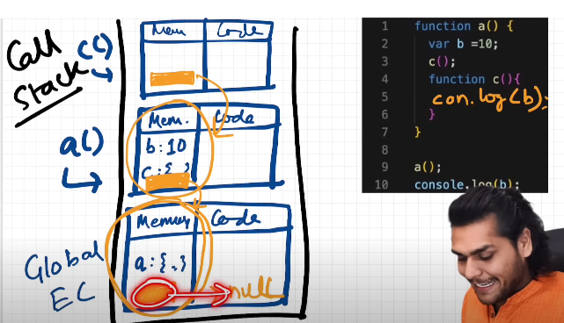

Let us see in browser:

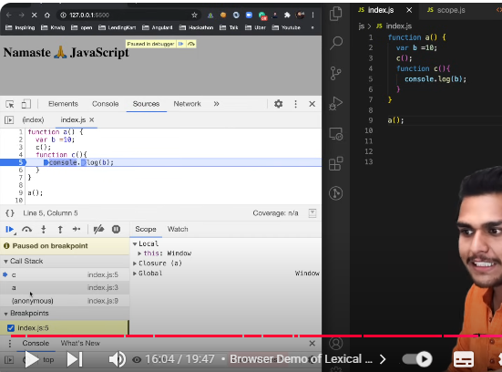

This is local mem of global context

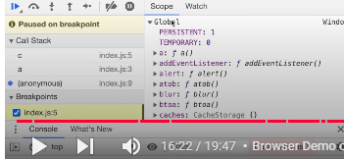

What is the lexical env of a()?

Local mem of a + lexical env of its parent (parent of a is global context here)

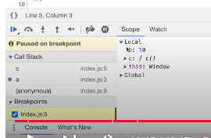

Lexical env of c():

Local memory of c + lexical env of its parent a() 🡪local mem + lexical env of a is global context so c() has accesss to all var and func

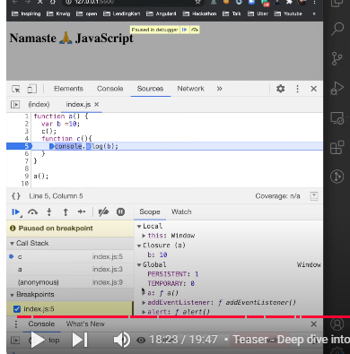

# Temporal Deadzone

The Temporal Dead Zone (TDZ) in JavaScript refers to the period between the declaration of a variable with let or const and the point in the code where it is initialized. During this zone, the variable exists in memory but cannot be accessed. Attempting to access a variable within its TDZ results in a ReferenceError

# Let and const declarations hoisted in JS

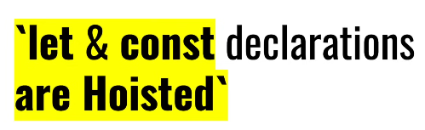

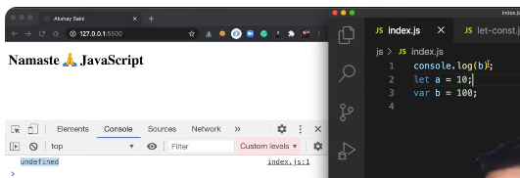

As discussed prev

GEC created

Phase 1: mem alloc 🡪 a, b undefined

Now people argue if let is hoisted then we should also get same result in case of let but if I run this code

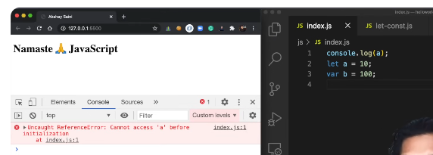

Can’t access a before initialization, this error tells us you can only access a after you assigned/ initialized some value to a

Whether this variable hoisted or not?

Was this variable allocated mem or not

Let see in browser

I put debugger on first line that is even before execution

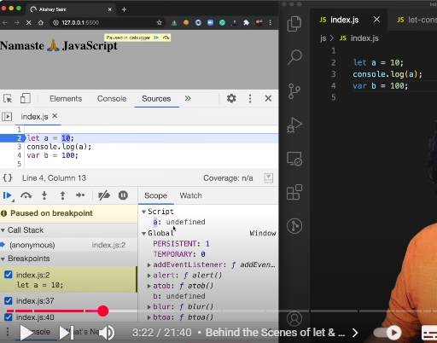

JS has allocated mem to a and b and value for these are undefined

**a** is in **global space** in case of **var**

in case of **let** : **b** is in **script** not in global space

in case of let ; variables are also allocated memory but not attached to global object but assigned a separate space and you can’t access this memory space, you cannot access this const and let declarations before you put in some value in them

When I press run :

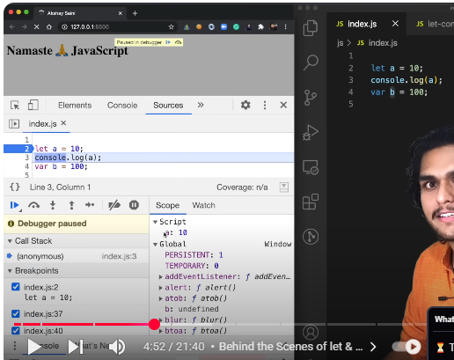

Value 10 is assigned to variable and it still in separate memory space and now it can be accessed and it got printed

Temporal deadzone : is the time since then this let variable was hoisted until its initialized some value , time b/w them is temporal deadzone  
The Temporal Dead Zone (TDZ) refers to the period during which a variable is declared but cannot be accessed.

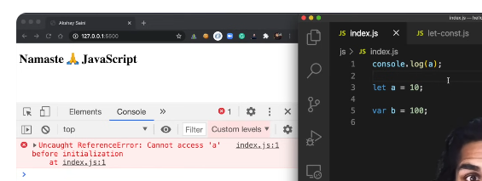

a is in temporal deadzone

window object:

window is global object ; var declerations were attached to this object

so var b is attached to it

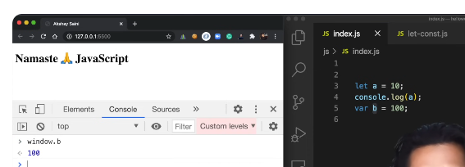

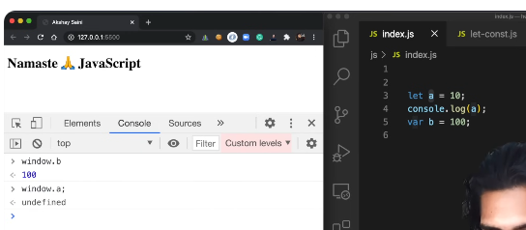

b/c let and const declarations have separate space

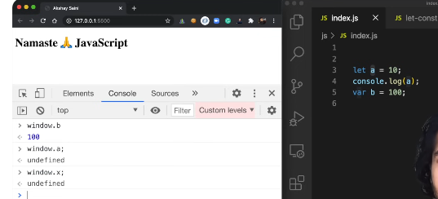

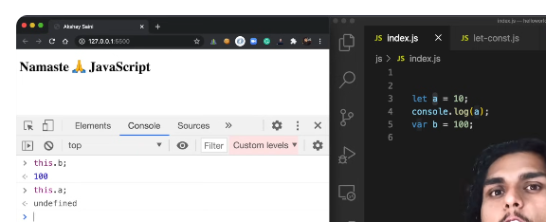

## let

Let is more strict than var

Redecleration is not possible

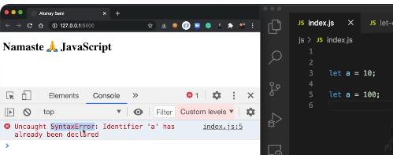

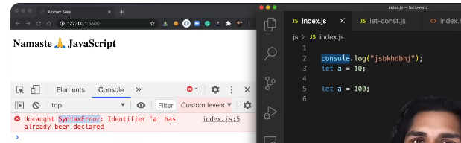

Javascript will reject it t upfront. It does not reach even a single line of code if it sees a redecleration or duplicate decleration 🡪 Syntax error

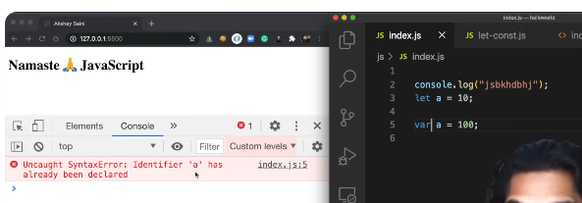

You can not redeclare the same name in same scope.

Its possible in var:

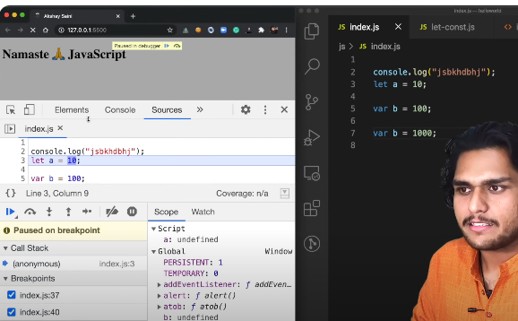

## Const:

More strict than let

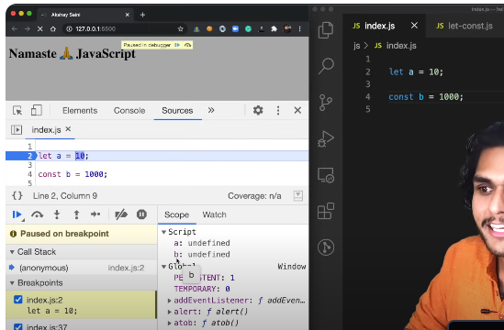

It is also stored in separate memory space

Also goes through temporal deadzone

You cannot access it globally

Re-assignment is not possible which is possible in let

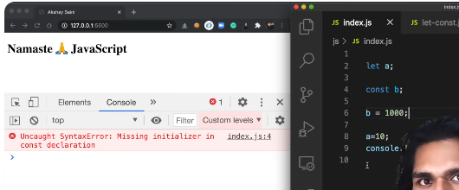

You will get a syntax error

Syntax error means: code cannot even run , it is rejected directly

You have to initialize value in same line in case of const, you can’t do it later!

## Syntax error, Reference Error and Type Error

**Type error**

**b** is type of const.(typeOf (b) = const), it should be initialized and declared together and you cannot assign value later on

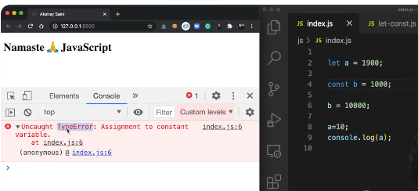

Syntax error:

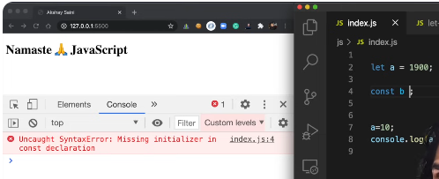

If there is const keyword , it expects there must be some equation like const then “name” then “=” then “value”

We also get syntax error in case of redecleration ;

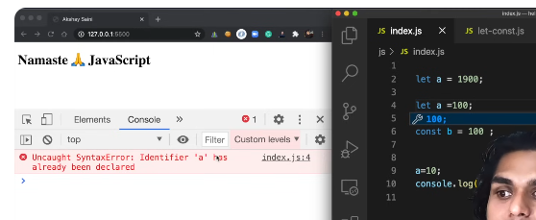

Reference error:

When javascript engine tries to find out a specific variable inside memory space and you cannot access it

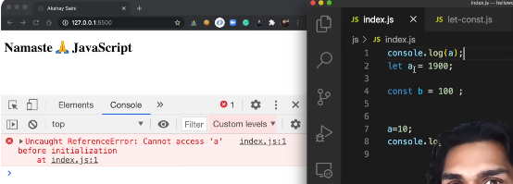

Because a is in temporary deadzone and it can’t find it

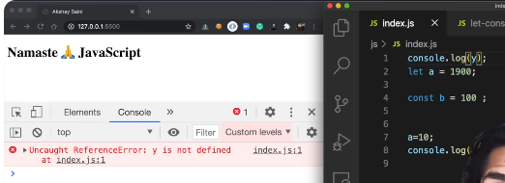

We are trying to access a var which was never defined in code and hence not in any memory

## What should be used?

Use const wherever possible.(more strict, can avoid unexpected errors)

And if not cost then let is preferable

Keep var aside not preferable now

Try to define variables at the top to avoid temporal deadzone so that firstly js engine hits initialization part then go into logic otherwise you can run into a lot of unexpected errors in js code

# Blocked Scope and Shadowing

## block

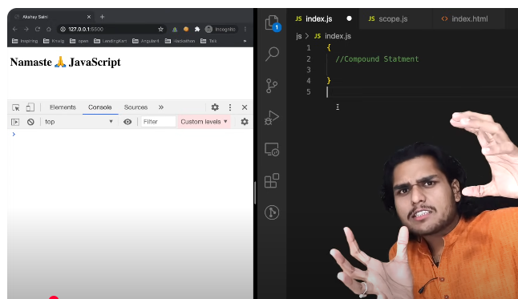

**Block is also called compound statement**

Block is used to combine multiple javascript statements into one group

Why do we need to combine these statements together?

We need to group these statements together so that we can use multiple statements in a place where JavaScript expects only one statement

E.g:

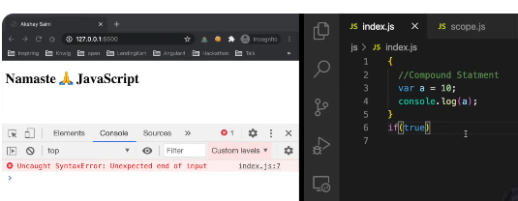

This if(true) expects one statement here

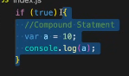

So this is a block which is holding multiple statements so that we can use it in a place where js expects 1 statement

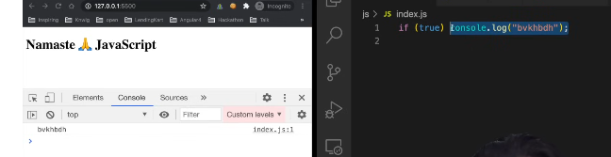

This is perfectly valid statement but we use this if(){} and similarly we use block with for loops while loops etc etc So this is lock and its use.

## Block scope

What All var and func we can access inside this block

{

}

This is known as block scope

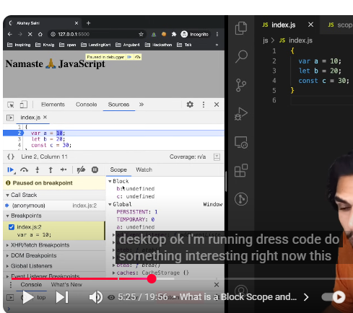

b and c are in block scope and are hoisted in separate memory space that is reserved for this block

a is undefined in global scope

once javascript finished executing this block and come to line 5 , you can’t access let and const variables after that , let and const are not accessible outside this block

var can be accessed outside this block b/c its global

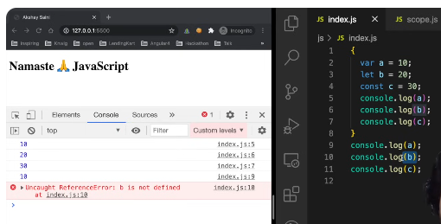

A,b,c ,a printed then it throws error

b/c b was not in global scope

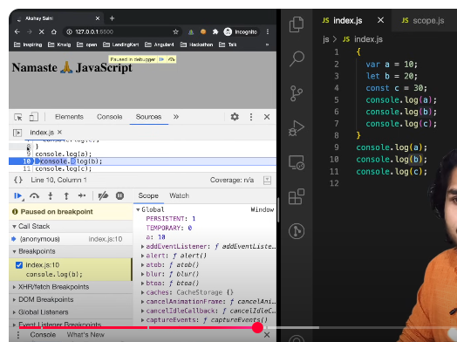

When we have finished executing , block is not there , block scope is gone from this scope now only a: 10 is accessible her

## Shadowing

If we have same variable name outside block scope , so block variable will shadow global variable

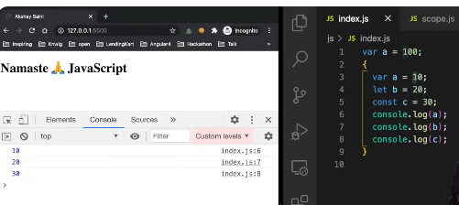

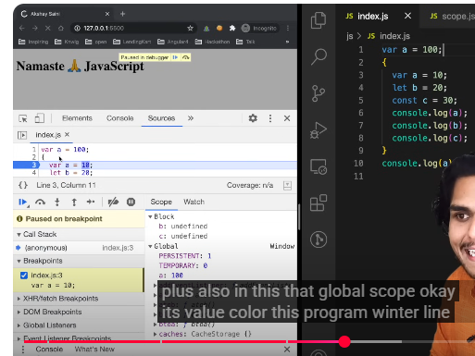

We will get o/p a: 10 b/c a was in global scope even written inside block was declared with var so its pointing to same memory location that’s why block wale a ne shadow krdia outside wale a ko b/c both were global scoped

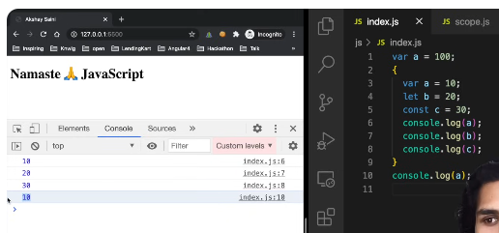

In case of let:

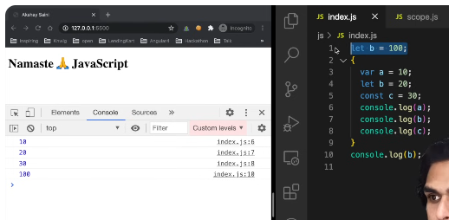

Outside jo b ha uska scope alg ha aur jo block k ander b ha uska scope alg h

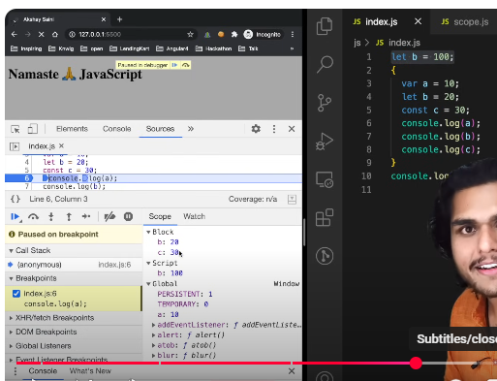

Now we have 2 b’s

One is in block

Other is not in global but in Script

Here we have 3 types of scopes:

One is global 🡪 var declerations ; a is attached here

Script space : where let and const are hoisted ; b is there

Block: we have separate place in memory for this bloc scope b and c are there

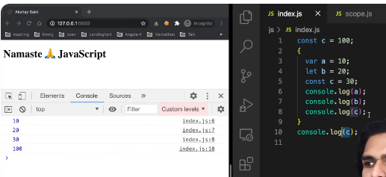

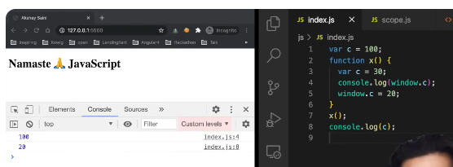

## Illegal shadowing

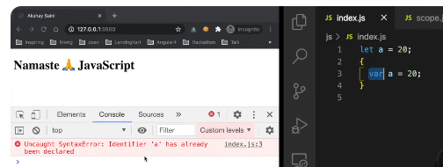

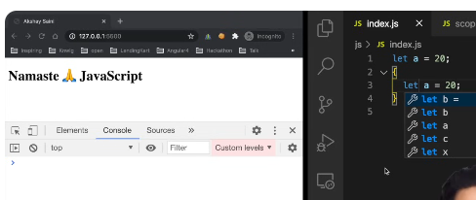

You can shadow a let using let but you can’t shadow let using var this is illegal shadowing but we can do vise versa that is we can shadow var using let

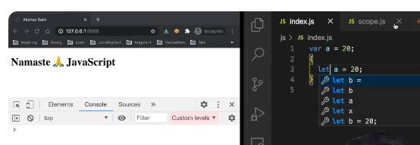

This is also ok

If a variable is shadowing something, it should not cross boundary of its scope. In a particular scope let cannot be redeclared so var should not cross its boundaries.

What is boundary of var?

Var is function scoped. If I put a function here , now it won’t show any error b/c var is in its boundary it is not interfering a now.

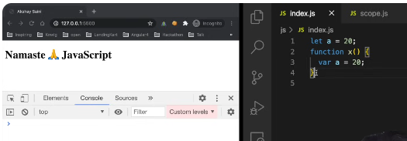

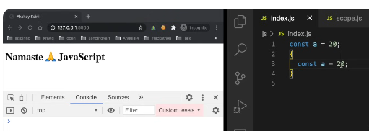

Block scope also follows lexical scope

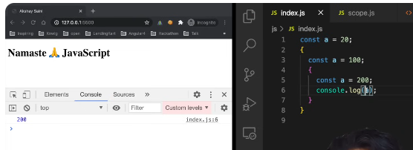

Lexical scope: nearest a will be printed

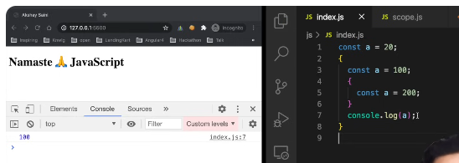

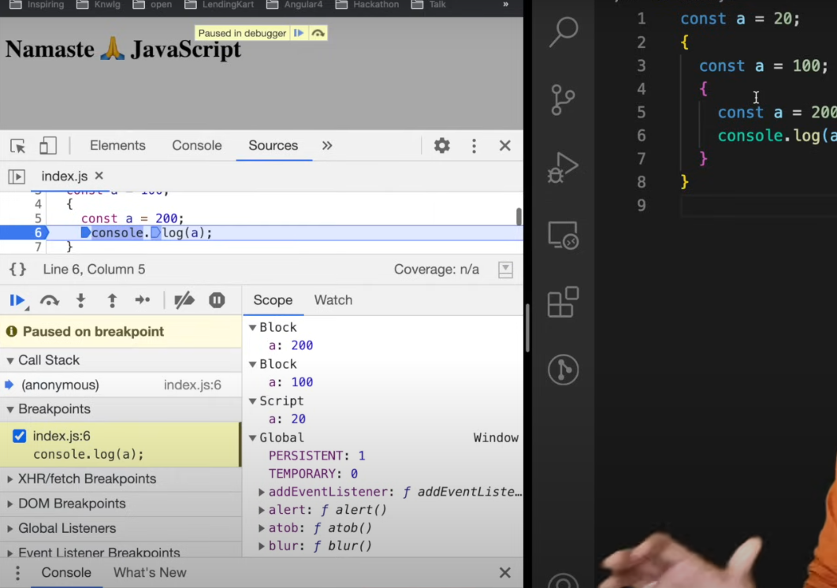

Lexical scope chain pattern

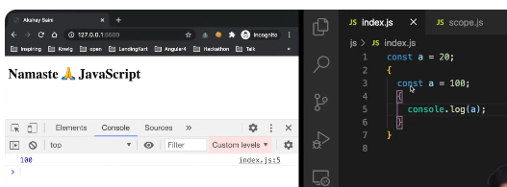

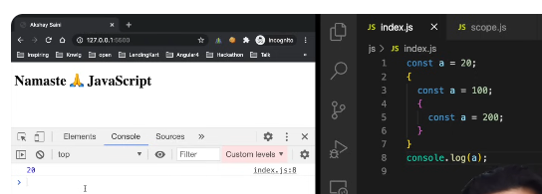

**Whether you use arrow functions or functions with function keyword they have same scope**

# Closures

A function bind together with its lexical environment

Inside y() , it forma a closure with the variable which was part of its lexical scope, the function y was bind to the variables of x.

It forms a closure , it has access to its parent lexical scope

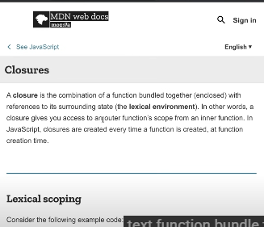

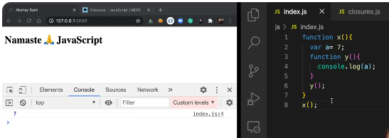

When y tries to run, it tries to find a in its local memory space when it does not found it, it goes to lexical parent and its get value of a there.

More examples:

You can assign function to a variable

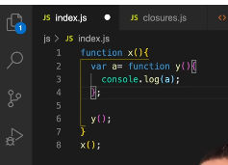

You can grab a function and pass it to another function as parameter.

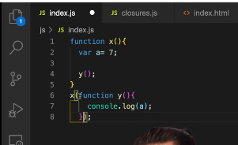

You can return a function from a function like this:

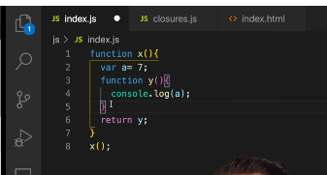

Y is the whole function which you are returning

As you invoke x 🡪 it returns y ; it returns y to the place where x is invoked

Lets grab it into variable and see what the value of this function return

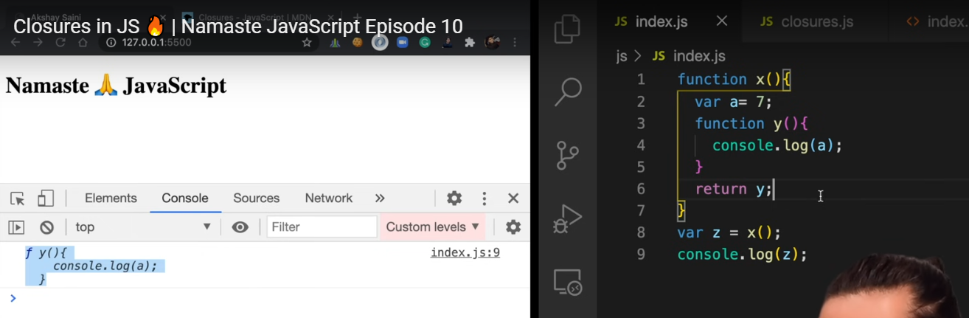

After execution function y is returned in z and x() will be vanished; js is synchronous so after running line 8 x() is gone. X() no loner in call stack ; its execution context is popped out.

If you call z() later on in program what will happen ? x() tou vanish hogaya so lets see

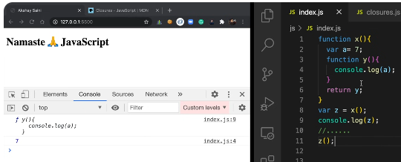

Functions are so beautiful that when they are returned from another function, they still maintain their lexical scope, they remember where they were actually present

So, though x() no longer exists , nothing is there but still this y() function remembers its lexical scope where it came from; it remembered there was something **a.  
when you returned y 🡪 so not only function was return but a closure was returned (the closure enclosed function along with its lexical scope) and it was put inside z.**

**so** when you execute z somewhere else in program ; it stills remember a or reference to a(lexical scope concept) and it tries to find value of a first in local mem then its lexical scope!

### Whenever interviewer asked what closure is?

Function along with its lexical scope bundled together forms a closure

And you ca provide this example

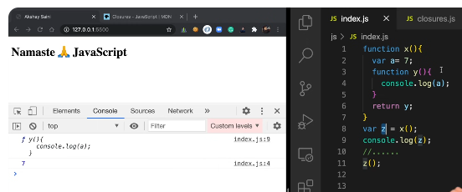

Similar thing different syntax:

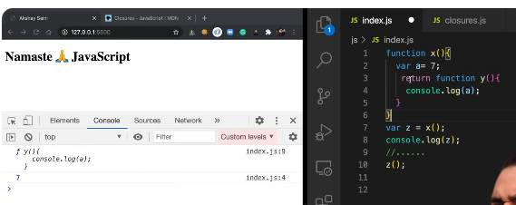

Another thing:

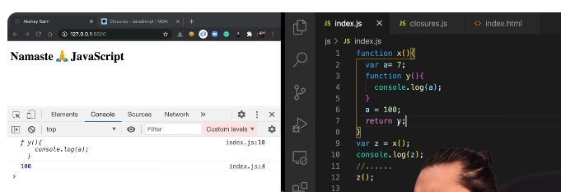

When you return y 🡪 y was the function [function y(){console.log(a)}] 🡪 it comes along with its lexical scope 🡪 so a does not refer to the value , this is a’s reference (the function along with reference to those variables not just the value) value 7 does not persist , the reference to a persist , the function remembers the reference to a’s memory location

When z() is running 🡪it will try to find out reference a 🡪 when it is executed , now that reference points to 100.

That means 100 is still in memory preserved b/c of closure and when x was gone, it was not garbage collected, b/c it has to be used later

So that way closure give us 100 not 7.

Another example:

One more nested function: we are trying to access two variables one from parent and there from parent’s parent:

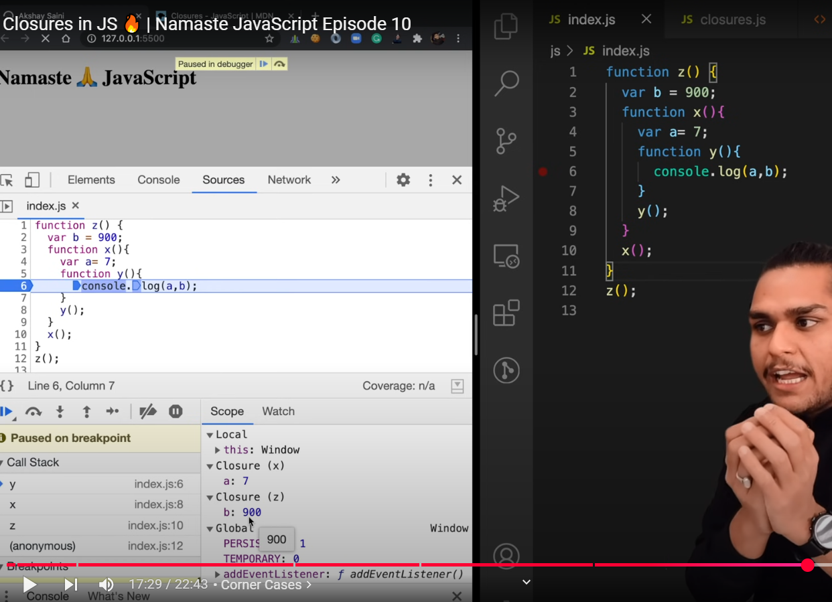

If I returned y outside somewhere , so it would have returned these values a, b , these memory locations a, b would not be garbage collected , these would have retained . this closure is very powerful concept of language just because function remembers things , even when they are not in that lexical scope , this makes language very powerful

### Few common uses of closure

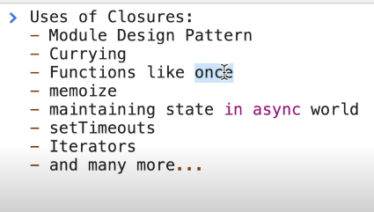

A "once" function in JavaScript ensures that a given function is executed only once, regardless of how many times it is called. This pattern is useful in scenarios where an action should not be repeated, such as initializing a library or setting up an event listener.

A real-life example is a function that awards a "welcome bonus" to a user upon their first login. The function should execute only once for each user.

Closure ek **JavaScript** ka concept hai jahan **inner function** outer function ke variables ko access kar sakta hai **even after outer function finish ho jaye**. Iska use kai useful cheezon mein hota hai. Niche har point ko simple words aur examples ke saath explain kiya gaya hai:

### 🔐 **1. Data Hiding and Encapsulation**

**Simple Words**: Closure se hum kisi data ko "private" rakh sakte hain. Sirf ek function ke through hi access hota hai, direct access nahi milta.

**Example**:

javascript

CopyEdit

function secretCounter() {

let count = 0; // private variable

return {

increment: function() {

count++;

return count;

},

decrement: function() {

count--;

return count;

}

};

}

const counter = secretCounter();

console.log(counter.increment()); // 1

console.log(counter.increment()); // 2

console.log(counter.decrement()); // 1

// count variable directly access nahi ho sakta

### 📦 **2. Module Design Pattern**

**Simple Words**: Is pattern me functions aur variables ko group karke ek module banate hain, jisme kuch cheezein private hoti hain aur kuch public.

**Example**:

javascript

CopyEdit

const myModule = (function() {

let privateVar = "I'm private";

return {

publicMethod: function() {

return "Accessing: " + privateVar;

}

};

})();

console.log(myModule.publicMethod()); // Accessing: I'm private

// console.log(myModule.privateVar); // ❌ Not accessible

### 🍛 **3. Currying**

**Simple Words**: Currying ka matlab hai ek function ko aise likhna ki wo arguments ko ek-ek karke accept kare.

**Example**:

javascript

CopyEdit

function multiply(a) {

return function(b) {

return a * b;

};

}

const double = multiply(2);

console.log(double(5)); // 10

console.log(multiply(3)(4)); // 12

**Closures ki wajah se b waala inner function a ko yaad rakhta hai.**

### 🧠 **4. Memoization (Speed Boost using Caching)**

**Simple Words**: Ek function agar same input pe dobara call ho to result ko memory se (cache) la sakta hai instead of recalculate — closure is used to remember previous values.

**Example**:

javascript

CopyEdit

function memoizedAdd() {

let cache = {};

return function(n) {

if (cache[n]) {

console.log("From cache");

return cache[n];

} else {

console.log("Calculating...");

let result = n + 10;

cache[n] = result;

return result;

}

};

}

const add = memoizedAdd();

console.log(add(5)); // Calculating... 15

console.log(add(5)); // From cache 15

### ⏳ **5. setTimeout / setInterval**

**Simple Words**: Jab hum setTimeout use karte hain to callback function closure banata hai jo original variables ko yaad rakhta hai.

**Example**:

javascript

CopyEdit

function greetLater(name) {

setTimeout(function() {

console.log("Hello " + name); // `name` is remembered

}, 2000);

}

greetLater("Ali"); // After 2 seconds: Hello Ali

### ✅ Summary in 1 Line Each:

| **Feature** | **What Closure Helps With** |
| --- | --- |
| Data Hiding | Private variables banane ke liye |
| Module Design Pattern | Code ko modular aur reusable banane ke liye |
| Currying | Ek function ka reusability barhane ke liye |
| Memoize | Speed boost by remembering past results |
| setTimeout | Delay ke baad bhi correct variable yaad rakhta hai |

call, apply and bind methods in JS:  
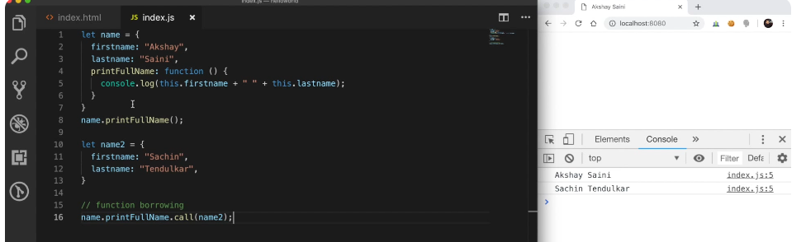  
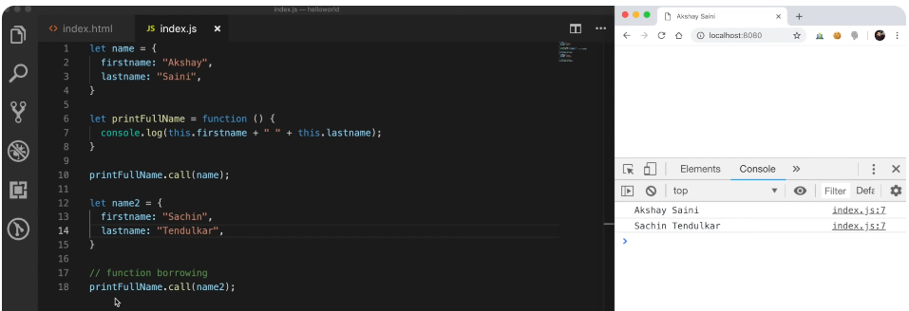

**Once**: a function which can only run once, if you try to run it twice it won’t.

Function can be called anytime anywhere, yehi purpose h function ka but this is possible just because of closure that function remembers something so you can store how many times a function has been rn by forming closure.

# Set Timeout and closures

It will wait for 3 sec and then print 1

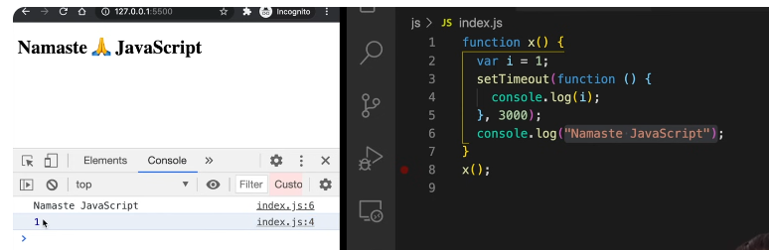

Pehle string print hua then 1 after 3 sec means ,it didn’t wait for set timeout?

Set Timeout forms a closure 🡪 means it remembers the reference to **I , so wherever this function goes it remembers the reference of I along with it**

**What does set timeout do?**

It takes this call back function

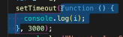

And stores it to some place and attaches a timer to it.

It takes this call back func and attaches a timer of 3000 ms to it and stores it somewhere and js proceeds , it does not wait , it goes to next line and print string.

Once timer expires , It takes that func put it again on call stack and runs it.

If you are given task to print 1 to 5 numbers , somehow that after every second 1 num should be printed like 1 after one sec 2 after two sec and 3 after three sec …

So most programmers will do:

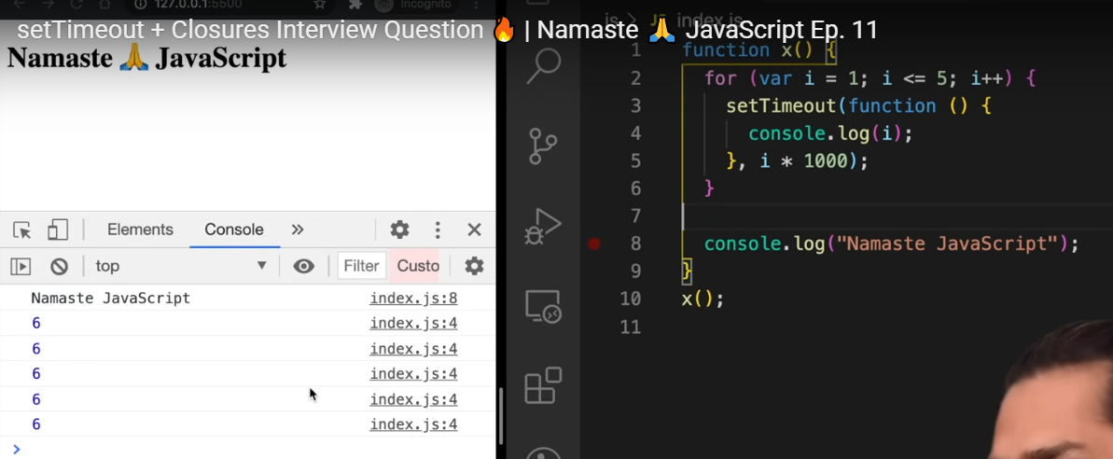

It is printing like this b/c of closure

A closure is func along with its lexical env, so even when function is taken out from its original scope

Still it remembers its lexical scope, it can access to its variables of its lexical env

So what will happen when setTimeout takes this func and stores it somewhere and attaches a timer so that function remembers the reference to I not the value of i

So when loop runs firt time,it makes a copy of this func , attaches a timer , and also remembers reference to I and similarly these 5 copies of func , all of them are pointing to same reference of I b/c environment for all these function is same. It refers to same memory space.

2.Js does not wait for anything, it will run the loop again and again, it will quickly push/store that func , settime will store all 5 func and javascript will move on and does not wait for timer to expire so it will print string and when timer expires it is too late and value of I b/c loop was running , it was 1,2,3,4,5,6 I value became 6 and when this call back func runs, by that time value of I is 6 in memory location, all of these call back func, all five unc are referring to same spot in mem

How can we fix this?

Use let

What let will do?

Let has block scope, that means for each and every loop iteration, this **i** is new variable all together, a new copy of I altogether and each time setTimeout runs this call back func has new copy of I with it, its own identity of I with it

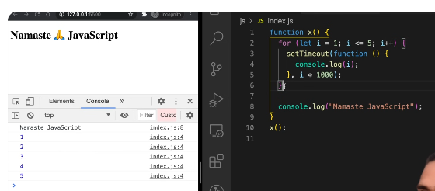

Every time setTimeOut method is called , this func forms a closure with a new variable itself, that means copy of I in each iteration is new

so that means if we do a i plus plus

here so i is equals to 2 is a new copy

of variable which forms a closure with

this function okay set timeout what it

will do set timeout will take this

function now this function has a new

copy of

i bound to it which has value 2 and send

it okay and saves it

and similarly when the i goes to three

it it forms a closure with i is equals

to three which is a fresh variable in

itself okay fresh new copy of i

and it like saves it and similarly it

like keeps on doing it keeps on doing it

and it makes five copies of this

variable i

and they form closure with each and

every function

so in simple term you can assume that

each and every time this function is

called it is it is referring to

different memory location which is their

individual i

uh separate copy of i which were in the

scope okay so why was it not working

with var and why it is working with lead

the only difference is that let is block

scope and it creates a new copy every

time this loop is executed but you know

**if you want to achieve similar thing with var?**

what we will do is we

will create a function okay let's call

it close let's call it close okay we

will enclose this set timeout inside

this function okay let us take this

so what we have to do is we want to kind

of have a new copy of i each and every

time this loop is executed like that is

what was working with let right

so what we will do is we wrap this

wrap this sept time out inside this

close function pay attention very

carefully so we wrap this set timeout

inside this closed function

and we somehow have to supply this i

every time with a new copy of i

right how we can do that

we can just call this close function

with an i okay so if i do a i over here

okay and if i pass in i here and

if i run it like this so it works

why it will work because every time

you call this close function with this i

it creates a new copy of i for itself

over here okay

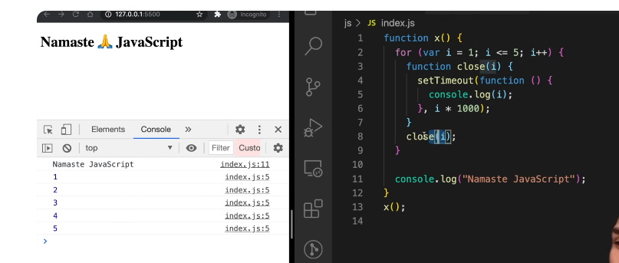

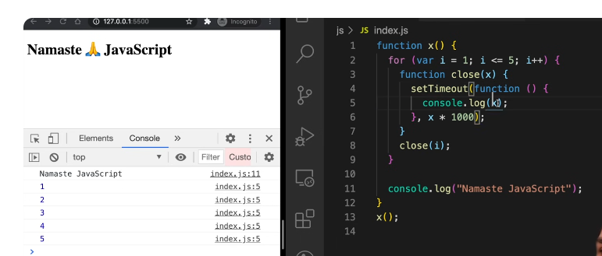

**we just**

**identified that problem that that**

**problem was because it was referring to**

**the same memory space now using closures**

**using this close function we kind of**

**created a new copy of**

**i or a new copy of x every time this set**

**timeout was called okay so every time**

**the set timeout callback function is**

**like stored in a separate memory and**

**like attach the timer right it stores so**

**it remembers a new copy of x every time**

**this close function is called it like**

**has a new copy of i in it okay.**

## CRAZY JS INTERVIEW 🤯ft. Closures

Give me example of closure:

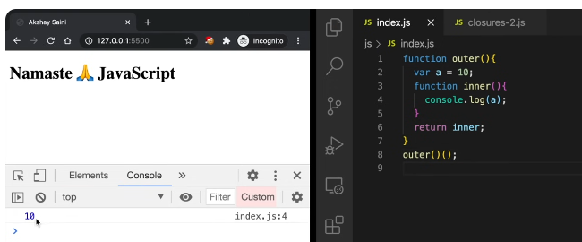

Outer ()();

To cal; the inner function also

We can writhe this also

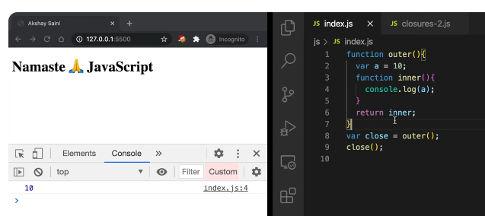

What if I move statement to line 5:

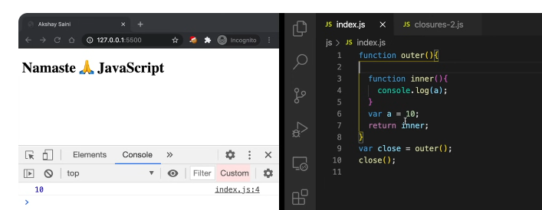

It still forms a closure that it has access to its outer environment ; sequence does not matter

What if I change var a to let a, what difference will it make?

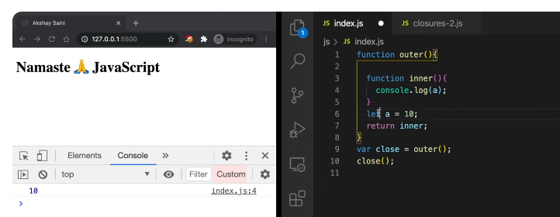

It will work the same way the inner func has access to its lec=xical env so although let is block scope inner func still forms a closure with it.

**What if we have parameter let say b in outer function?**

Ans: b is also part of outer environment for inner func so it will be treated the same way, it forms closure with b also

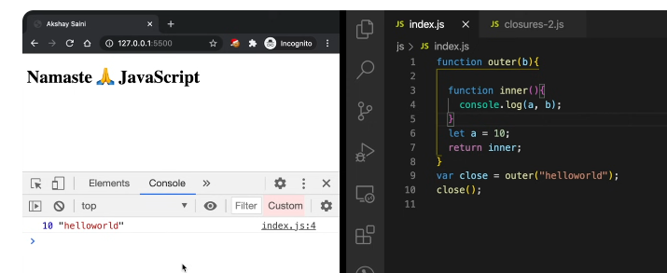

What if your outer func is nested inside a func?

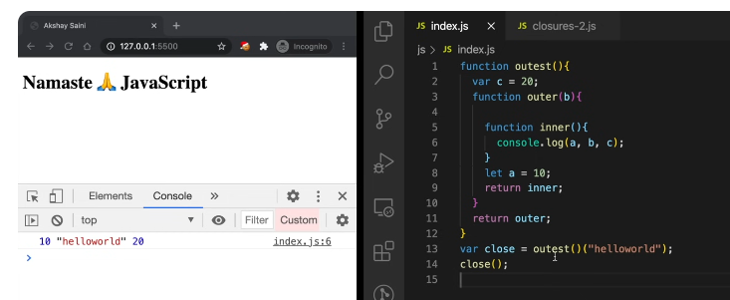

**What does line 13 doing?**

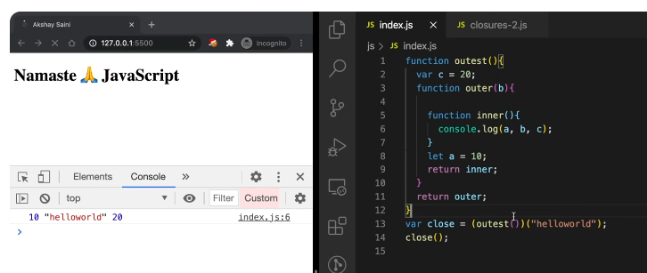

**So what if we have conflicting variable after line 12?**

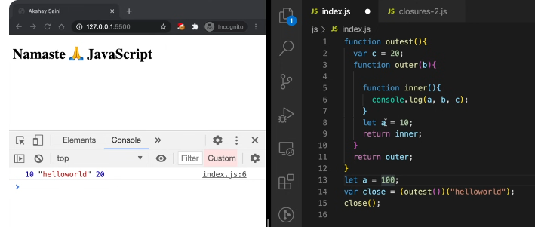

**Ans: it will print the same o/p:**

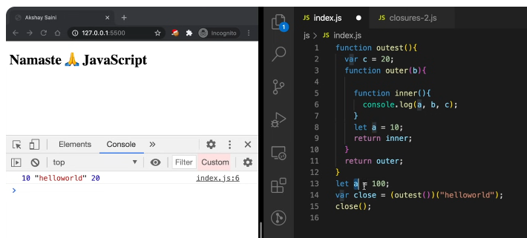

**Reason:** inner func forms a closure with it outer env and ir=t will try to find a first in local memory space then in its lexical env and when found there it prints it.

Let a = 100 ; 🡪 is global there means if line 8 is commented out then it goes more level up hieracy and goes to global env to find a

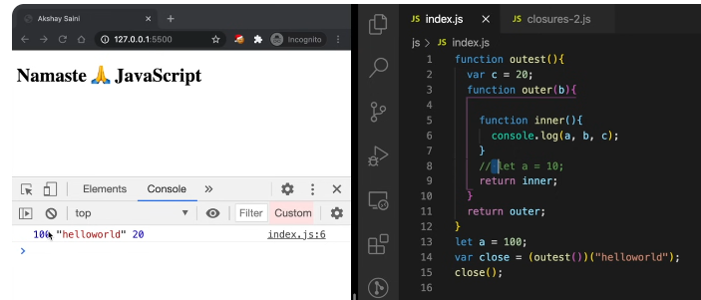

**Aur agr ine 13 bhi comment krden then we will get an error:**

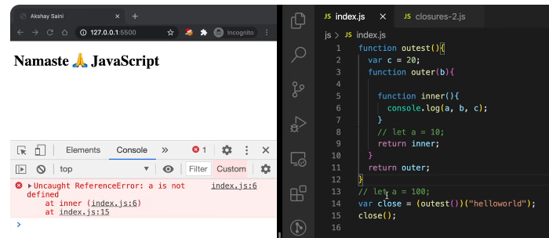

It tries to resolve it in scope chain, and inner func won’t find anywhere In scope chain(like In outer env, its parent env, its grandparent’s env)

### Few advantages of closure

Very useful

It is udes in module pattern

Func currying

In some higher order func like memorize

One more imp use of closure is:

It also used in data hiding and encapsulation

Suppose if we have a variable and we want to have some data privacy over it, other functions and variables and other pieces of code should not have access to it; that is called data hiding or encapsulation

Example:

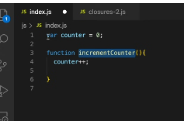

Anybody can change this counter value; what if I want that nobody could change value of counter ; it can only be changes by this func increament counter; here comes closure in this pic:

If I enclose it in a func that is I make closure of it:

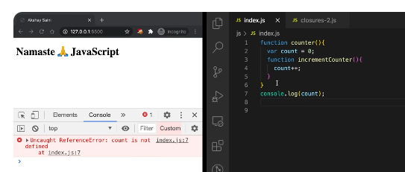

Now it cannot be accessed outside like direct console log nhi krsate.

Now there is data privacy to this count variable

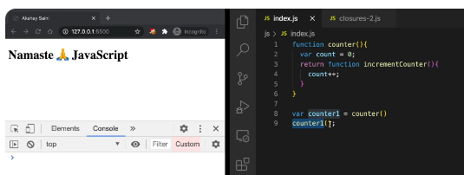

That’s how we can access it

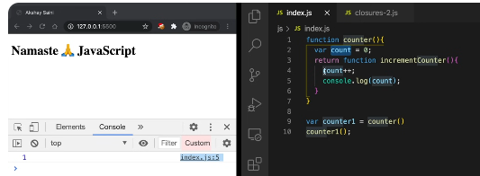

Count is private variable in this counter

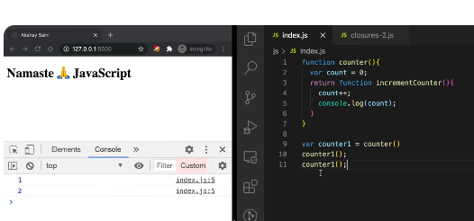

Q: What if we call this in another variable? One more time

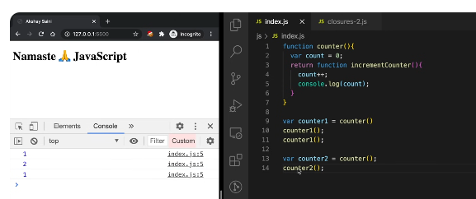

It will make another copy which is independent from prev one

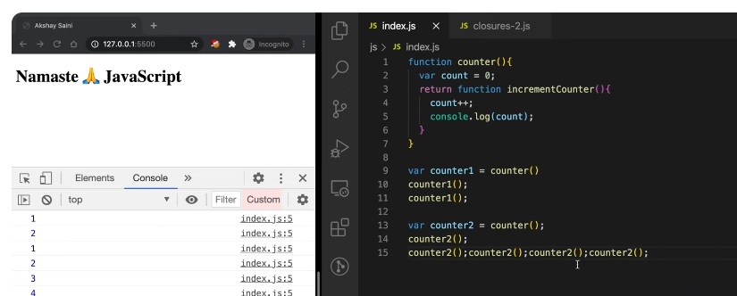

It behaves a s a seperae counter

Q: Is it a good practice in case of counter? What if I want to apply decreament as well?

Its not good practice in terms of scalability, we can use constructor let me show you

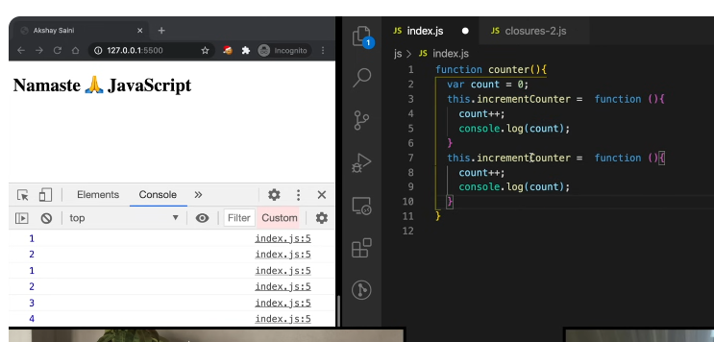

Anonymous functions

This is a constructor function, it constructs a new counter whenever this counter function is called and give us

Data is still hidden, counter is still private

This.increamentCounter still forms a closure with count

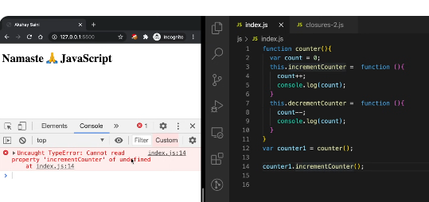

b/c it’s a constructor we have to use new keyword and it should be named with capital letter.

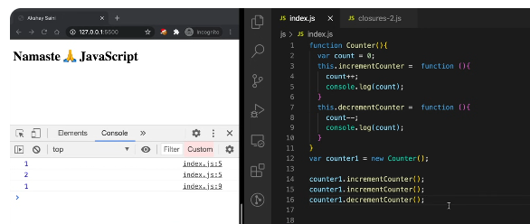

### Disadvantages of closures:

There could be over consumption of memory in case of closures. And those closed variables are not garbage collected till the program expires and if not handles correctly it could lead to memory leaks, b/c memory is accumulated over time , it can also freeze the browser.  
Memory leaks  
A memory leak in JavaScript occurs when memory allocated to the program is not released after it's no longer needed, causing the application to consume more and more memory over time. This can lead to performance degradation, slow response times, and eventual crashes.

Common causes of memory leaks in JavaScript include:

Accidental global variables:

Variables declared without the const, let, or var keywords become properties of the global object, persisting until the browser window is closed.

Closures:

Closures that retain references to variables from their outer scope can prevent those variables from being garbage collected, even after the outer function has completed execution.

Timers and intervals:

setTimeout and setInterval functions can create persistent references to objects if not cleared properly using clearTimeout or clearInterval.

Event listeners:

Event listeners attached to DOM elements or other objects can prevent the referenced objects from being garbage collected if not removed when they are no longer needed.

Detached DOM elements:

DOM elements that are removed from the DOM tree but still referenced in JavaScript code will not be garbage collected.

Caching:

Unbounded caching of data can lead to memory leaks if the cache grows indefinitely without a mechanism for removing unused items.

To prevent memory leaks, developers should:

Use strict mode: Strict mode helps prevent accidental global variables.

Avoid closures when unnecessary: Closures can be powerful, but they should be used judiciously to avoid retaining unnecessary references.

Clear timers and intervals: Always clear timers and intervals when they are no longer needed.

Remove event listeners: Remove event listeners when the associated elements or objects are no longer in use.

Avoid detached DOM elements: Ensure that DOM elements are properly dereferenced when removed from the DOM tree.

Implement cache management: Use a caching strategy that limits the size of the cache and removes unused items.

**Q: What is garbage collector what does it do?**

GARBAGE Collector is the program in BROWSER OR JS ENGINE WHICH FREES UP UNUTILIZED MEMORY.JS is high level programming lang so in prog lang like C or C++ what we generally do, its upto developer we have access to memory, its upto developer how to allocate and deallocate memory, but in high level programming lang most of the work is done by JS engine, so there is a garbge collector wherever unused variables, it frees out memory whenever they are no longer needed

**Q: What is relation b/w closures and garbage collector?**

**Ans:e.g**

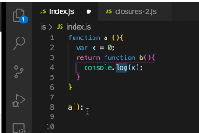

When a() execute hojaye tou it should be removed from call stack or iske jo bhi variabes the wo garbage collected hojane chhaye the but in case of closure ais nhi hota

**b has a closure with x so x cannot be free b/c b may later used somewhere**

we cannot free memory of x until we know that we no longer needed

### smart garbage collection

<https://youtu.be/t1nFAMws5FI?si=42lv8P9VCohLZJzp>

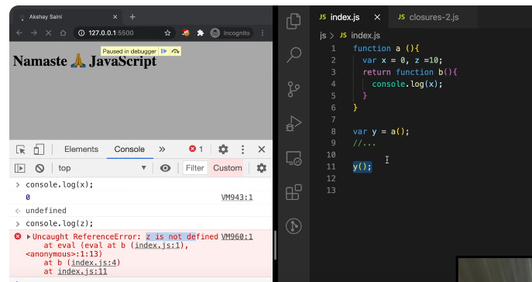

In JavaScript, Garbage Collection (GC) is an automatic memory management feature that helps free up memory that is no longer needed by a program. JavaScript uses a garbage collector to identify and remove unused objects, ensuring efficient memory usage and preventing memory leaks.

# First Class Functions, Anonymous Functions

<https://youtu.be/SHINoHxvTso?si=OqFC_20M2nEZytj_>  
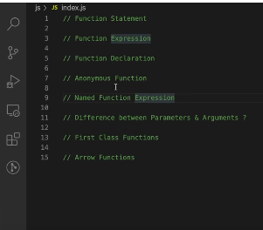

## Difference between function statement and function expression

Its hoisting difference:

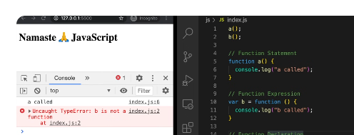

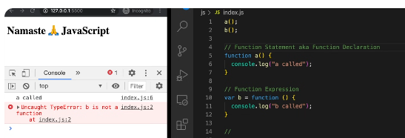

## Anonymous function

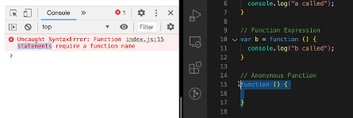

It’s a syntax error. Function statement or declaration must have name?

So where it is used

Where function used as value

## Named Function Expression

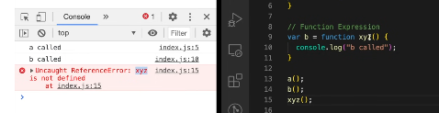

Xyz() is not created in outer scope/ global scope but it is created as a local variable

You can do this

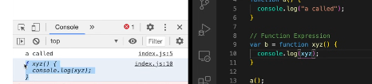

## Difference b/w parameter and argument:

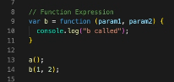

Jo local variable h func k param1 , param2 they are parameters

Aur jo func call krte wqt pass hue wo arg

## First class functions:

The ability of functions to be used as values is known as first class func. Can be passed as arg to another func and can be returned from functions.

Functions are first class citizens same thing

We can pass func inside func as arguments

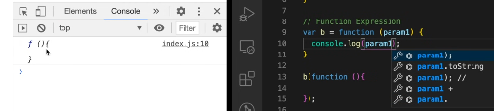

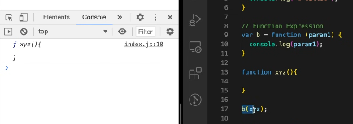

We can return a func from a func:

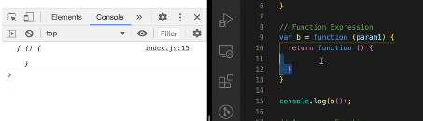

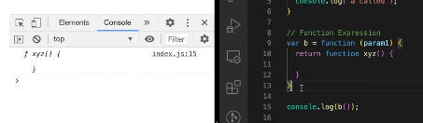

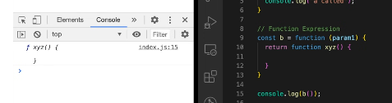

# Callback Functions

A callback is a function passed as an argument to another function

This technique allows a function to call another function

A callback function can run after another function has finished

<https://youtu.be/btj35dh3_U8?si=SyWOHFHmQtoCzevQ>  
  
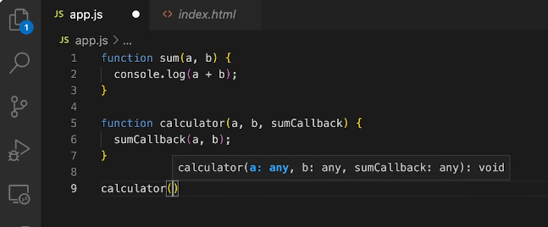

sum is call back func here

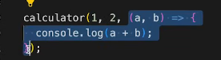

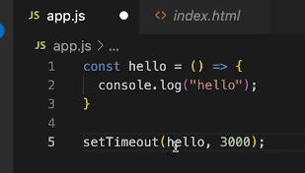

Hello is also call back func here

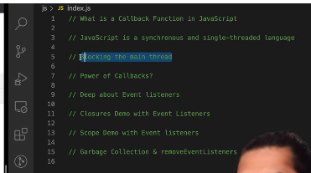

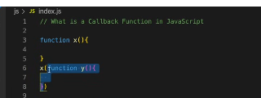

y() is call back function

why its known as call back function?

b/c we give the responsibility of func y to x. now it is upto x where it want to call this y. this func y will be used sometime later in your code.

## How it is used in asynchronous task?

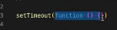

This func which you passed to setTimeout as parameter is known as callback function. That means it is passed out to setTimeout and this will be called later in your program

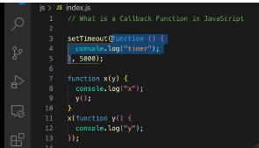

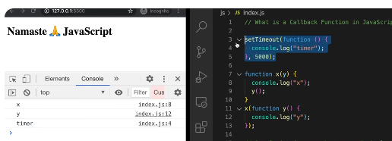

So as js is synchronous single threaded language it means one task(one line) at a time and in particular order from top to bottom so

1. Registering a setTimeout 🡪 it will take call back func and store it in a separate space and it will attach a timer to it of 5sec

2. js won’t wait for set Timeout to finish over here that is why we say that this call back give us power of asynchronous behavior.

3. it will go next line of code and it will see function definition of x and it will try to call this x function , it will pas function y to parameter of x function and it will do console log of x then it will print y and it will go on , once timer expires , call back func of setTime out is executed.

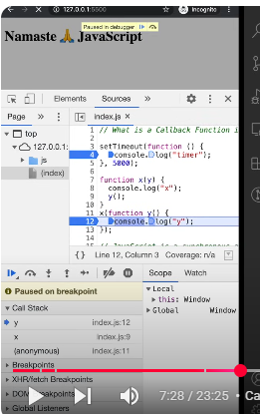

Call stack is empty then

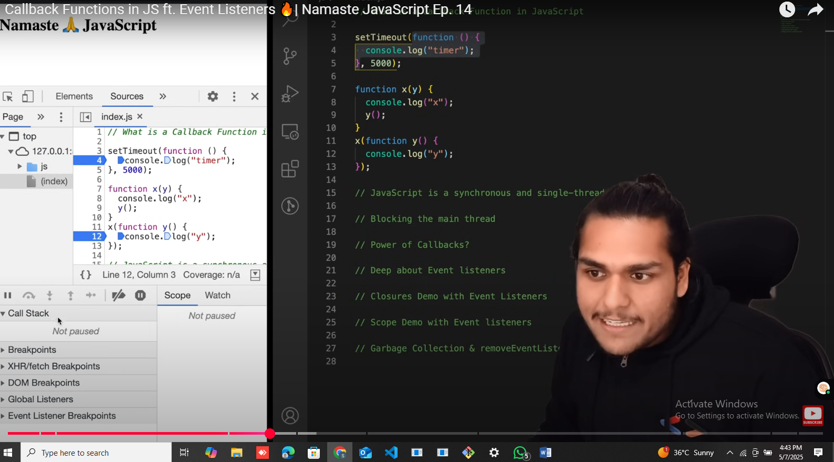

After 5 sec , this anonymous func automatically come into call stack and executes

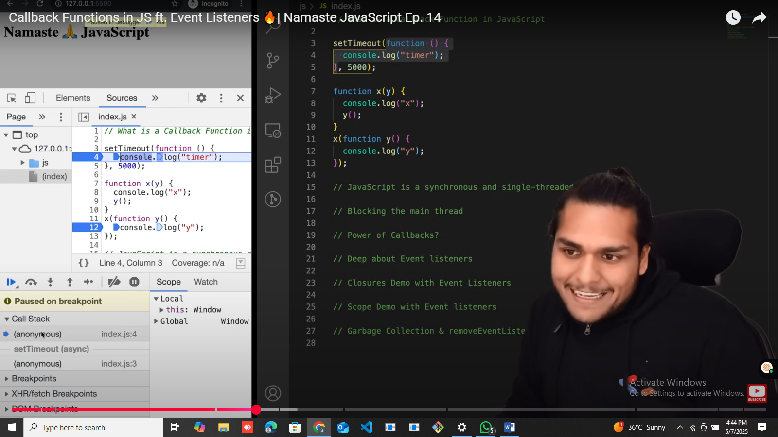

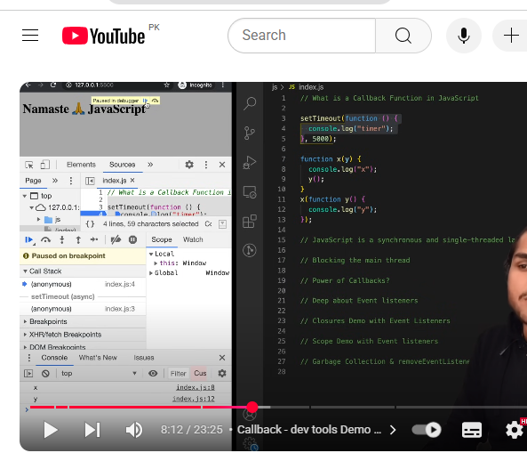

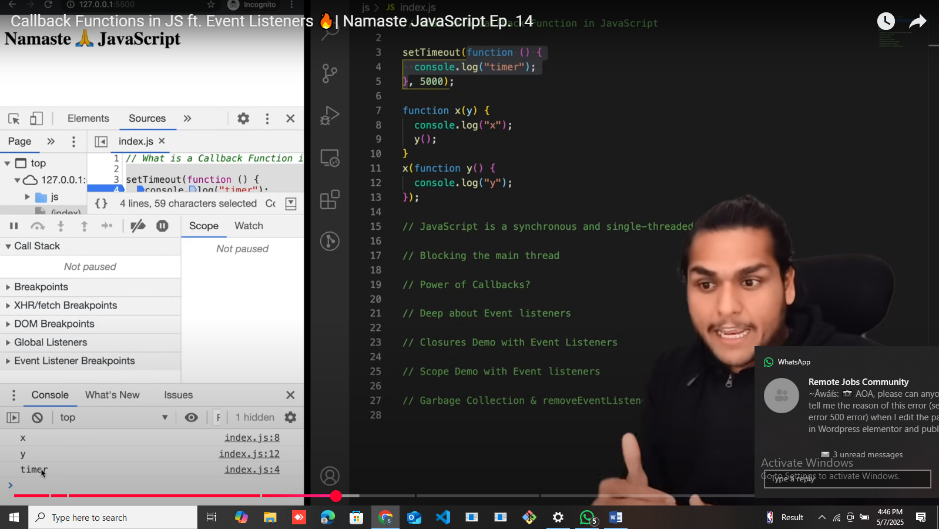

## Main thread

Js has one call stack also called main thread, so everything whatever executed in page is executed through call stack only

So x() y() call back func from setTimeout will be executed through call stack

So if any operation blocks this call stack, i.e blocking main thread

So suppose your function x has a very heavy operation which takes around 20, 30 sec to complete, so it won’t be able to execute any other function on code

We should never block it, we should always try to use async for things which take time as we did using setTimeout.

setTimeout. Will take a call back and will execute this piece of code somewhere else and gets out of call stack

so if js had not these first class citizen or call back func and we could not pass function as parameter, we would not be able to do asynchronous operations.

## Event Listeners:

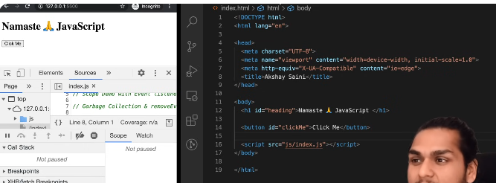

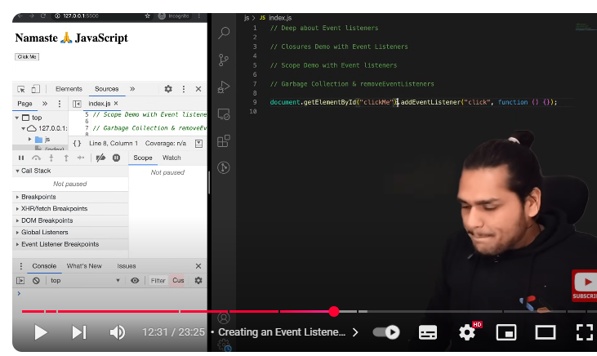

Function(){} inside addEventListener is also call back function , it will come into call stack only when click event happen

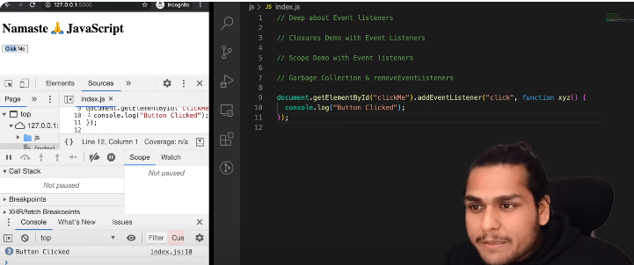

If I put a debugger :

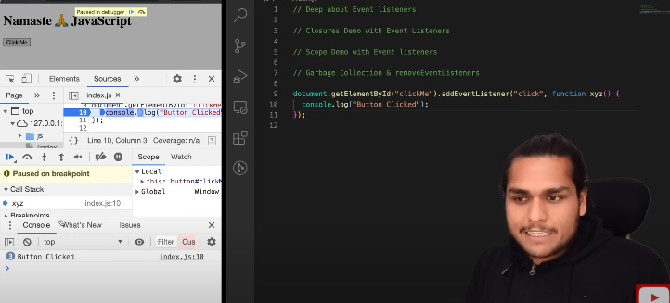

Whenever I press click me button this xyz func come onto the call stack

Lets add closure with eventListeners:

So what if we want to count how many times a button is pressed

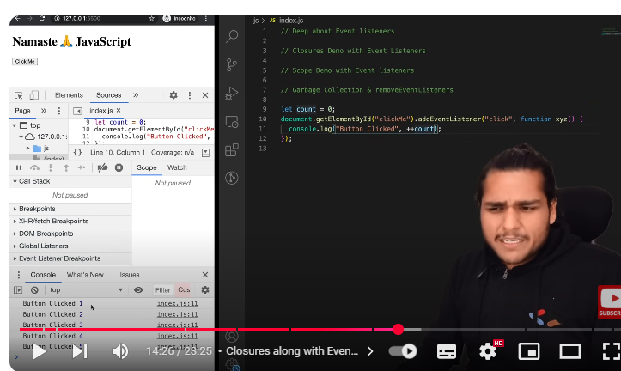

But using a global variable is not good solution

So how can we make a closure and ensures that this count is secure an cannot be modified by any other inside our program, we use closure for data hiding.

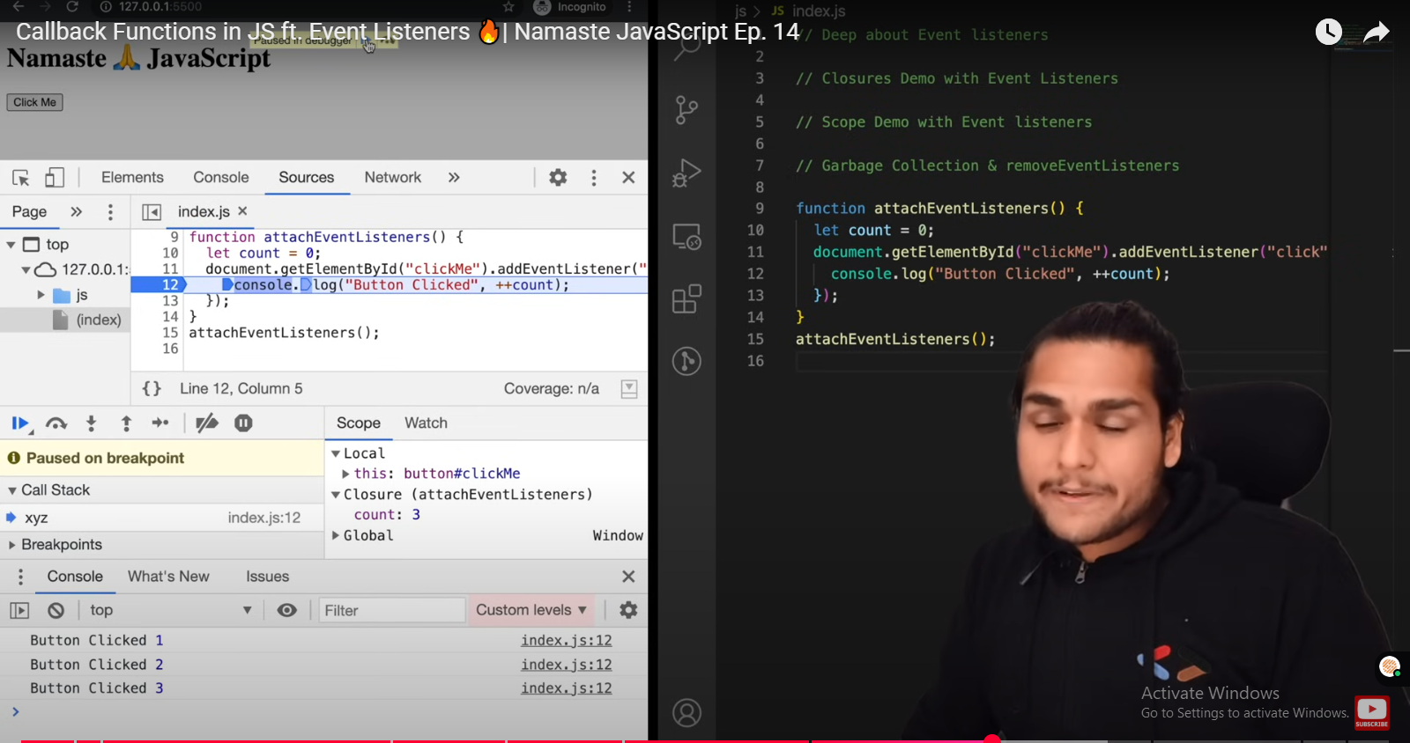

Function xyz forms a closure with outer scope or lexical scope and has access to count variable and it remembers it.

One more thing to show in dev tool:

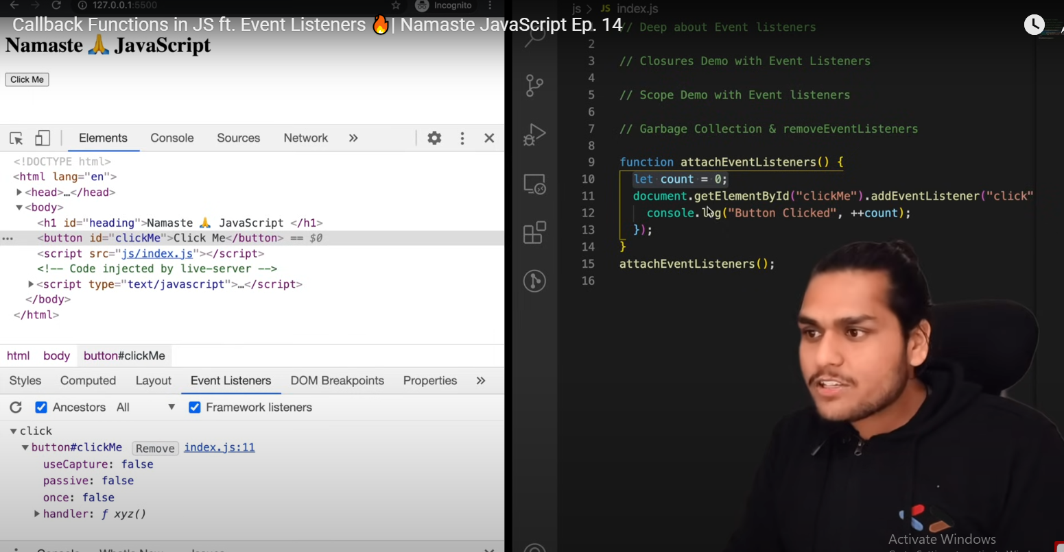

Html Elements tab 🡪 when I clicked on button ; there is tab eventListners

We have click (event listener attached)

And what this click doing?

It has handler: this handler is call back function, the same func we passed in line 12 of our code , its also tells the scope of func

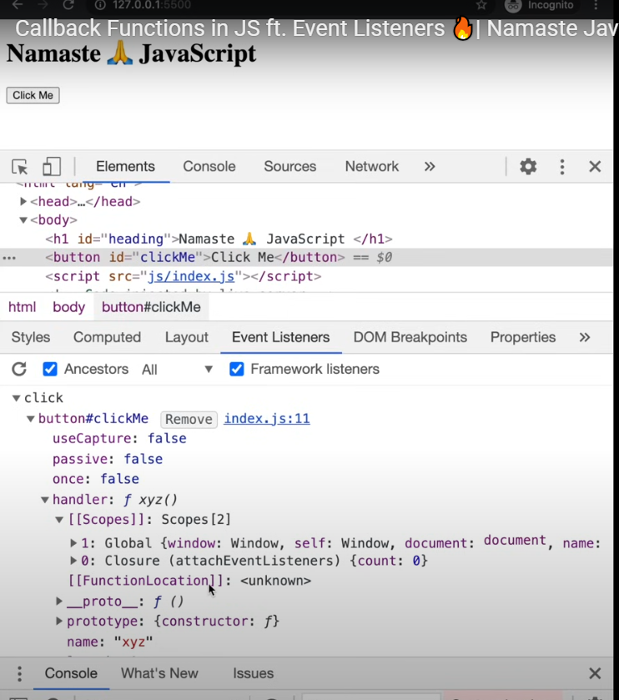

The concept of lexical scope and scope chain we studied ; firstly xyz lexical scope which is closure and then its parent lexical scope which is GEC.

## GARBAGE COLLECTION AND REMOVE EVENT LISENERS

Why do we need to remove event listeners?

event listeners are heavy 🡪 takes memory 🡪 b/c of closure 🡪 even when call stack is empty we are not executing any code

this program is not freeing up memory, it can’t free up this count b/c

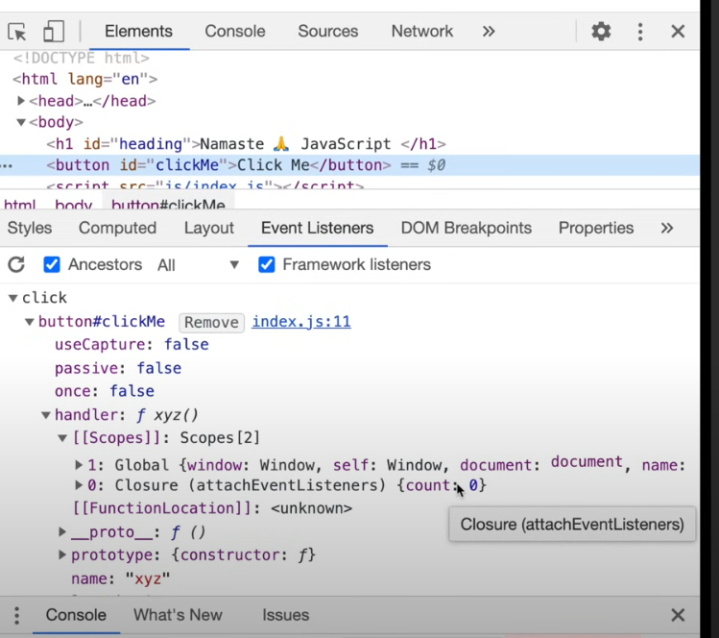

When somebody clicks on this button and you need this closure, so that is why we cannot free up this extra mem, that is why they are heavy ,  
suppose our page has lot of event listeners, on mouse scroll, on mouse click etc etc, pg can be slowed down b/c of these so many closures sitting in memory consuming lot of memory of all their scopes and call back func

Good practice is to remove event listener or free up space then all those variables which are held by this closure will be garbage collected.

# Event LOOP

The event loop is a crucial mechanism that allows JavaScript to handle asynchronous operations efficiently despite being single-threaded. It continuously monitors the call stack and task queues, executing tasks when the call stack is empty.

The event loop operates in a cyclical manner:

* **Call Stack:**

When JavaScript code is executed, it's added to the call stack. The stack follows a Last In, First Out (LIFO) principle.

* **Task Queue(s):**

Asynchronous operations, like setTimeout, network requests, and user interactions, are placed in task queues (macrotask and microtask queues).

* **Event Loop:**

The event loop continuously checks if the call stack is empty. If it is, it takes the first task from the macrotask queue (e.g., setTimeout, setInterval, UI rendering) and moves it to the call stack for execution. After the execution of the macrotask, the event loop checks the microtask queue (e.g., promises, MutationObserver) and executes all microtasks before picking up the next macrotask. This prioritization of microtasks ensures that promises and other related operations are handled promptly.

* **Repetition:**

Steps 1-3 repeat continuously, allowing JavaScript to handle multiple tasks concurrently without blocking the main thread.

This model enables non-blocking I/O operations and efficient handling of events, ensuring a smooth and responsive user experience.

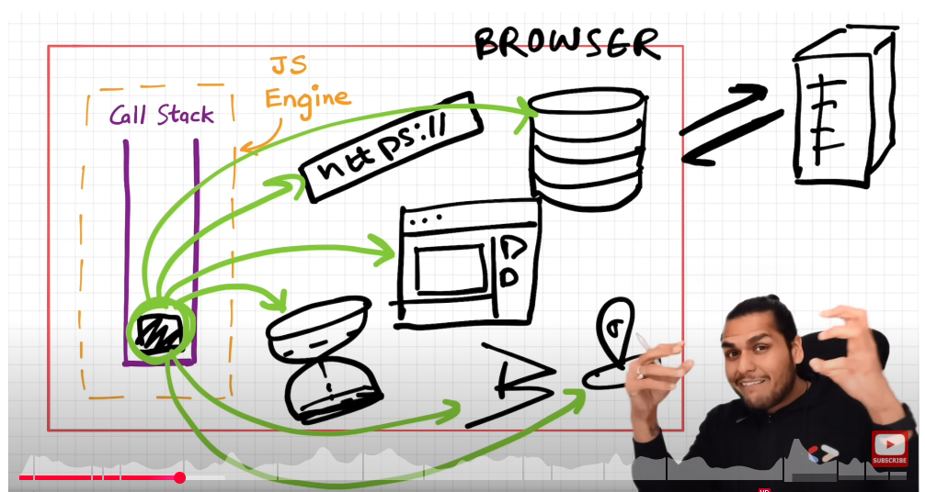

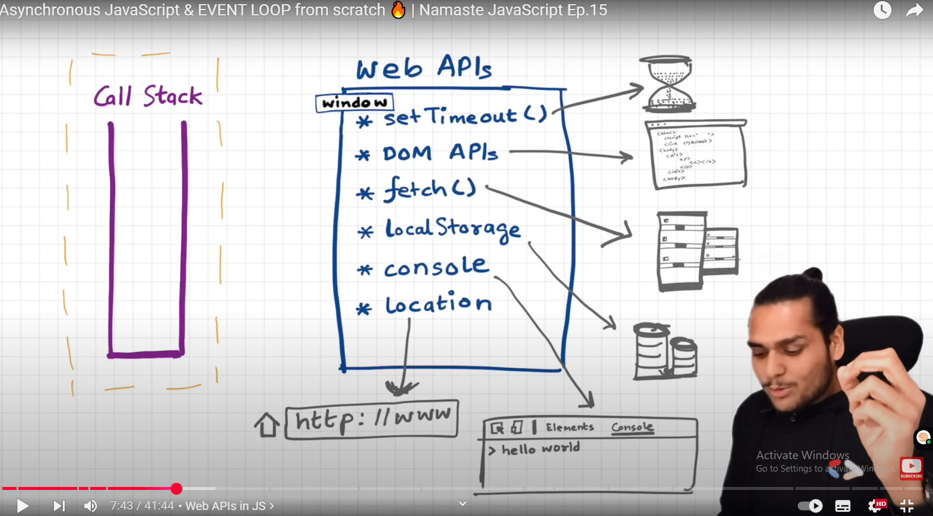

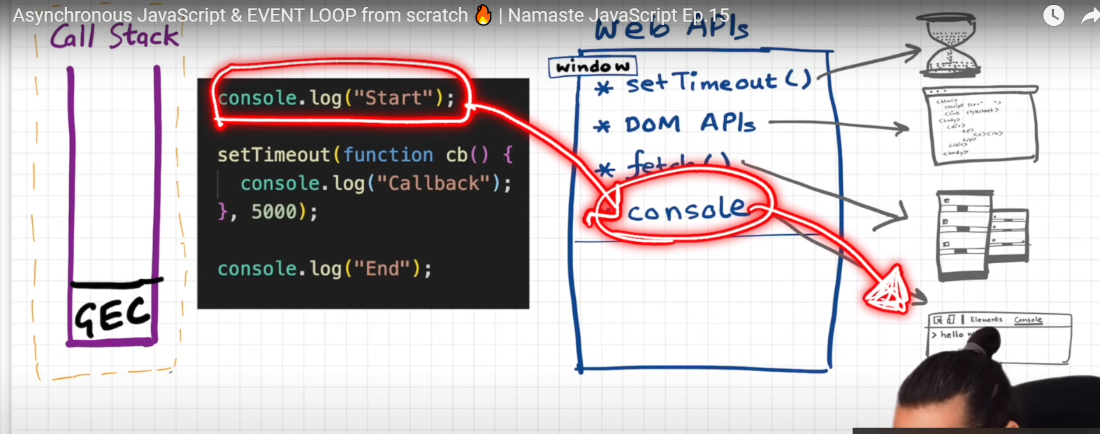

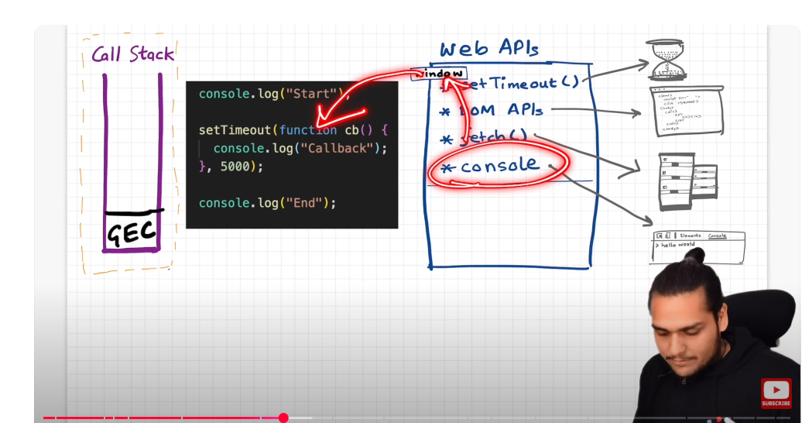

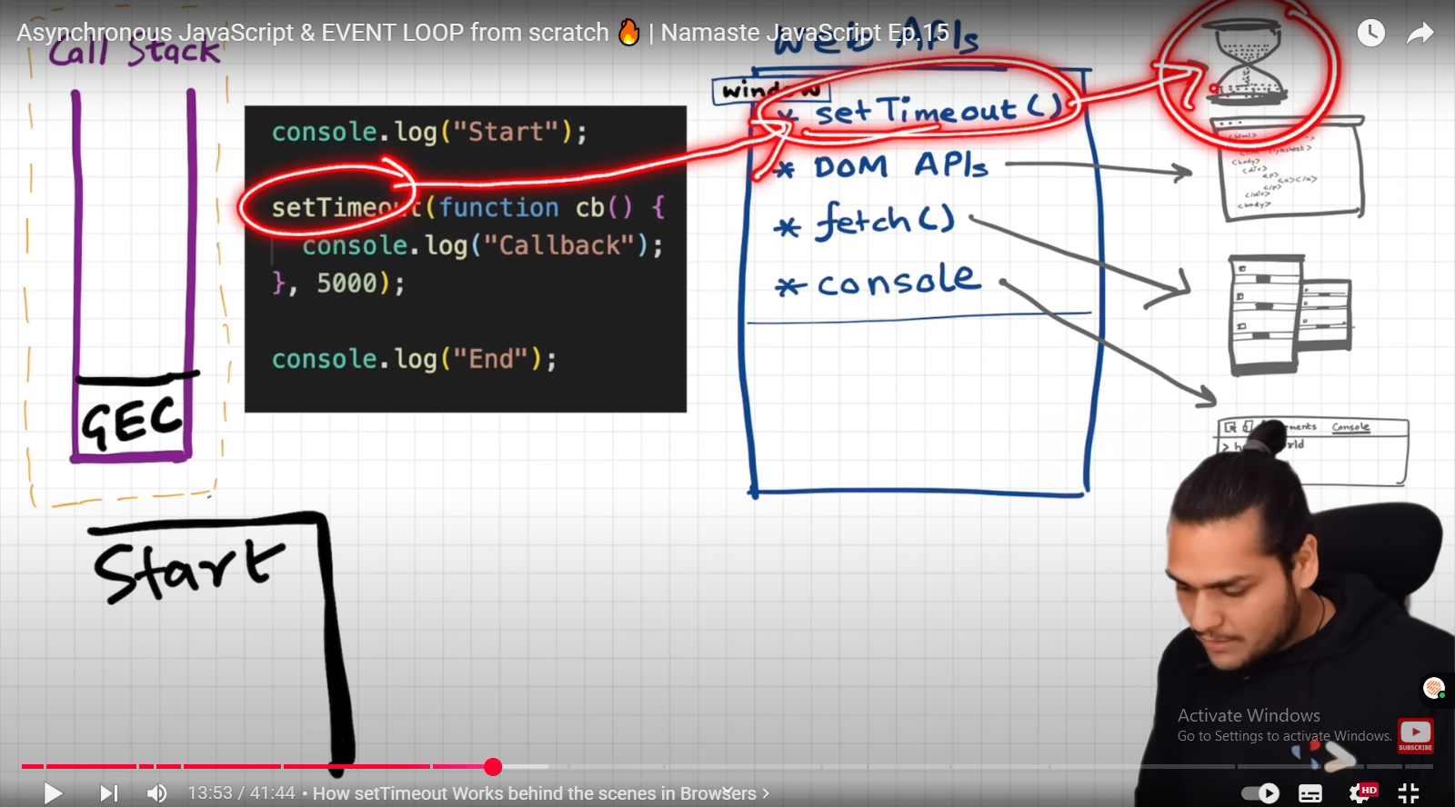

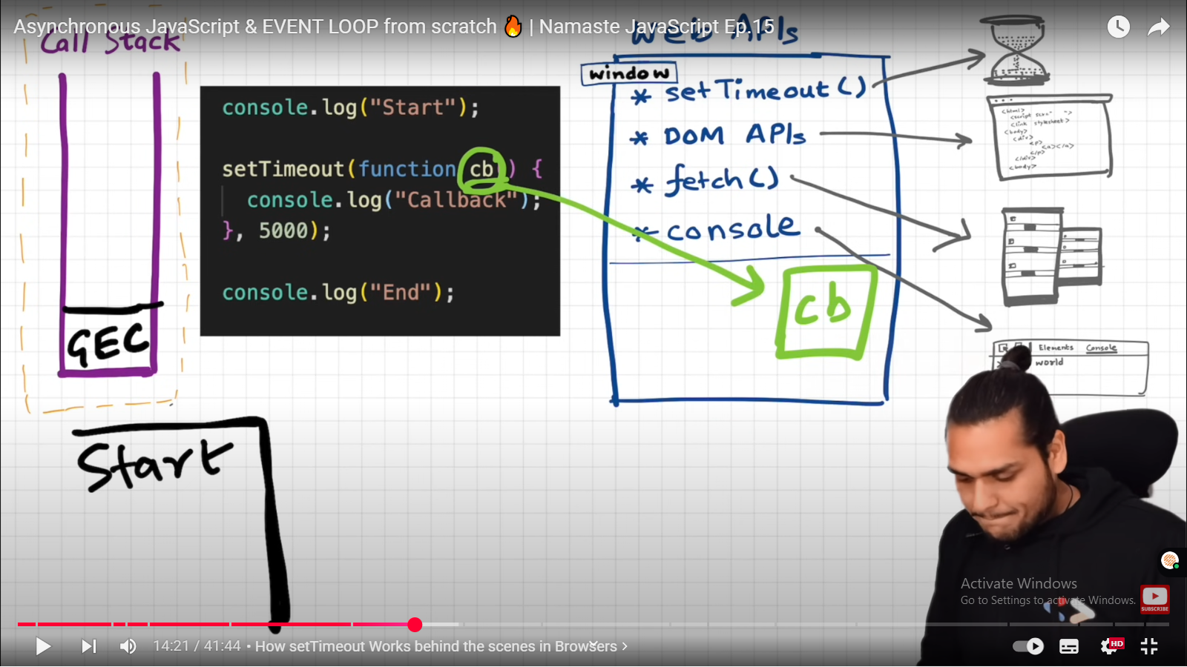

IT REGISTER CALL BACK over here.

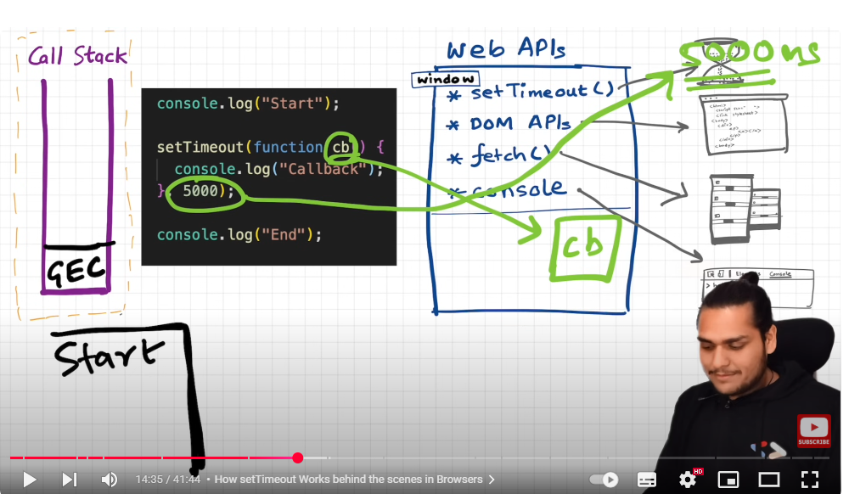

And it starts timer over here (setTime out is not part of js,it is web API 🡪 BROWSER PROVIDES as many other apis illustrated in prev ss)

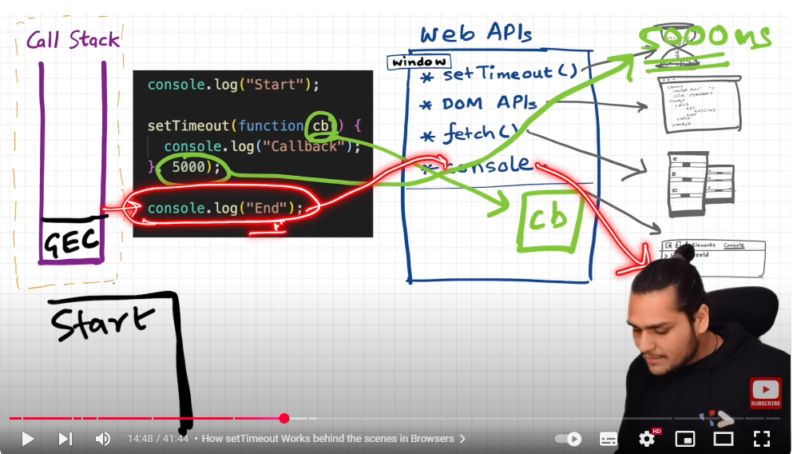

Once our code executed:

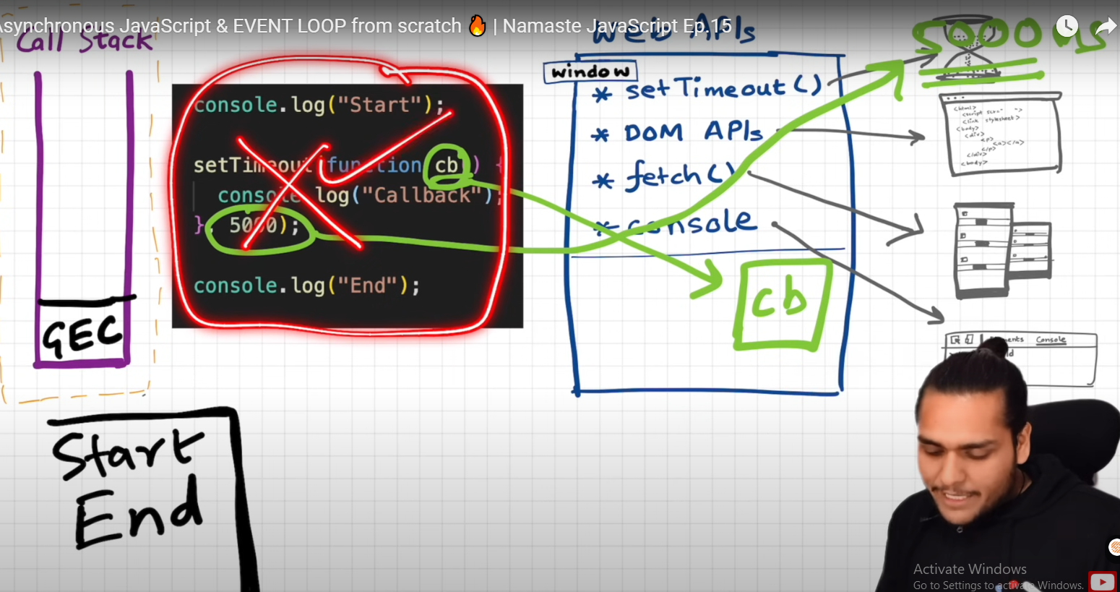

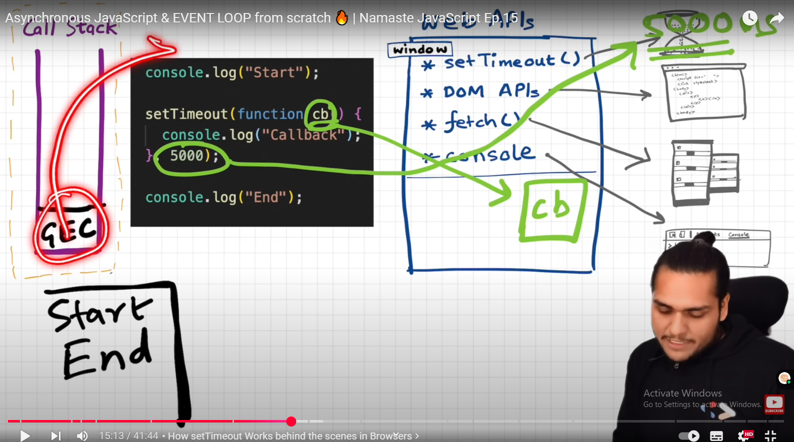

As timer expires, call back func needs to go to call stack to execute:

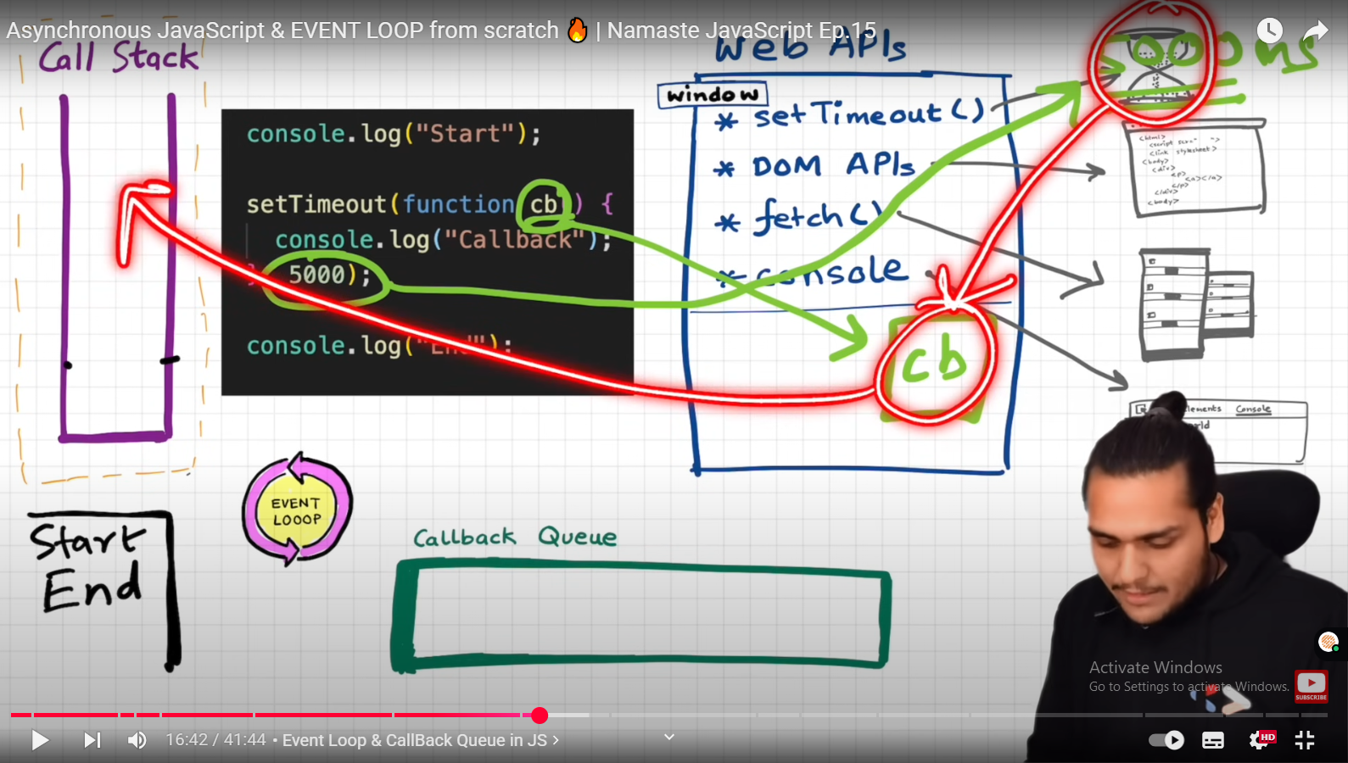

It cannot go directly

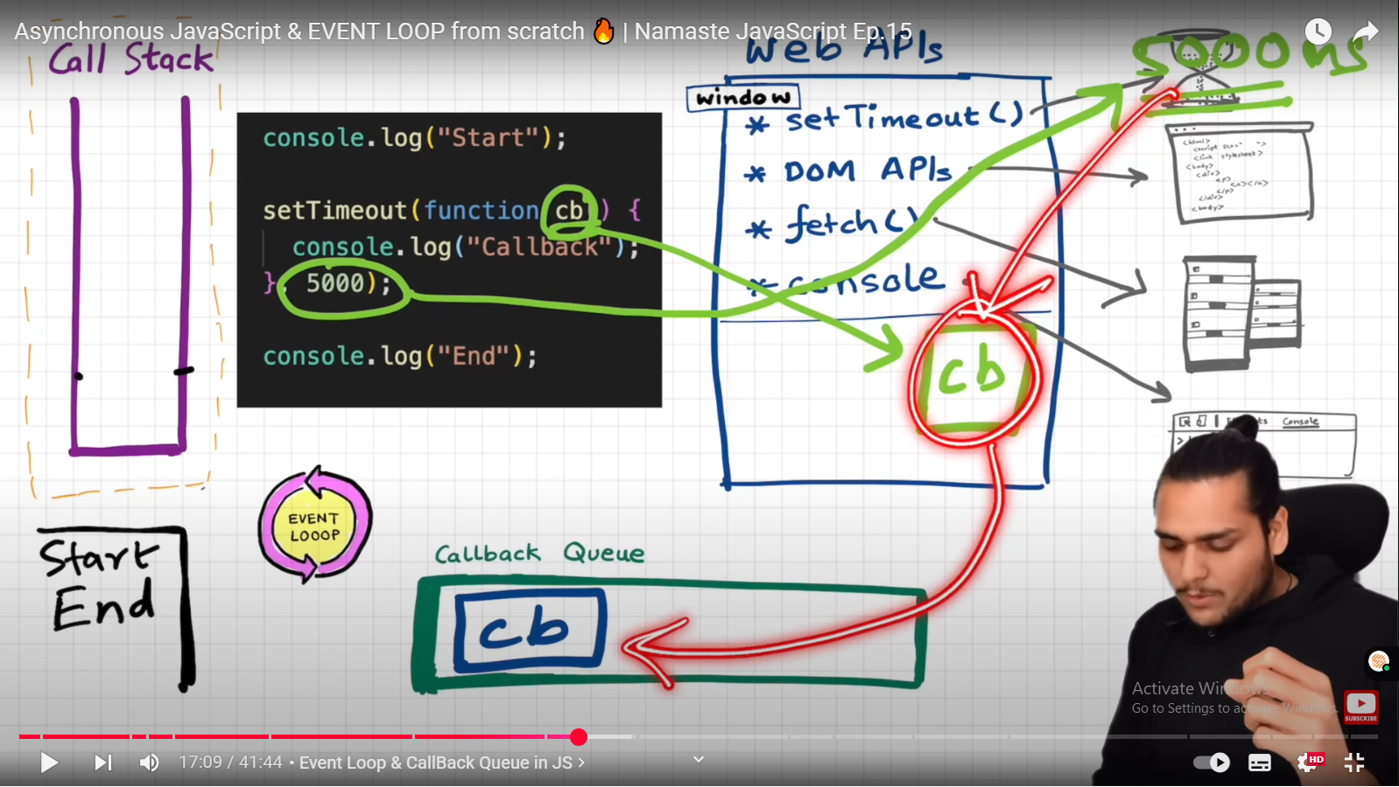

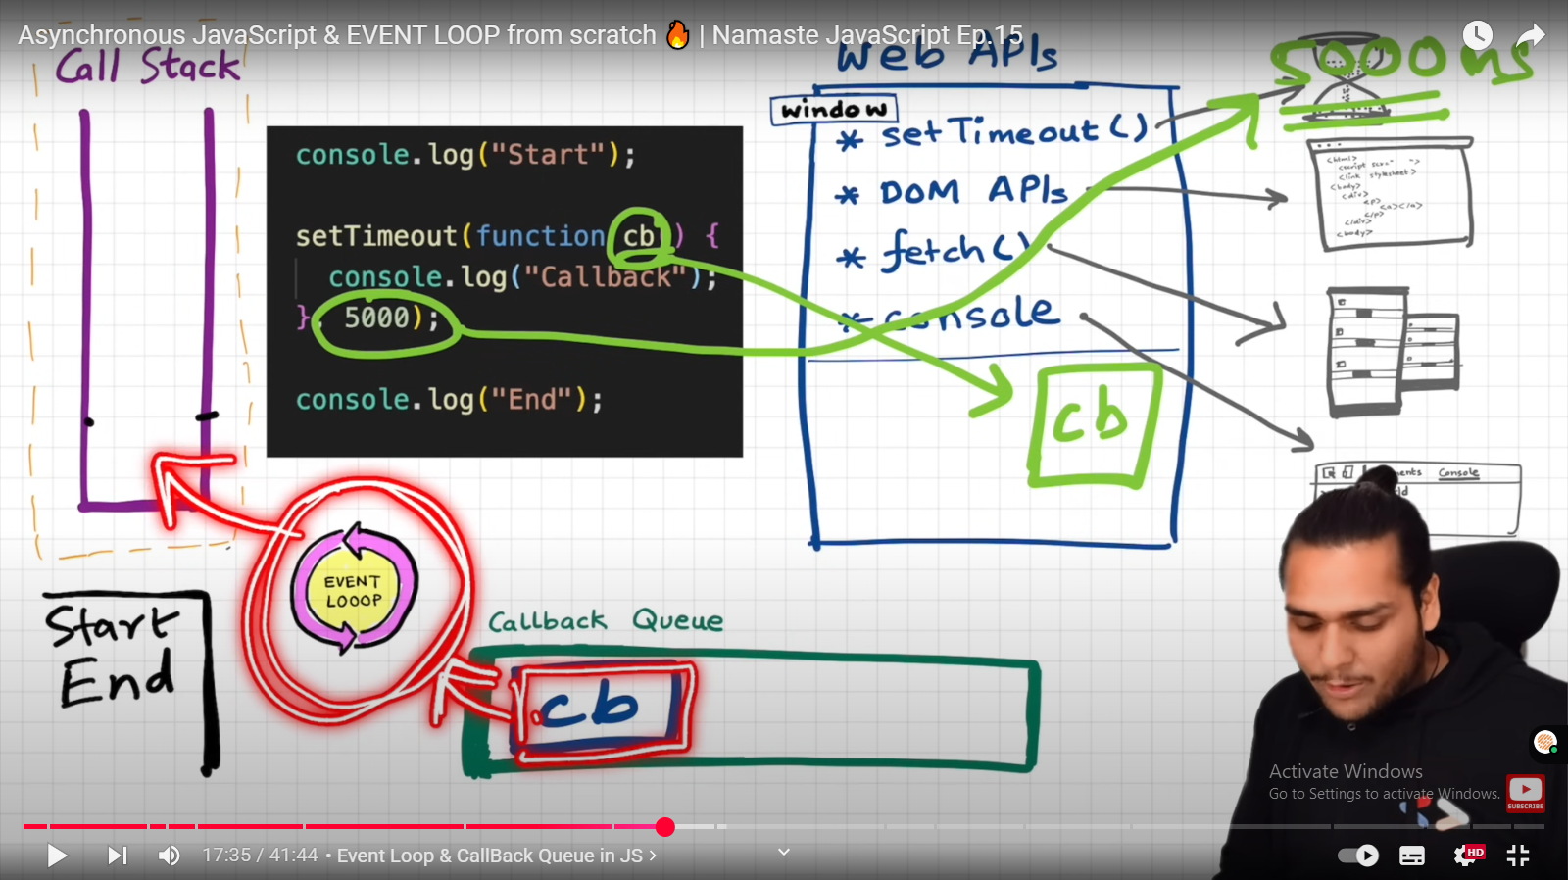

Event loop is gateway ; it needs to check if there is something in call bac queue and put it onto the slack

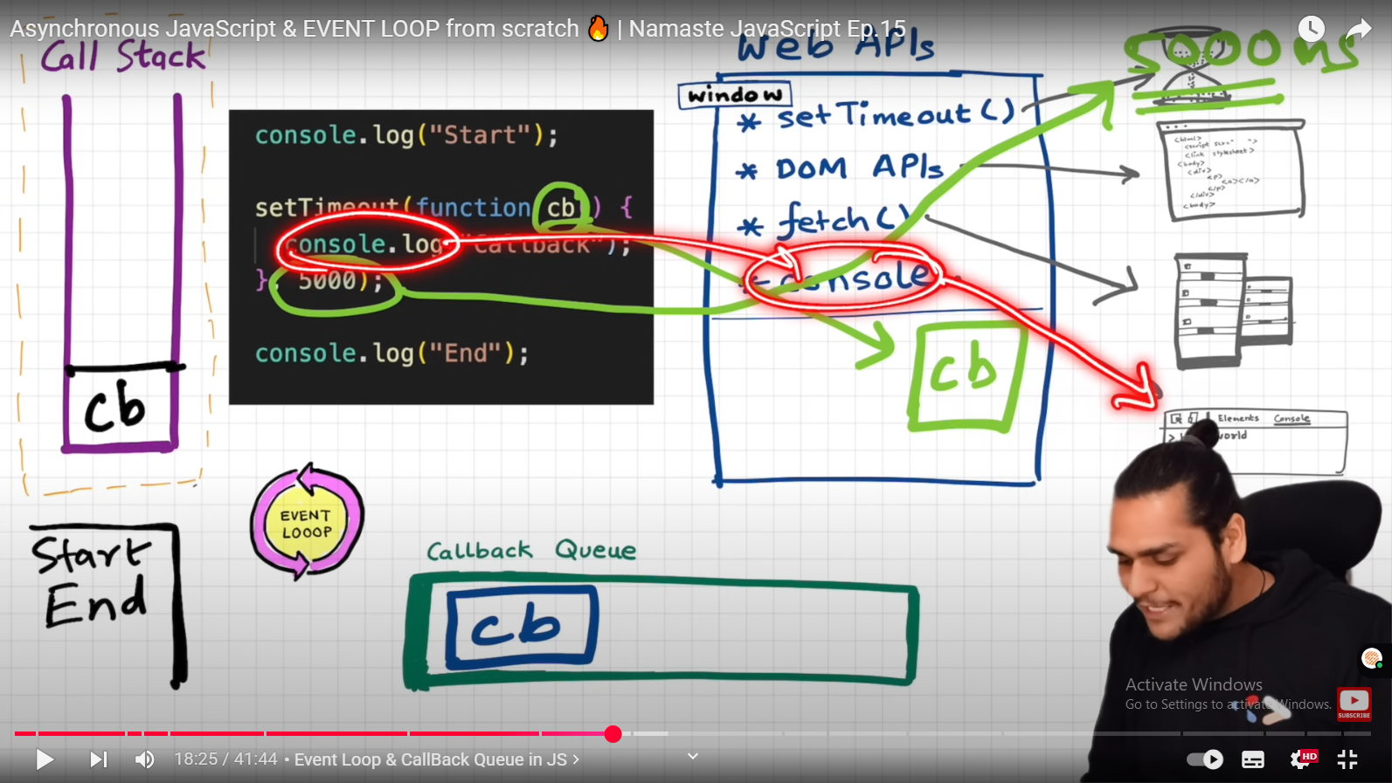

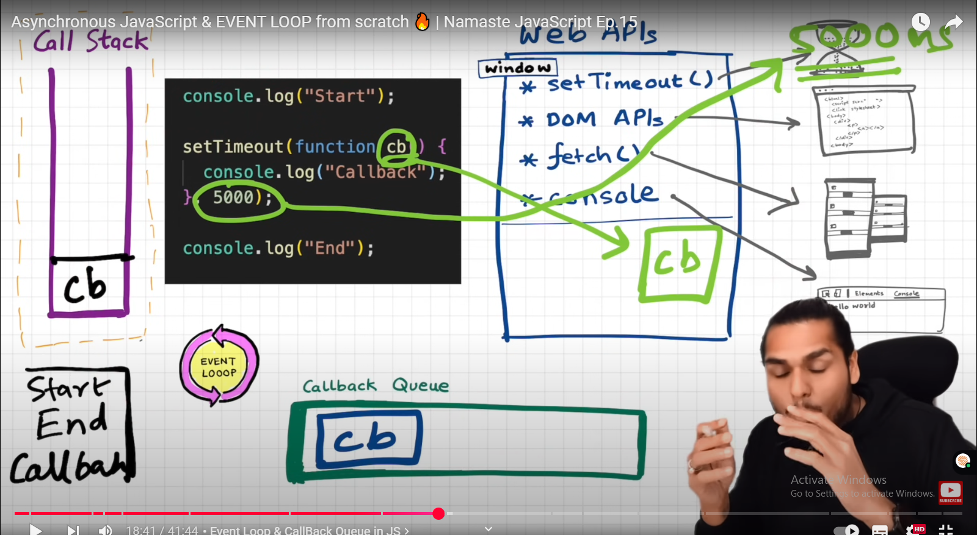

Example 2:

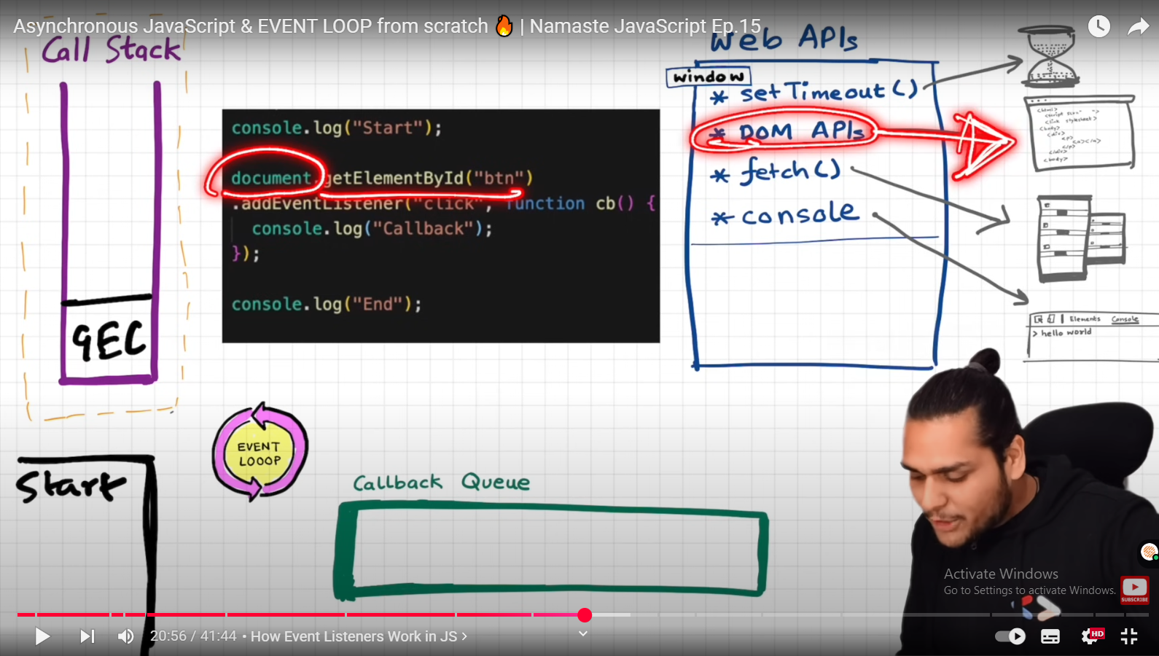

DOM:

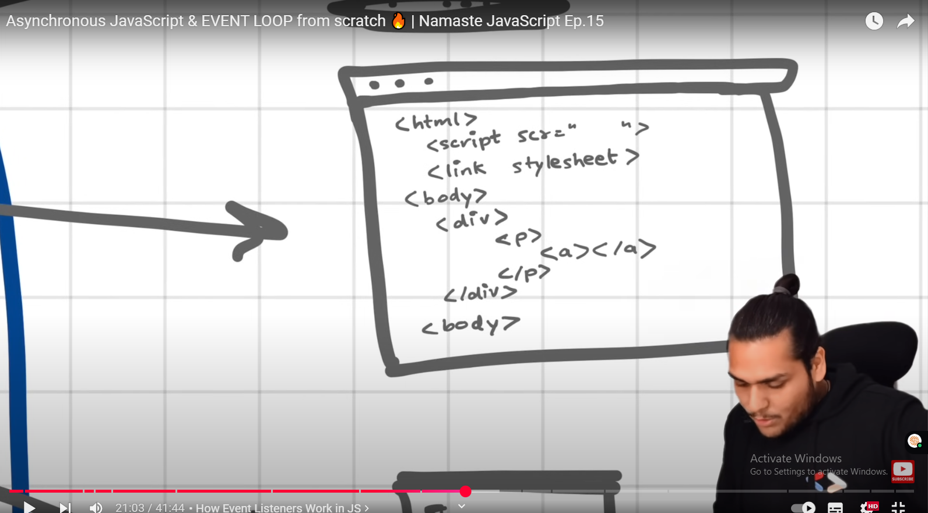

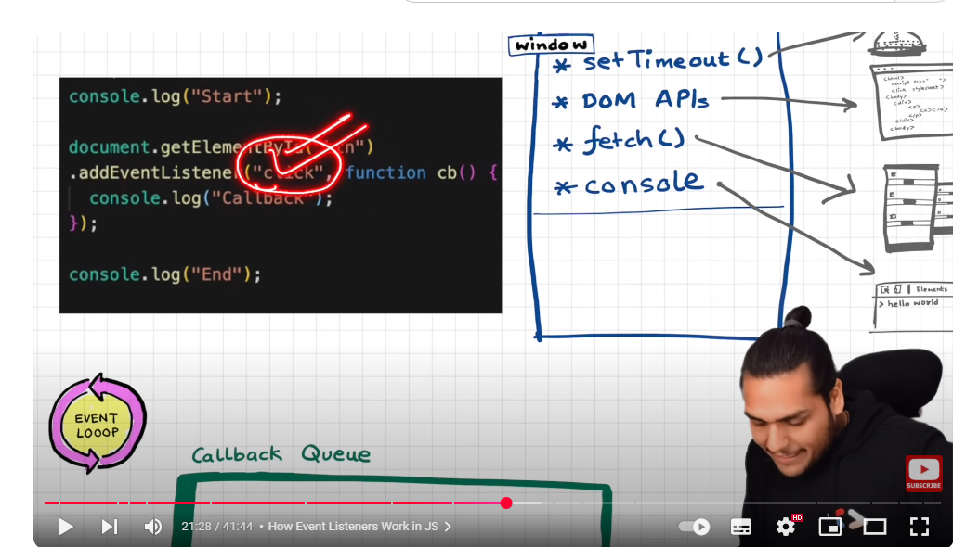

addEventListener register call back func and attach an event click to it

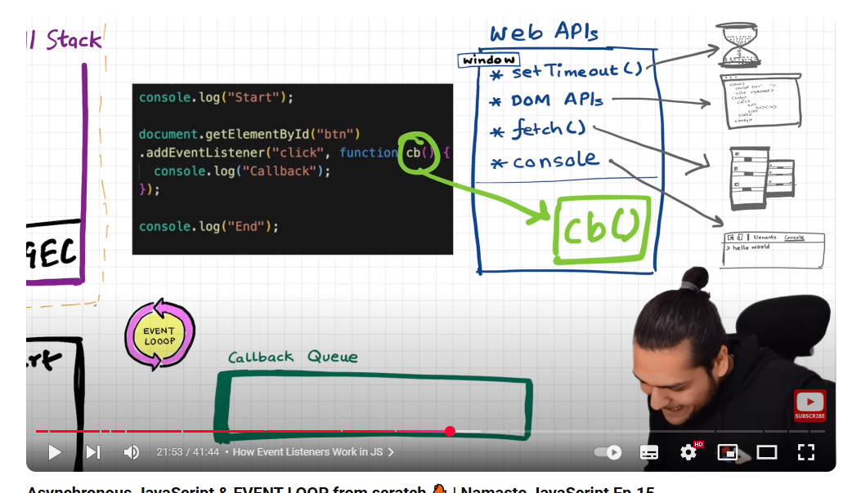

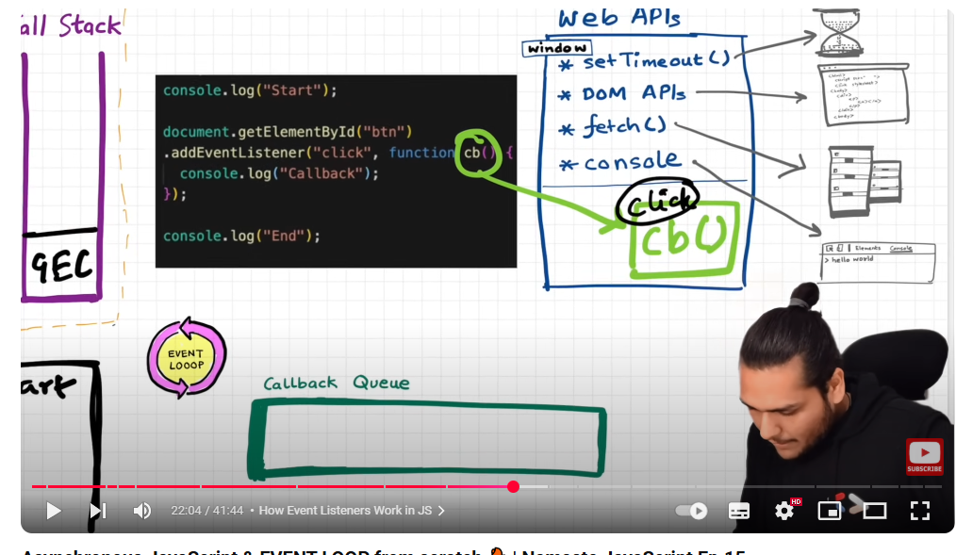

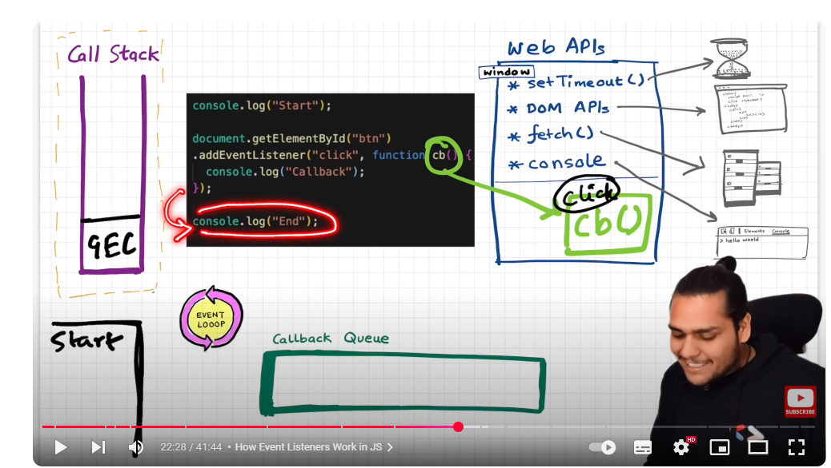

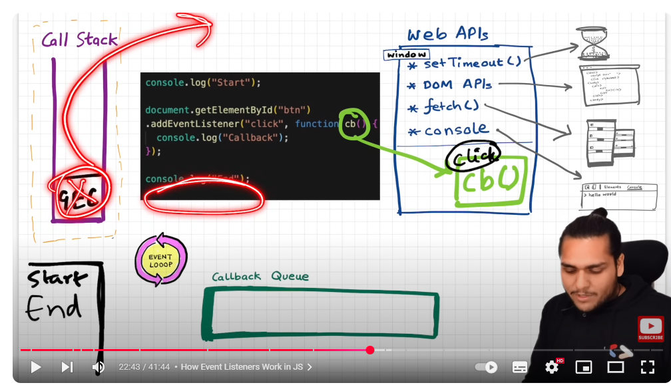

Now call back method stays in web API Environment in hope that at some time user clicks and this call back func will be executed

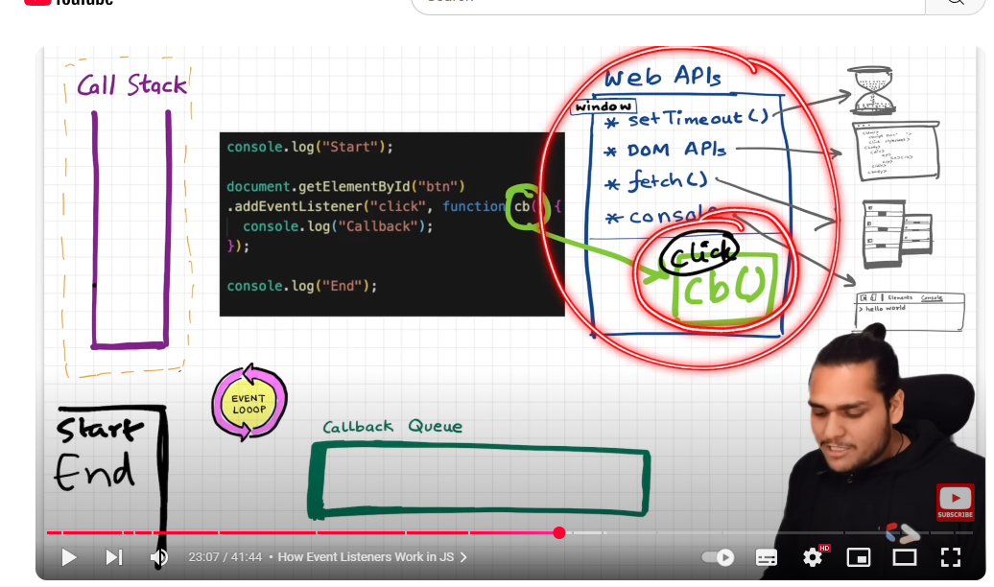

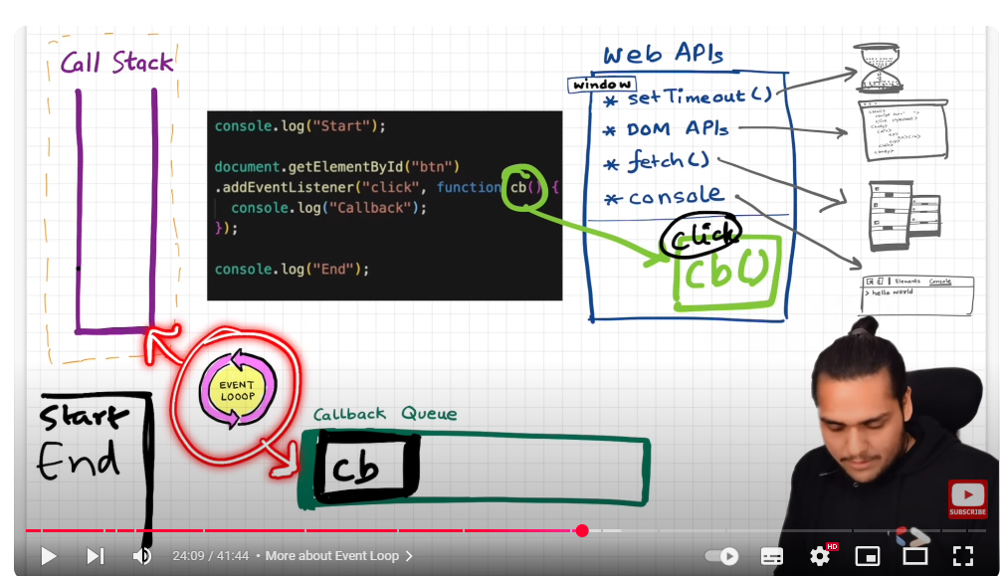

This event loop has one job to continuously watching callback queue and call stack

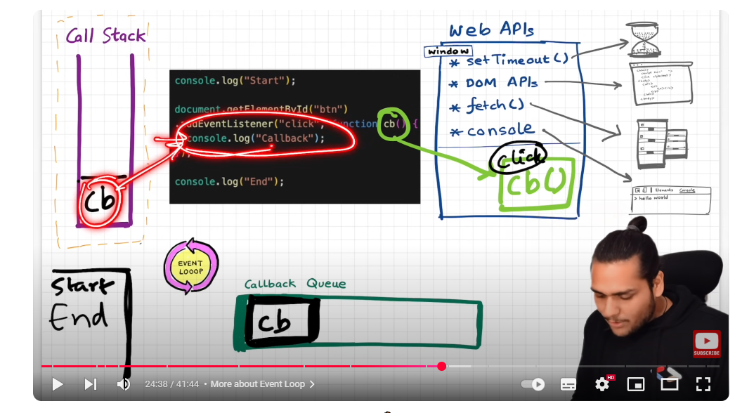

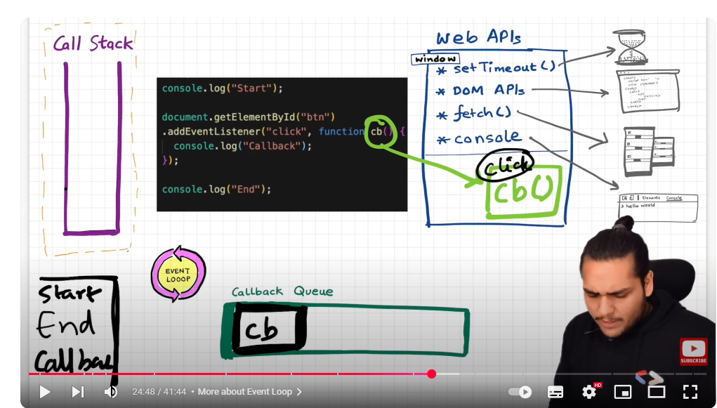

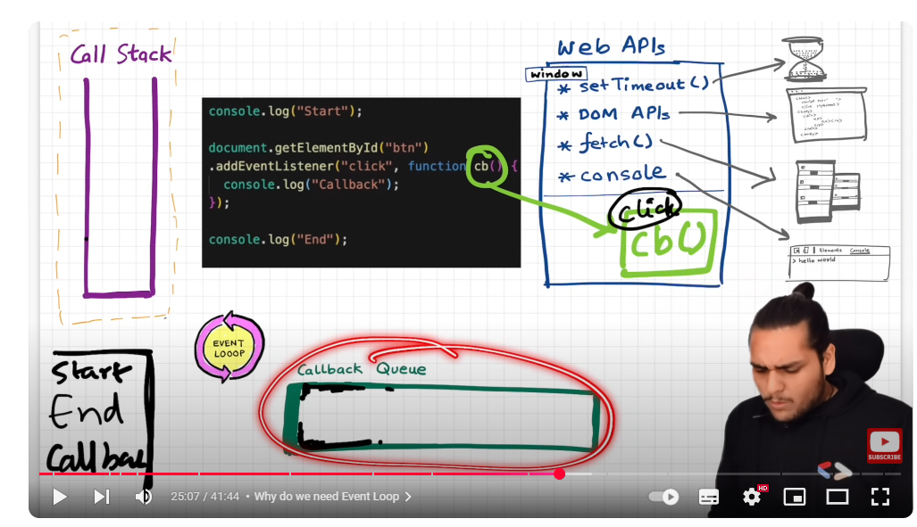

Why do we need this callback queue?

If user clicks 7, 8 times the cb functions will be in callback queue and executed 1 by 1 as event loop checks call stack is empty or not and put them on call stack one by one

### Example 3: fetch() web API

Fetch returns a promise and we have to return a call back function which will be executed once this promise is resolved. Promise resolved means once we get data from url then we will perform this call back func

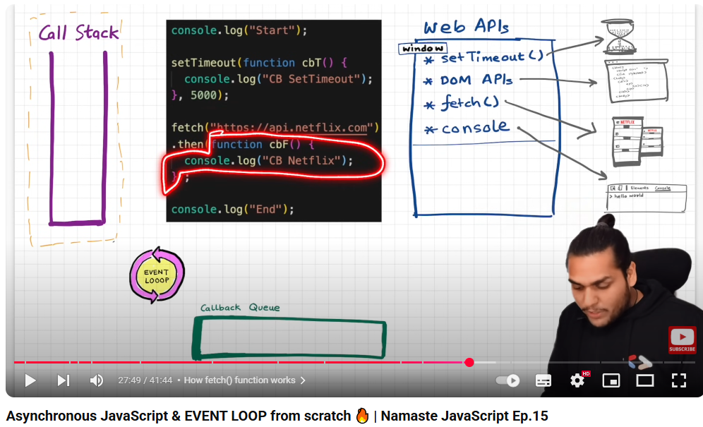

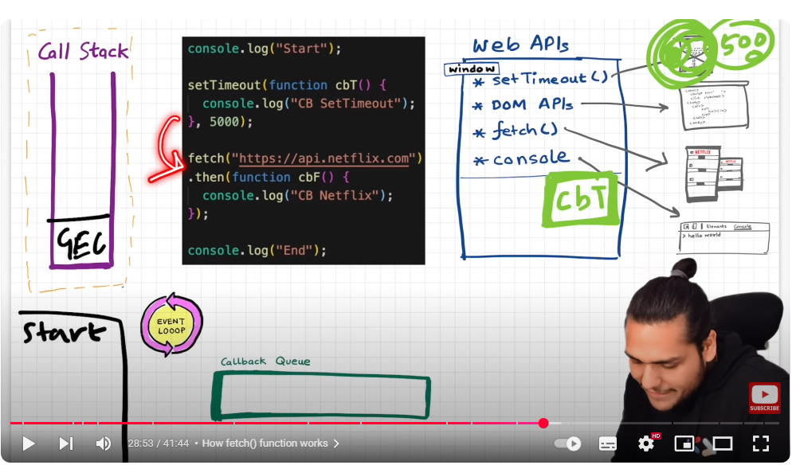

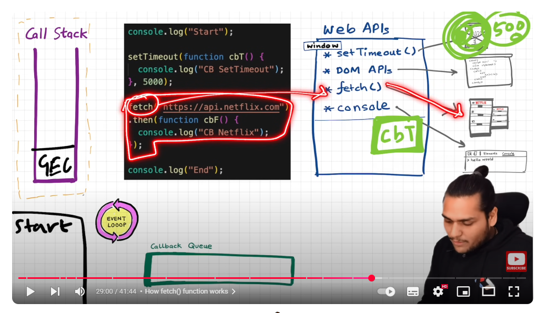

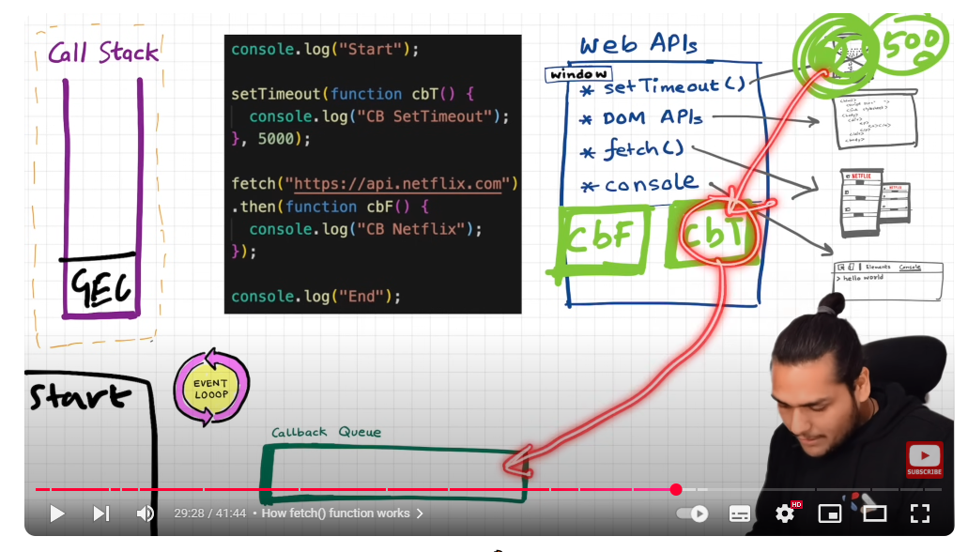

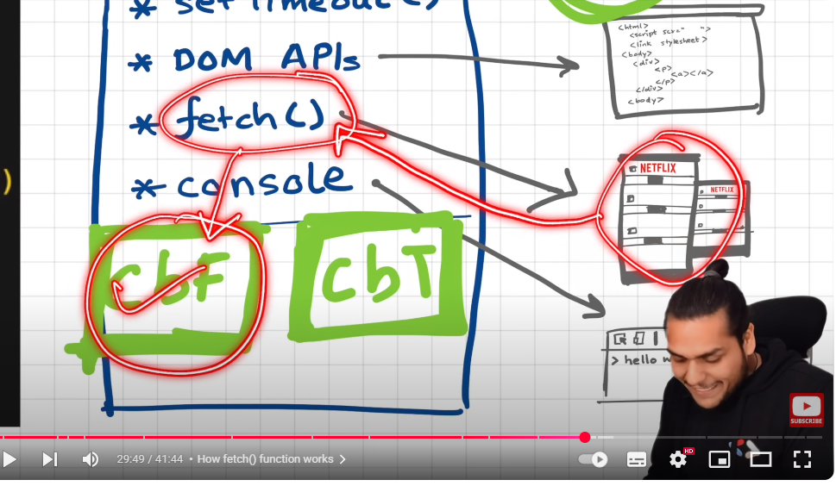

### Microtask queue

It has higher priority than call back queue

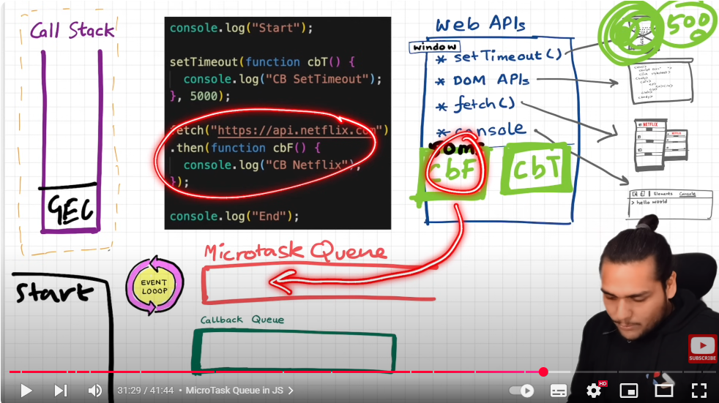

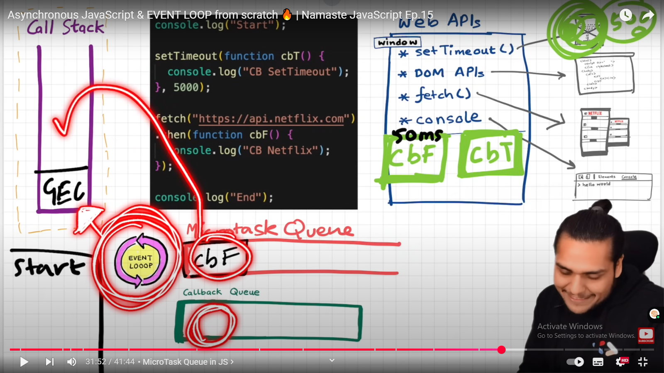

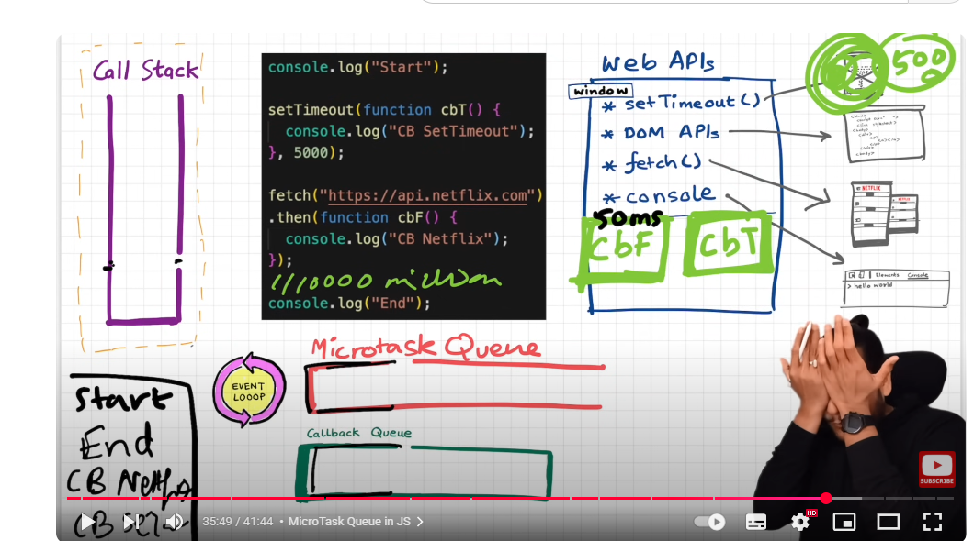

All the call back functions which are coming through promises will go inside micro task queue.

Mutation observer. Keeps on checking whether there is some mutation in DOM tree or not? If there is some mutation in DOM tree , it can execute some call back function

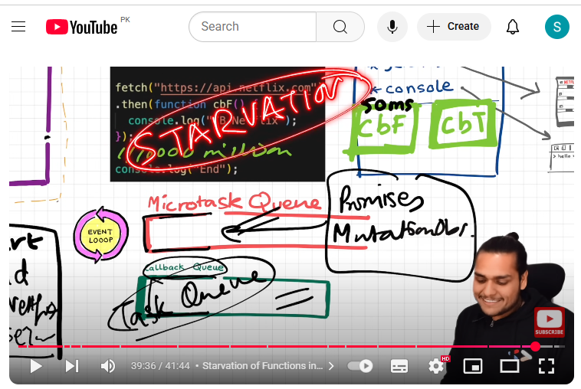

**Startvation of callback queue; means microtask queue me bhtt sare tasks hain aur q k uski priority ziada ha isilye call back queue ki turn hi nhi aaarahi isko kehte hain starvation of call back queue**

# EVENT Delegation:

## **Event Delegation**

### 📘 What is it?

Event delegation is a technique in JavaScript where you attach a single event listener to a **parent element** instead of individual child elements. The event bubbles up from the target element to the parent, and you handle it there.

### 🧠 Why use it?

* **Performance**: Fewer event listeners = better performance.
* **Dynamic elements**: Works on elements added to the DOM later.

### 🔍 Example:

html

CopyEdit

<ul id="menu">

<li>Home</li>

<li>About</li>

<li>Contact</li>

</ul>

<script>

document.getElementById('menu').addEventListener('click', function(event) {

if (event.target.tagName === 'LI') {

console.log(`You clicked on ${event.target.textContent}`);

}

});

</script>

You didn’t attach a click listener to each <li>. You only attached it once to the parent <ul>.

### 🎯 Real-world Analogy:

Imagine a security guard at the entrance (parent) checking IDs of people (children) entering a building. The guard doesn't go door to door.

### ❓ Interview Question:

How does event delegation work in the DOM and when would you use it?

### ⚠️ Mistakes to Avoid:

* Not checking event.target or using it incorrectly.
* Forgetting that some events like focus or blur don’t bubble (but you can use focusin and focusout).

# Event Bubbling:

Event Bubbling kya hoti hai?

Jab aap kisi HTML element (child) pe click karte ho, to event sabse pehle us element pe fire hota hai, phir uske parent pe, phir uske parent ke parent pe — is tarah upar ki taraf bubble karta hai. Is process ko event bubbling kehte hain.

📶 Simple Definition:

Event bubbling means an event moves from the innermost element (target) up through its ancestor elements (parents) in the DOM.

📊 Ek Simple Example:

html

Copy

Edit

<div id="parent">

<button id="child">Click Me</button>

</div>

js

Copy

Edit

document.getElementById('child').addEventListener('click', () => {

console.log("Child clicked");

});

document.getElementById('parent').addEventListener('click', () => {

console.log("Parent clicked");

});

🧪 Output:

nginx

Copy

Edit

Child clicked

Parent clicked

Jab aap button pe click karte ho:

child ka event run hota hai

Phir woh event bubble hoke parent tak chala jaata hai, isliye parent ka handler bhi chal jaata hai

📌 Real-Life Analogy:

Agar ek bacha cheekhta hai (child element), to awaaz pehle uske paas sunayi deti hai, phir uske room ke bahar, phir uske ghar mein — upar upar tak pohchti hai.

🔁 Event Bubbling kahan useful hoti hai?

Jab aap ek parent element pe event listener laga ke uske child elements ke events handle karna chahte ho (i.e. event delegation)

❌ Kabhi Kabhi Aapko Bubble Rokna Padta Hai

Agar aap chahte ho ke event sirf child tak limited rahe, to use this:

js

Copy

Edit

event.stopPropagation();

### ❓ **Q: What is event bubbling and how does it relate to event delegation?**

**✅ Answer:**

Event bubbling is a mechanism in the DOM where an event triggered on a child element propagates upwards through its parent elements until it reaches the root of the DOM tree.

For example, if a user clicks a button inside a <div>, the click event will first run on the <button>, then on its parent <div>, and then up through the body and document. This is called "bubbling up."

Event delegation takes advantage of this behavior. Instead of attaching event listeners to multiple child elements individually, you attach a **single listener to a common parent** and use the event.target property to figure out which child was interacted with.

This improves performance and also works well for dynamically added elements, since the listener is already on the parent and doesn't need to be re-attached.

### 💡 Bonus Tip:

Mentioning that not all events bubble (e.g., blur and focus) and that delegation works best with bubbling events will make your answer stronger in an interview.

# Event Capturing:

### Definition:

Event capturing mein event **pehle parent elements se start hota hai**, phir gradually **andar ki taraf** (child elements) jata hai.

Yani:

css

CopyEdit

document → html → body → parent → child

This is the **opposite** of **event bubbling**, jo andar se bahar ki taraf jaata hai.

## 🔁 Bubbling vs Capturing

| **Feature** | **Bubbling** | **Capturing** |
| --- | --- | --- |
| Direction | Child ➡ Parent | Parent ➡ Child |
| Default phase | Yes (by default) | No (you must enable) |
| Syntax | 3rd arg = false / omit | 3rd arg = true |

## 🧪 Example:

html

CopyEdit

<div id="parent">

<button id="child">Click Me</button>

</div>

js

CopyEdit

document.getElementById("parent").addEventListener(

"click",

() => {

console.log("Parent clicked (capturing)");

},

true // Capturing phase

);

document.getElementById("child").addEventListener("click", () => {

console.log("Child clicked");

});

### 🧾 Output when button is clicked:

java

CopyEdit

Parent clicked (capturing)

Child clicked

Kyunki true diya gaya hai, parent ka listener **pehle run** hoga — capturing phase mein.

## 🎯 Kab Use Karte Hain Capturing?

* Rare cases mein jab aapko kisi event ko sabse pehle pakadna hota hai, before it even reaches the target.
* Advanced use-cases, like:
  + Custom form validation
  + Blocking/preventing event before it reaches target

**Lekin** — **event delegation** mostly bubbling phase mein hi kaam karta hai, isliye bubbling zyada commonly used hai.

## ❗ Note:

If you want to handle an event during **capturing phase**, use:

js

CopyEdit

element.addEventListener("click", handler, true);

Default (or false) means bubbling phase:

js

CopyEdit

element.addEventListener("click", handler); // or false

# JS ENGINE EXPOSED

<https://namaste-javascript-handbook.vercel.app/docs/lecture-16>

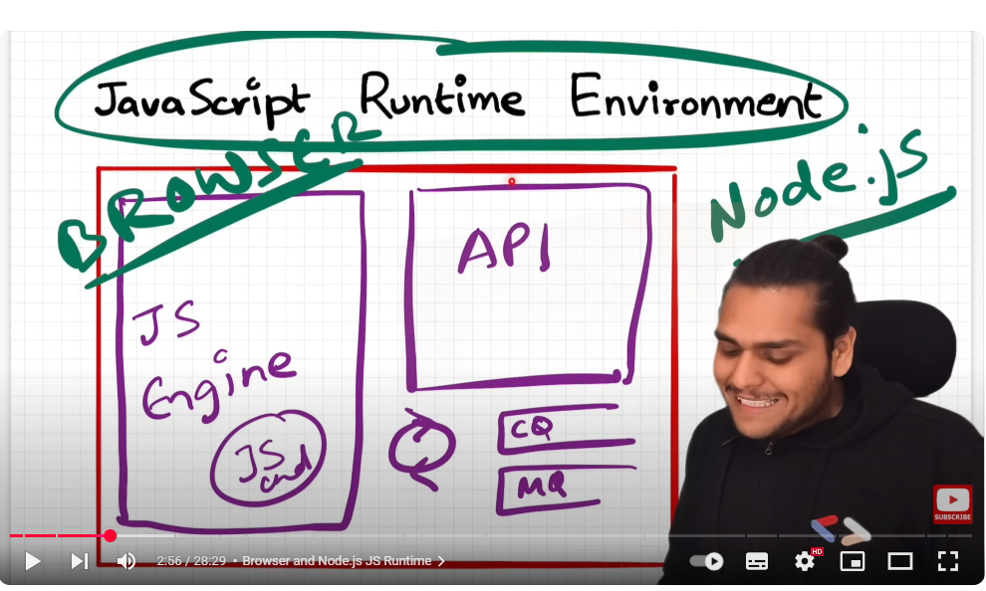

Javascript is capable of running into many devices b/c of this javascript run time environment and these set of APIS give access to super power which we can use inside javascript code. It is different in case of browser , different in node

For e.g:   
javascript run time environment inside browser has an API called **local** **storage** that give us super power of accessing local storage from our code.

Another example setTimeOut  
**setTimeOut** is an API present inside the run time environment of browser as well as node js and same is case with **console**

You can access that outer environment through set of APIS AND YOU CAN JAVSCRIPT PIECE OF CODE INSIDE JAVASCRIPT RUN TIME ENVIRONMENT

# List of javascript engine

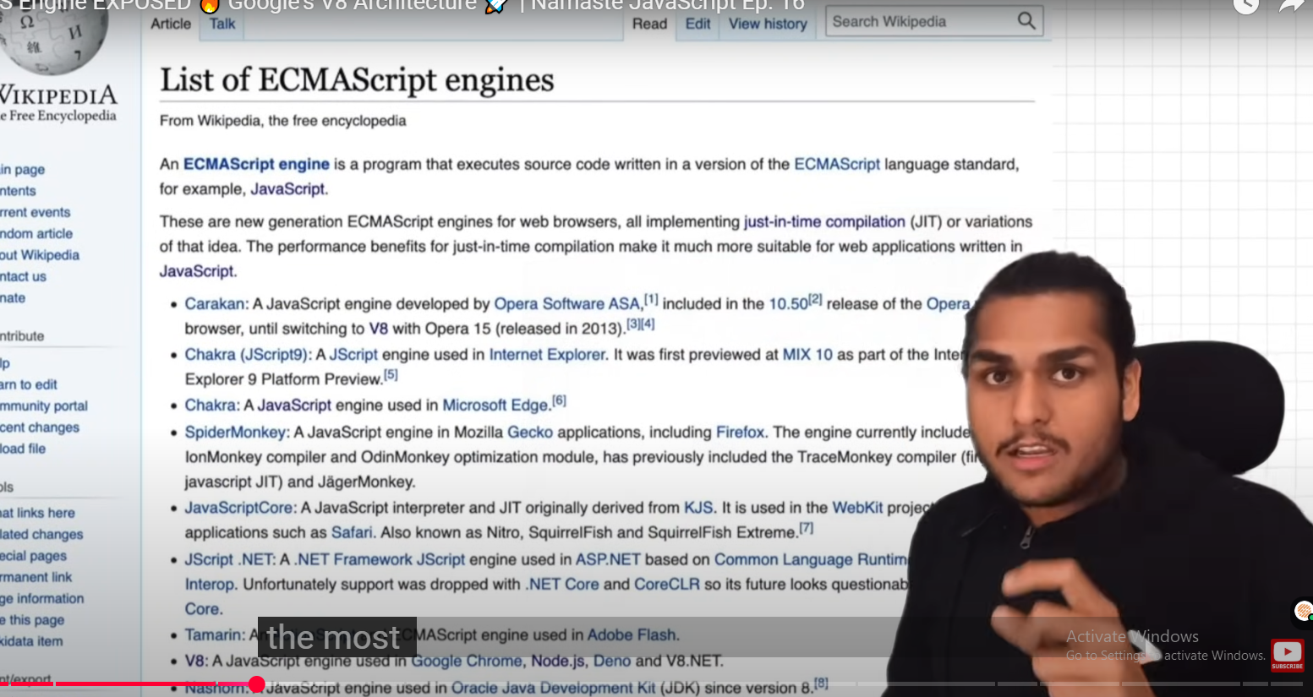

You can create your own js enine

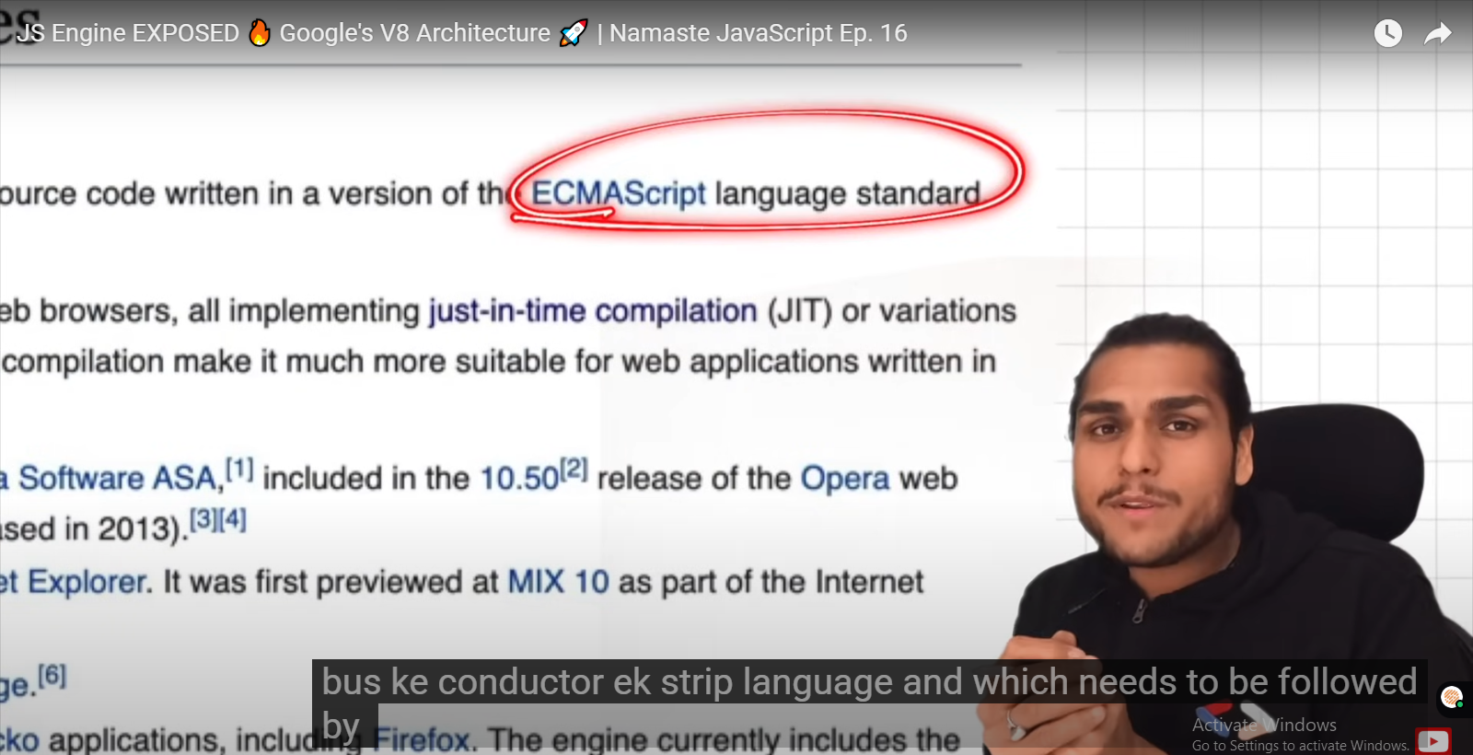

ECMAScript:

is governing body

first js engine: which has now modified a lot

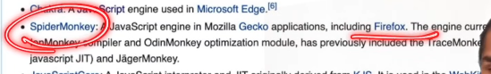

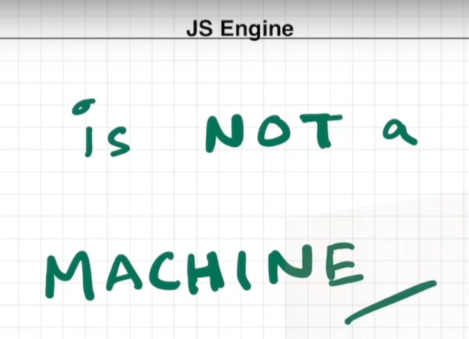

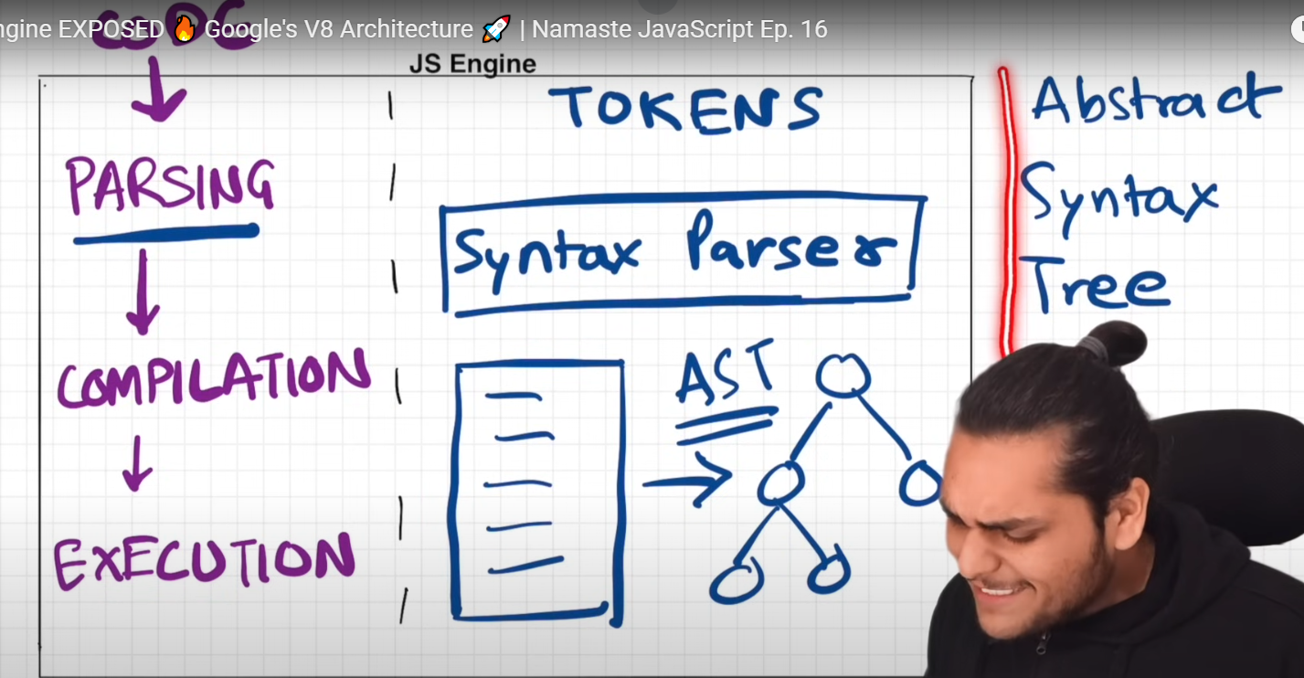

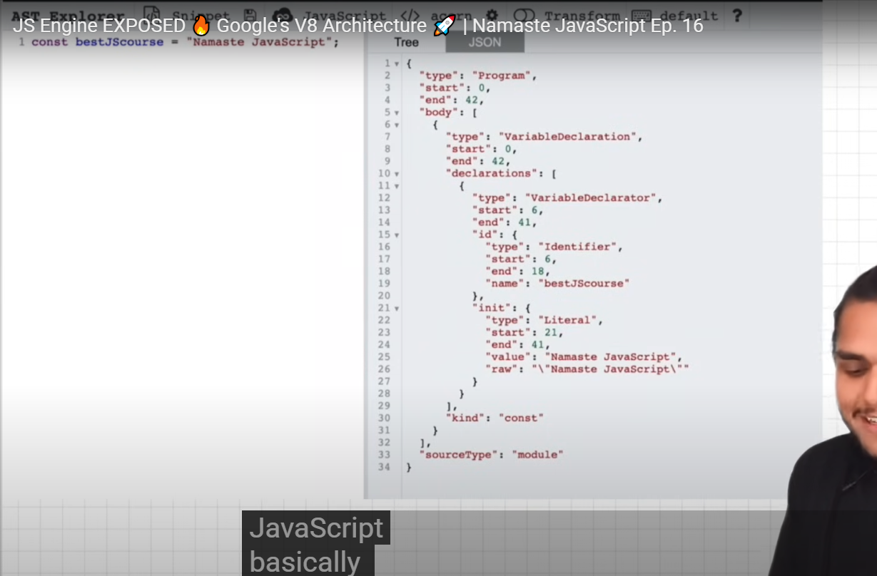

Syntax tree for one line of code

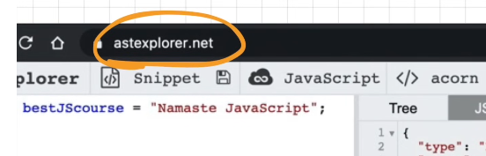

## JIT Compilation:

### Interpreter

Faster

Executes code line by line in order

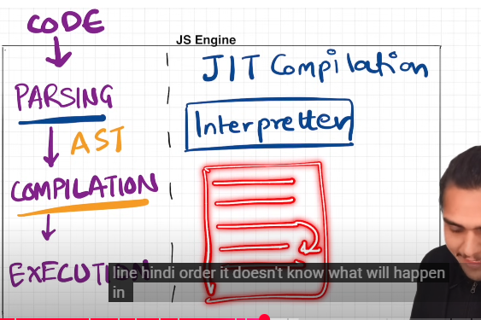

### Compiler

More efficiency

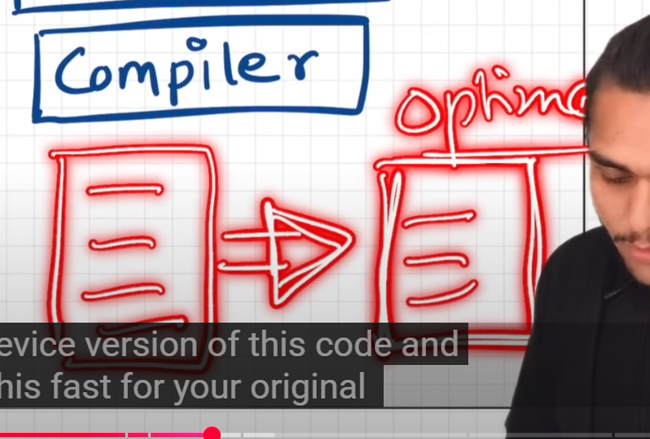

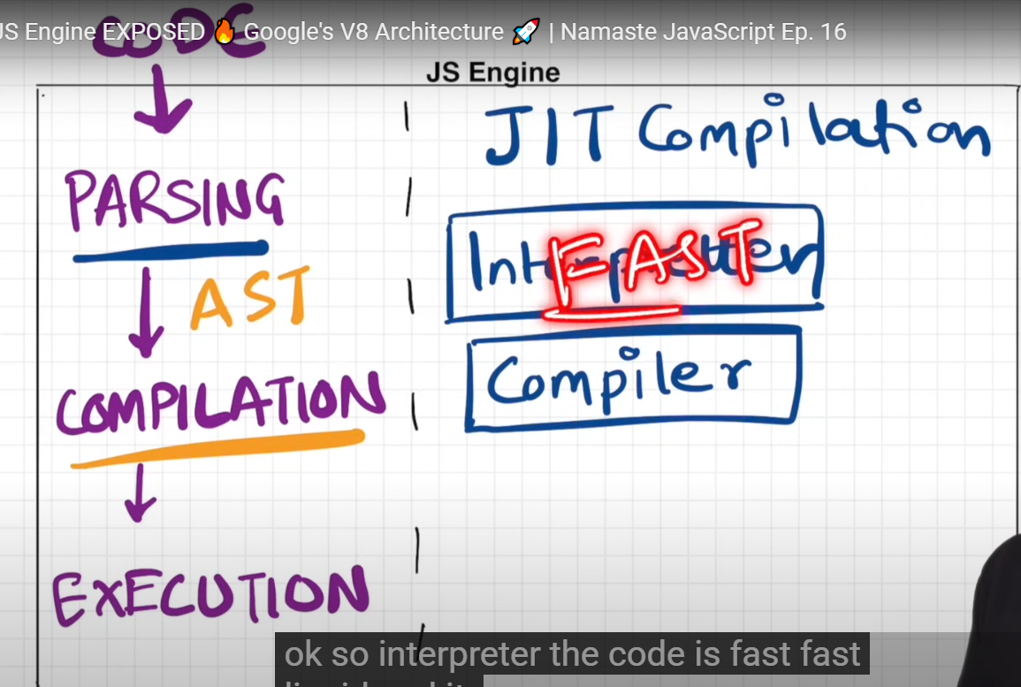

Initially js was interpreter lang but nowadays both compiler and interpreter lang depends on js engine whether its purely an interpreter or both

Just in time compile = interpreter along with compiler

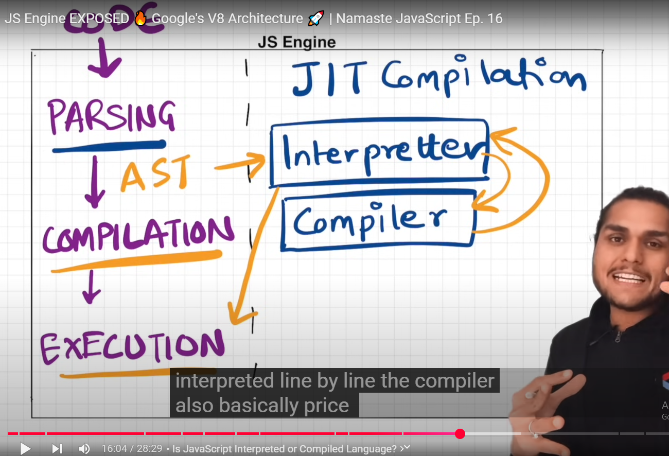

While interpreter runs program line by line , compiler optimizes it the same time , in contact with interpreter, its not just one phase process, it can happen in multiple phases

All js engines have their own algos to do it

Job of compiler is to optimize the code as much as it can on runtime that is why is called JIT compilation

#### AOT: Ahead of time compilation

### Memory heap

### Call stack

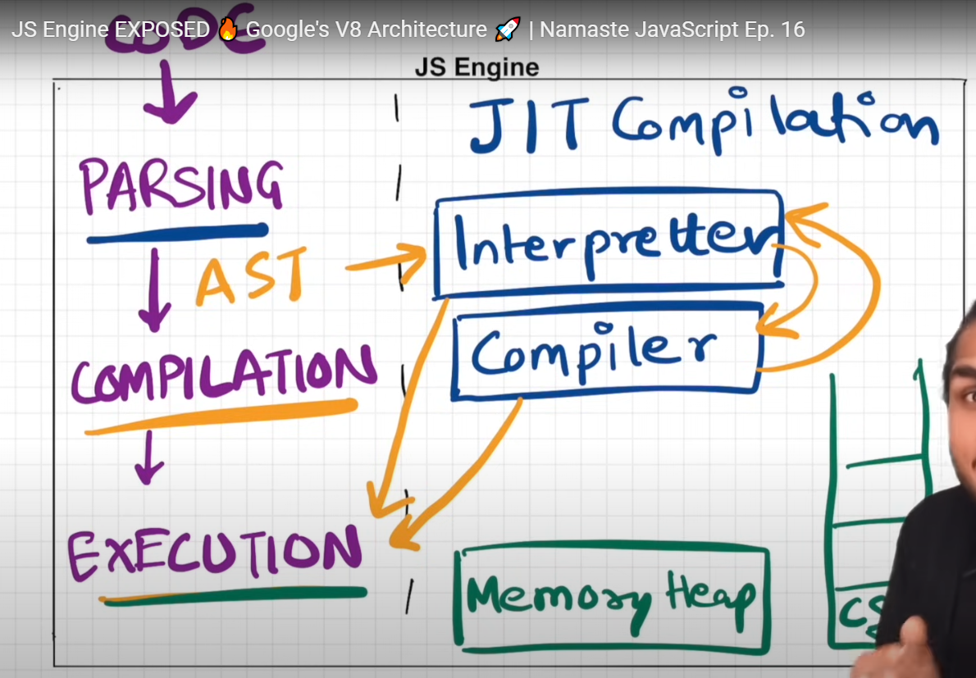

# Higher Order Functions

A **function that takes another function as an argument or return a function from it, is known as higher order function, this is only possible because functions are first-class-citizens in JS**

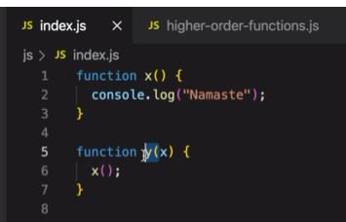

y() is higher order func , x() is the call back function

e.g 2:

suppose an array of radius is given , you need to find area, circumference and diameter of circle for all radii.

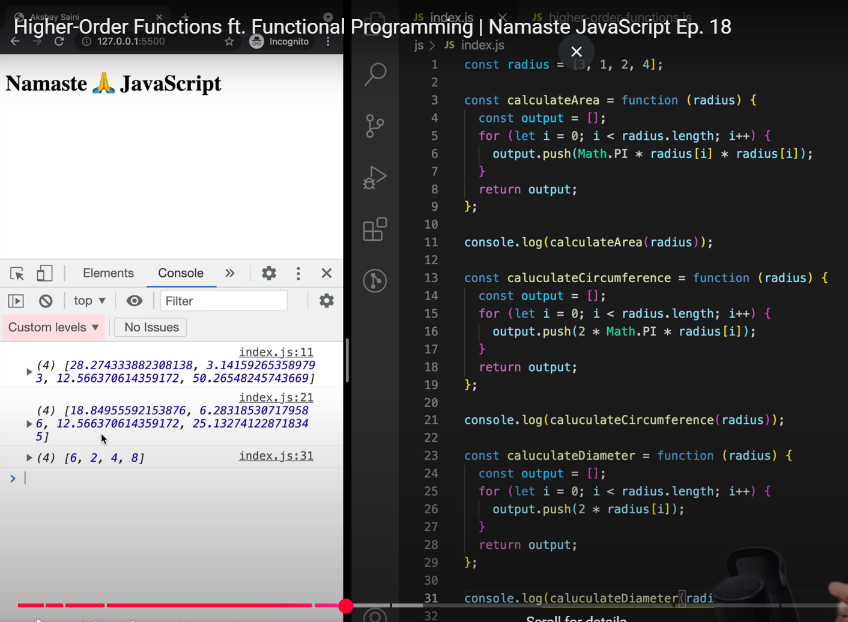

Problem with above code:

1. We are repeating code a lot principle: **DRY(Don’t repeat yourself)**
   1. Only logic is diff for area, circum and diameter , rest of the code is same,

So how to write optimized code for this?

Write a generic function

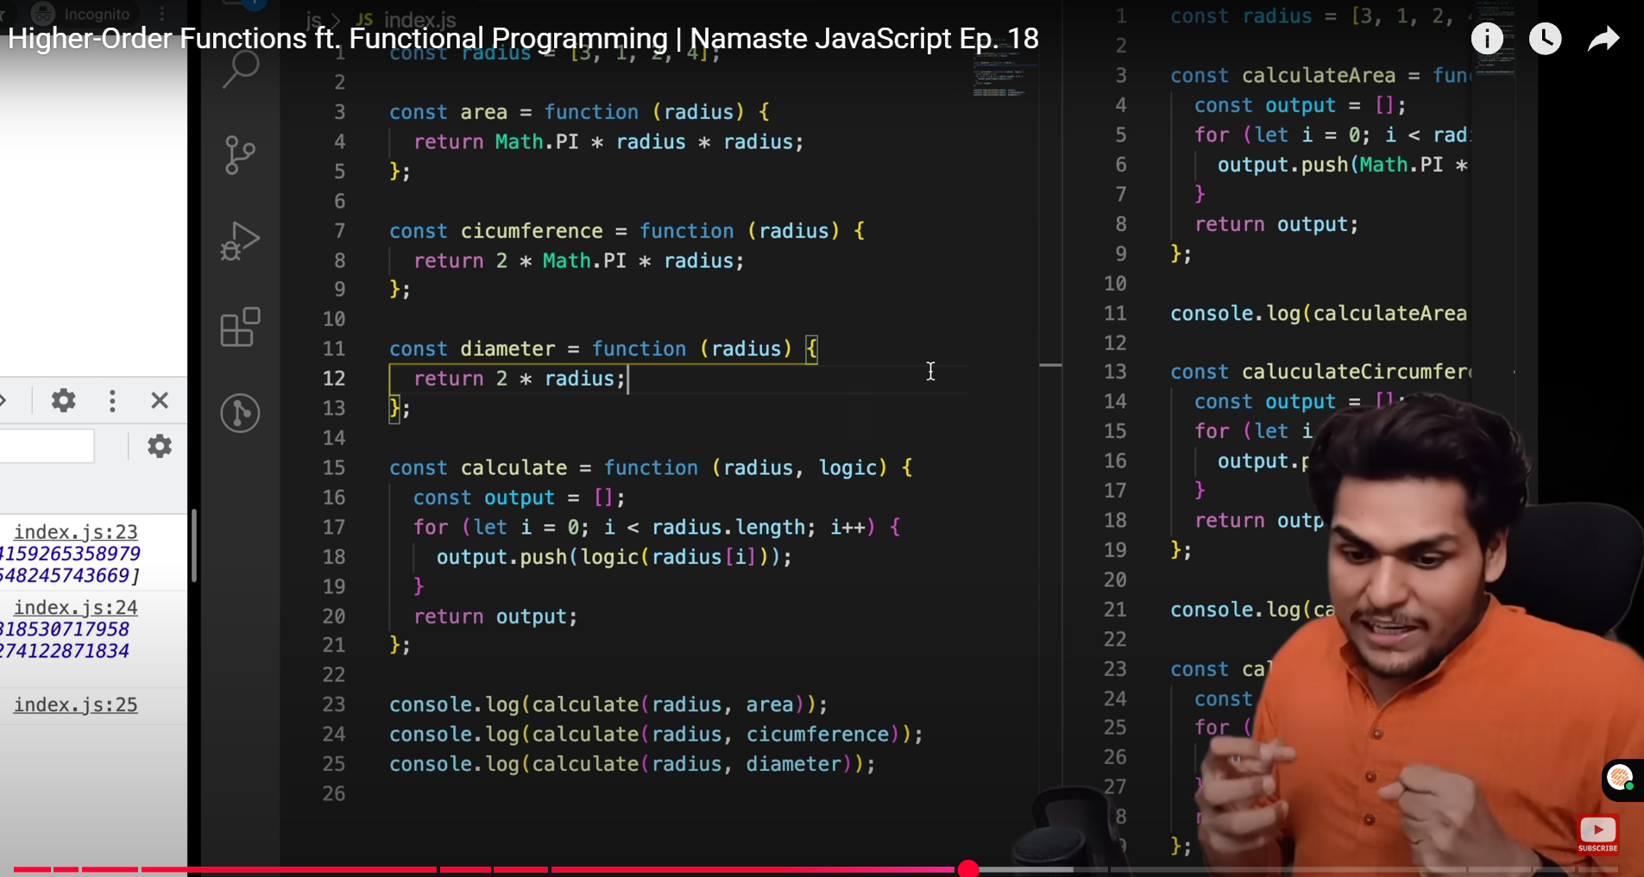

1. We have abstracted our code into smaller functions, we are not repeating anything, every func has simple task to do , beauty of functional programming : think logic into small reusable components which are functions  
   **(reusability, modularity)**
2. **Calculate is Higher Order function, area is call back function**
3. **Map: is HOF >map the whole array with some logic**
   1. 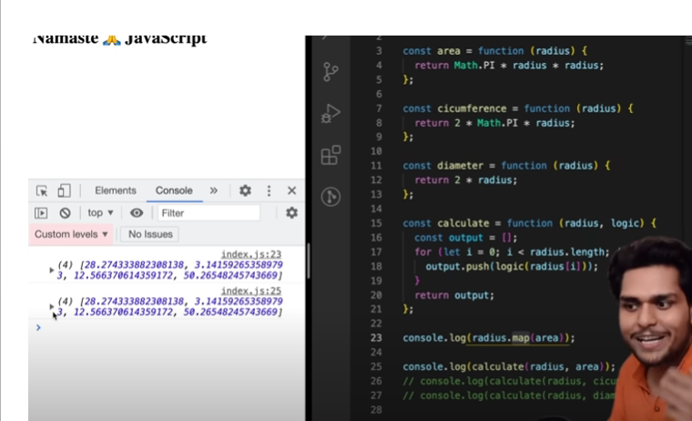
   2. Calculate and map are same func here ; we wrote are implementation of map in calculate
   3. Map creates a new array and iterate on each of the element in array and returns output with logic implemented on each item in array
   4. 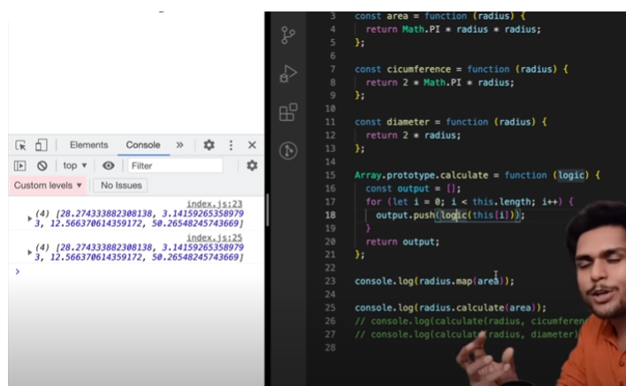
   5. **Study polyfill, array.prototype**

# Coercion:

#### 7. What Is Implicit Type Coercion in JavaScript?

Implicit type coercion is a JavaScript concept that refers to the automatic conversion of a value from one type to another. In JavaScript, this conversion follows a priority order that typically begins with strings, then numbers, and finally booleans. If you try to add a [string to a number](https://builtin.com/articles/javascript-string-to-a-number), JavaScript will implicitly coerce the number to a string before performing the addition operation because strings have the highest priority in type coercion.

For example, when you combine the number 5 with the string '10' using the addition operator, the result is the string '510'. This occurs because JavaScript will implicitly convert the number 5 to a string following the priority of coercion, and then concatenate it to the string '10'.

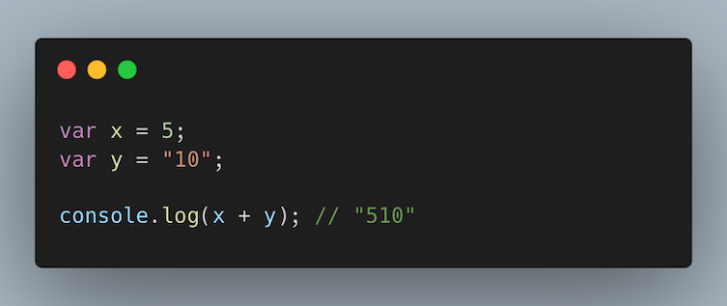

# IIFE: Immediately Invoked Functions

Jo immediately excute hojaye and to remove **global scope population**

**In JavaScript, an Immediately Invoked Function Expression (IIFE) is a function that runs as soon as it is defined. An IIFE involves having a function expression enclosed in parenthesis and then immediately calling the function expression. IIFEs tend to be used to create a local or private scope for variables, preventing them from affecting the global scope in a program.**

e.g:

Let say ham aik file likhte hain aur isme sirf db connection ha aur ham chhate hain jaise hi program run ho / application start ho wo fauran run hojaye  
 **global scope population**

Kai bar scope k ander kuch variables declare hote hain aur ham nhi chahte k function k ander wo variable kuch problem kren , q k child can access parent’s var and func

To avoid global scope population , we create separate scope and let say we want it to be executed immediately.  
syntax:()() 🡪 first paranthesis = function definition , sec paranthesis = execution call   
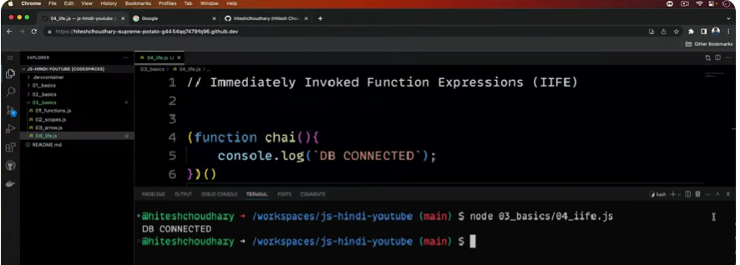

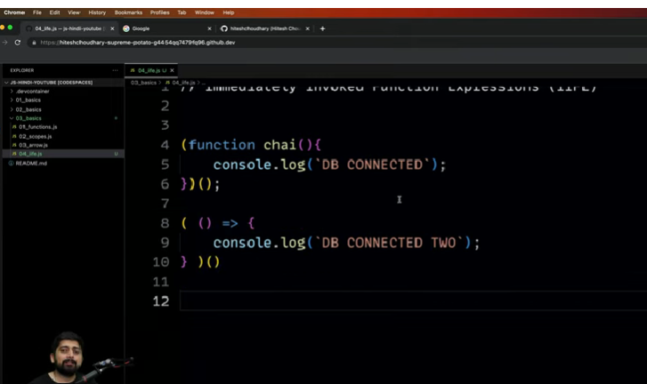

Arrow function can also be written in IIFE func

If we want to pass a parameter:

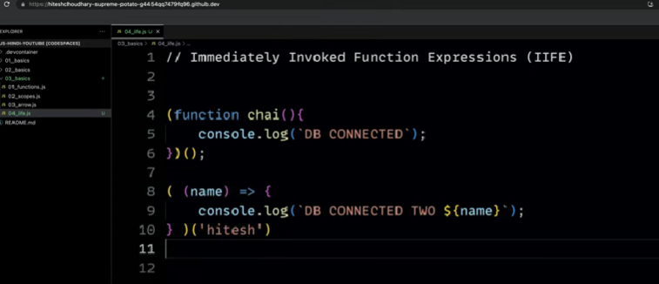

## Named IFFI:

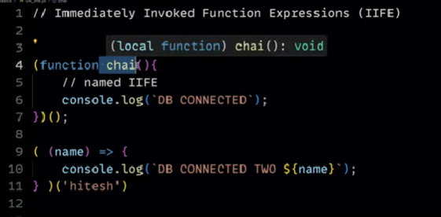

Write two IIFI together:

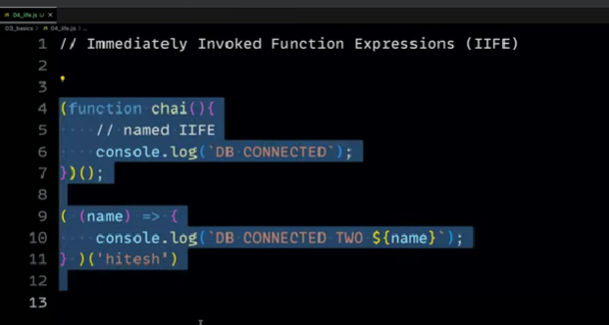

Bs semi colon lagana nhi bhoolna IFFI likhne k baad usse error aayega q k func invoked tou hojayega lakin usey ye nhi pta k context end kahan krna ha tou ; lagana must h.

# Map(), filter(), reduce()

* **Hgher order functions**

## Map()

* Map func is used to transform array
  + what is transformation logic that we need to apply to each ele in array
  + 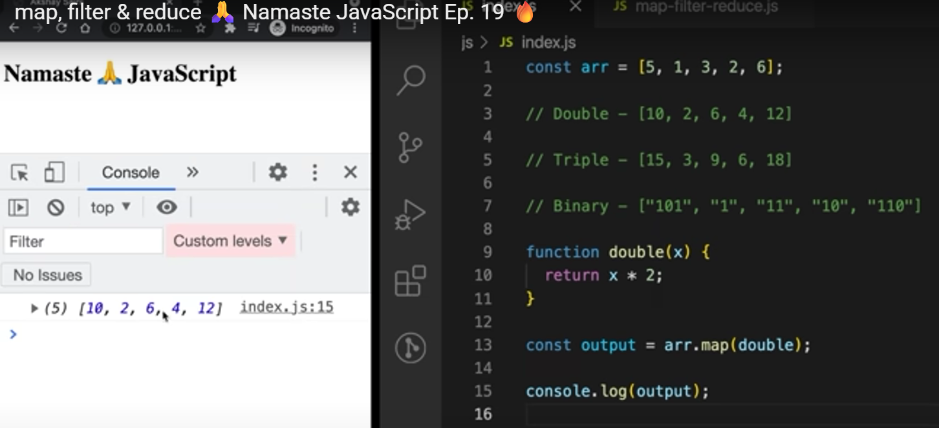
  + 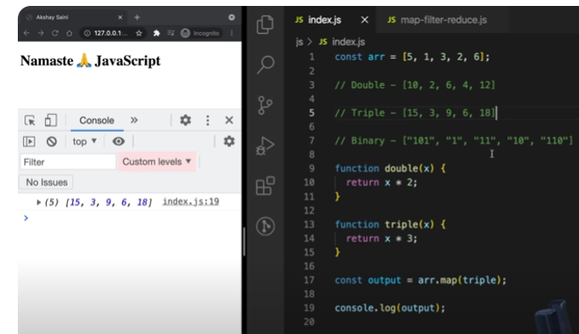
  + 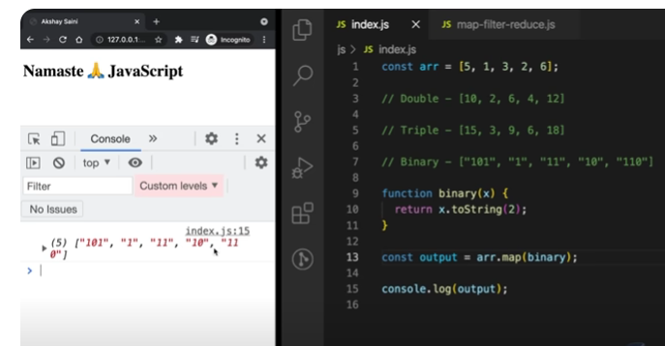
  + 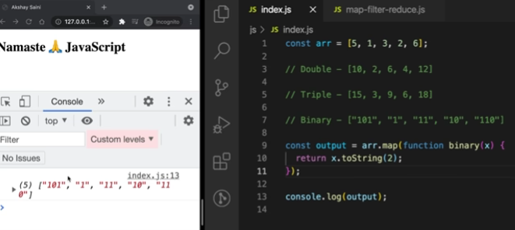
  + 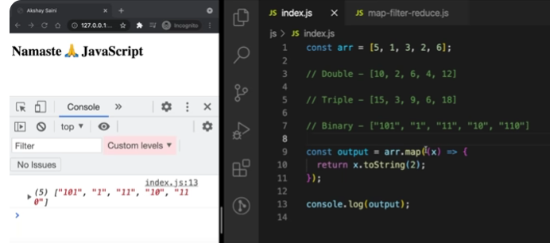
  + 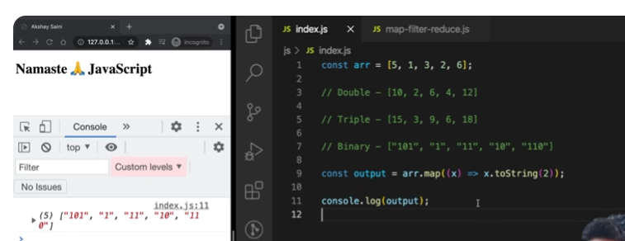
  + **Another real world example:**
  + 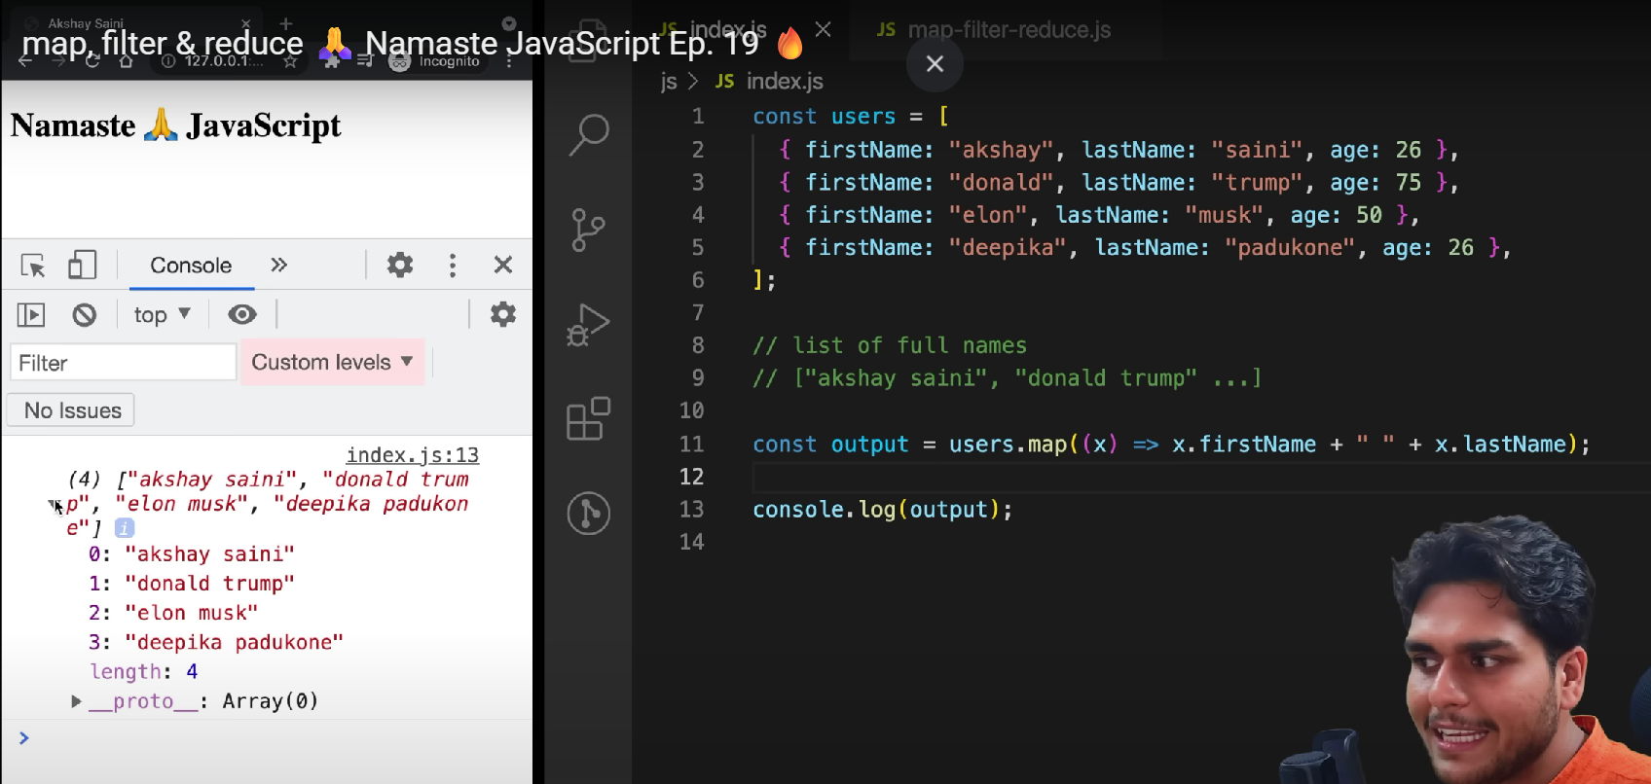

## Filter

* + Filter func is used to filter values inside the array
    - Taking array as input and finding out array which has only values that are filtered based on some logic

## Reduce

* **This function is used in places where you have to take all elements of array and come up with single value out of them**
* 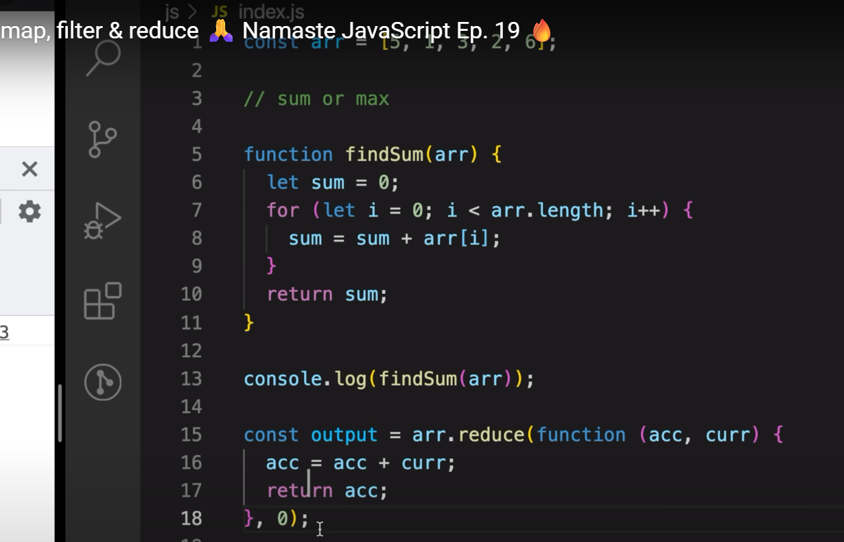
* **1st method in pic: is non-functional programming**
* **2nd method is func prog method: acc= sum variable , curr is iteration counter arr[I] and we need an initial value for sum t**

# This keyword:

#### What Is the Purpose of the “this” Keyword in JavaScript?

The this keyword refers to the object that is executing the current function or method. It allows access to object properties and methods within the context of that object.

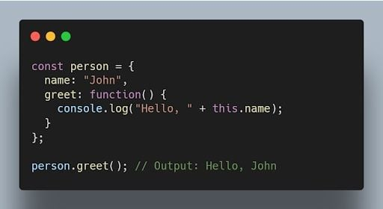

# Bind() method

#### What Is the Purpose of the bind() Method in JavaScript?

The bind() method is used to create a new function with a specified this value and an initial set of arguments. It allows you to set the context of a function permanently.

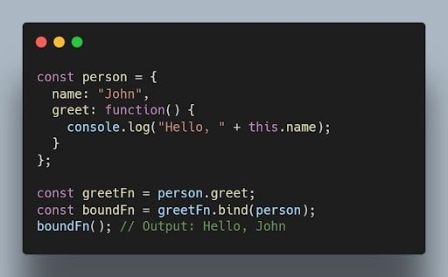

JavaScript's this is dynamic.

bind() locks the this context permanently.

Use it when you pass a method as a callback or want to ensure the method keeps its original context.

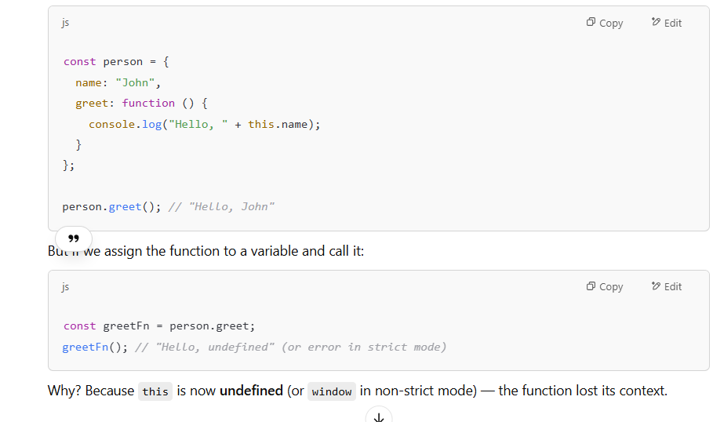

# Constructor Function in JS:

### 🏗️ **What is a Constructor Function in JavaScript?**

A **constructor function** is a **special function** used to create and initialize **multiple objects with the same structure and behavior** (like a class in other languages).

### 📌 **Syntax:**

js

CopyEdit

function Person(name, age) {

this.name = name;

this.age = age;

this.greet = function () {

console.log("Hello, my name is " + this.name);

};

}

const person1 = new Person("John", 25);

const person2 = new Person("Alice", 30);

person1.greet(); // Hello, my name is John

person2.greet(); // Hello, my name is Alice

✅ The new keyword is used to create a new object from the constructor.

### **Why Use Constructor Functions?**

* To avoid **repeating code** for similar objects.
* To create **multiple instances** with their own data.
* For **object-oriented programming** in JavaScript.

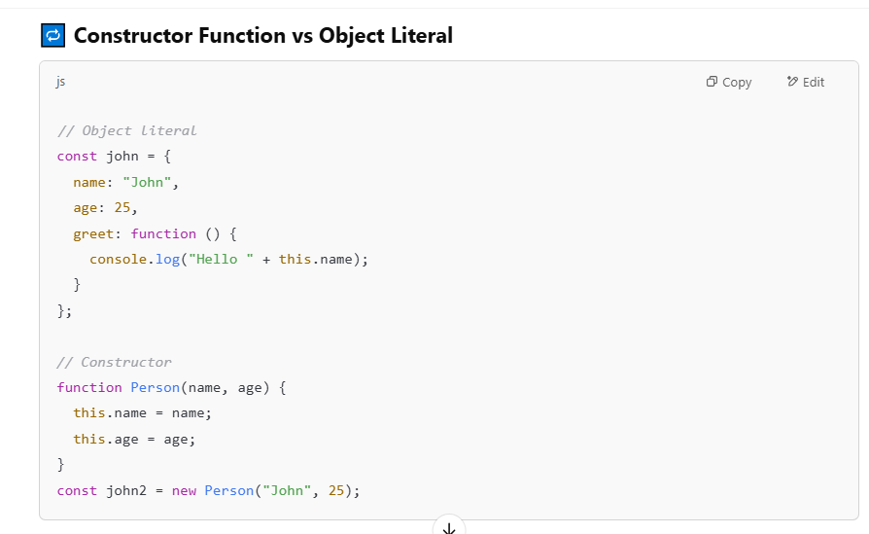

### Bonus: Constructor with Prototype

To avoid duplicating functions for every instance:

js

CopyEdit

function Person(name) {

this.name = name;

}

Person.prototype.greet = function () {

console.log("Hello " + this.name);

};

This saves memory by sharing greet across all instances.

### 🧪 ES6+ Alternative: class syntax

js

CopyEdit

class Person {

constructor(name, age) {

this.name = name;

this.age = age;

}

greet() {

console.log("Hello " + this.name);

}

}

This is **syntactic sugar** over constructor functions — it’s the **modern way**.

### ✅ Summary

| **Term** | **Meaning** |
| --- | --- |
| Constructor Function | A function used to create objects using new |
| Purpose | Reusable object blueprints |
| Modern Alternative | class in ES6+ |
| Common Use | OOP-style JavaScript, creating instances |

# Debouncing in JS

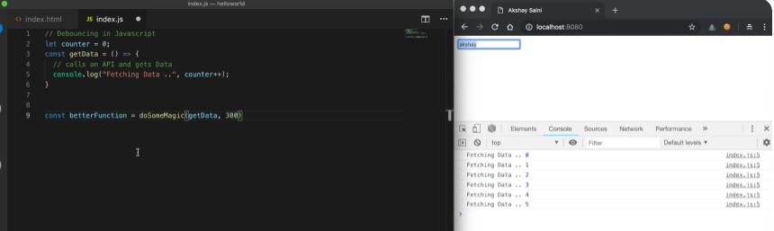

Whenever I press a key stroke, api call made as can be seen  
we should come up with batter function which should actually do some magic onto our getData() method,

What should be magic? It should do some magic onto our getData() don’t make api call again and again on each key stroke rather it should only called when user stop typing

Lets take eg of 300ms so if only difference of time of two key press events > 300ms then only call get Data method or fetch api.

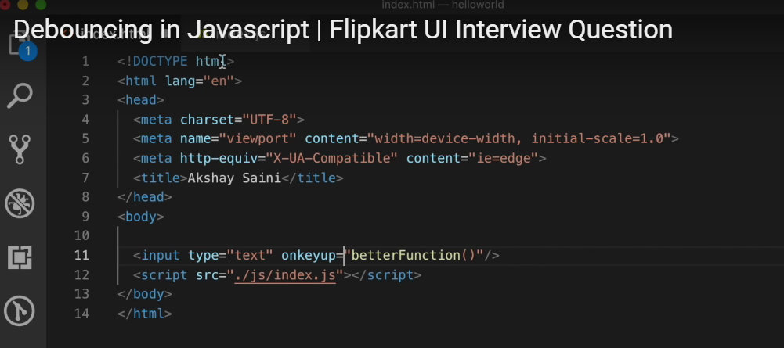

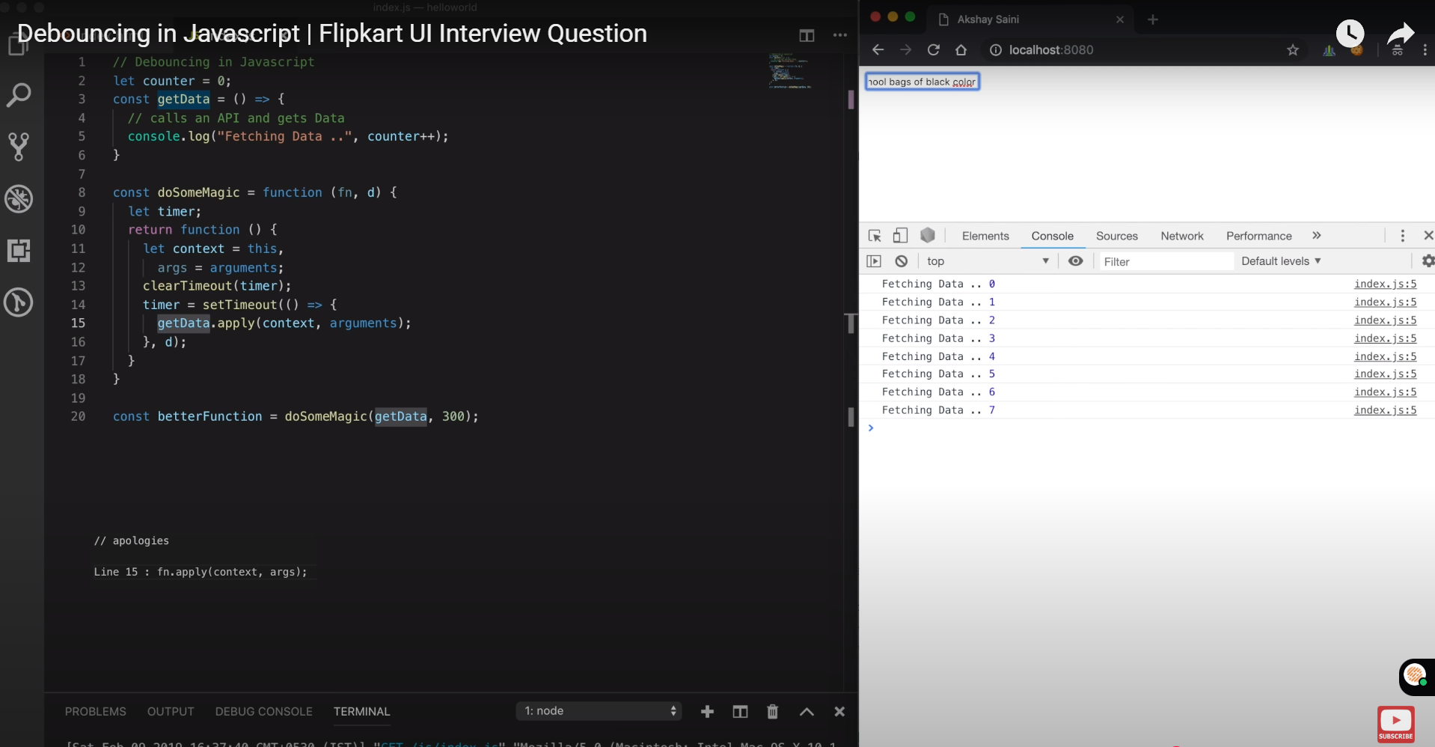

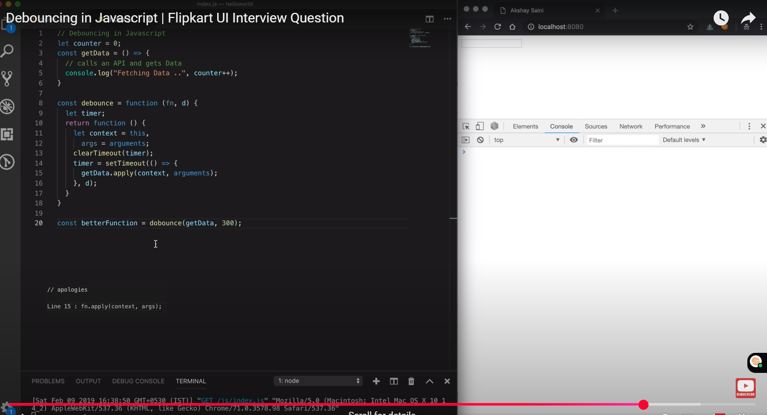

## 📌 What is Debouncing?

**Debouncing** is a programming technique used to limit the rate at which a function is executed. It ensures that the function is called only after a specified period of inactivity. This is particularly useful in scenarios where a function is triggered frequently, such as during user interactions like typing, scrolling, or resizing.[GreatFrontEnd+3GeeksforGeeks+3Devtools Tech+3](https://www.geeksforgeeks.org/debouncing-in-javascript/?ref=lbp&utm_source=chatgpt.com)

## 🧠 Why is Debouncing Important?

* **Performance Optimization**: Reduces the number of times a function is called, thereby improving application performance.
* **Resource Management**: Prevents unnecessary API calls or computations, saving bandwidth and processing power.
* **Enhanced User Experience**: Ensures that applications respond efficiently to user inputs without lag or unnecessary delays.

## 🛠️ How Does Debouncing Work?

When an event is triggered (e.g., a keypress), the debounced function delays its execution until after a specified delay period has elapsed without any new events. If a new event occurs before the delay period ends, the timer resets. This process continues until the events stop, and only then does the function execute.[GreatFrontEnd+3GeeksforGeeks+3Devtools Tech+3](https://www.geeksforgeeks.org/debouncing-in-javascript/?ref=lbp&utm_source=chatgpt.com)

## 🔧 Implementing a Debounce Function in JavaScript

Here's a basic implementation of a debounce function:

javascript

CopyEdit

function debounce(func, delay) {

let timer;

return function (...args) {

clearTimeout(timer);

timer = setTimeout(() => {

func.apply(this, args);

}, delay);

};

}

**Explanation**:

* func: The function to debounce.
* delay: The delay period in milliseconds.
* timer: A variable to store the timeout ID.
* clearTimeout(timer): Clears the existing timer if the function is called again before the delay period ends.
* setTimeout(...): Sets a new timer to execute the function after the delay period.[GreatFrontEnd+3Devtools Tech+3GeeksforGeeks+3](https://devtools.tech/blog/what-is-debouncing-explain-with-examples---rid---bn9IQcem9rnLw7rT6gqk?utm_source=chatgpt.com)

## 📋 Real-World Use Cases

1. **Search Input Fields**: Delay API calls until the user has stopped typing.
2. **Window Resize Events**: Prevent multiple executions of resize handlers during window resizing.
3. **Scroll Events**: Limit the rate at which scroll-related functions are called.
4. **Form Validations**: Validate inputs only after the user has finished typing.[Devtools Tech+1GeeksforGeeks+1](https://devtools.tech/blog/what-is-debouncing-explain-with-examples---rid---bn9IQcem9rnLw7rT6gqk?utm_source=chatgpt.com)[GeeksforGeeks](https://www.geeksforgeeks.org/debouncing-in-javascript/?ref=lbp&utm_source=chatgpt.com)

## ⚠️ Debouncing vs. Throttling

* **Debouncing**: Delays the function execution until after a specified period of inactivity.
* **Throttling**: Ensures the function is executed at regular intervals, regardless of how many times the event is triggered.[GeeksforGeeks](https://www.geeksforgeeks.org/debouncing-in-javascript/?ref=lbp&utm_source=chatgpt.com)

# Throttling

To limit the rate of execution of some function  
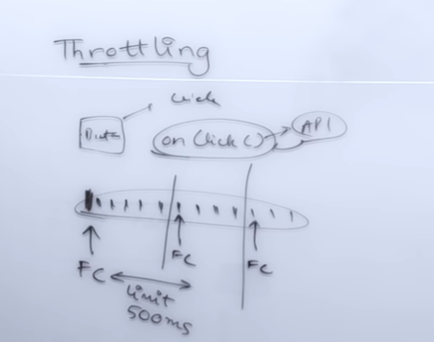

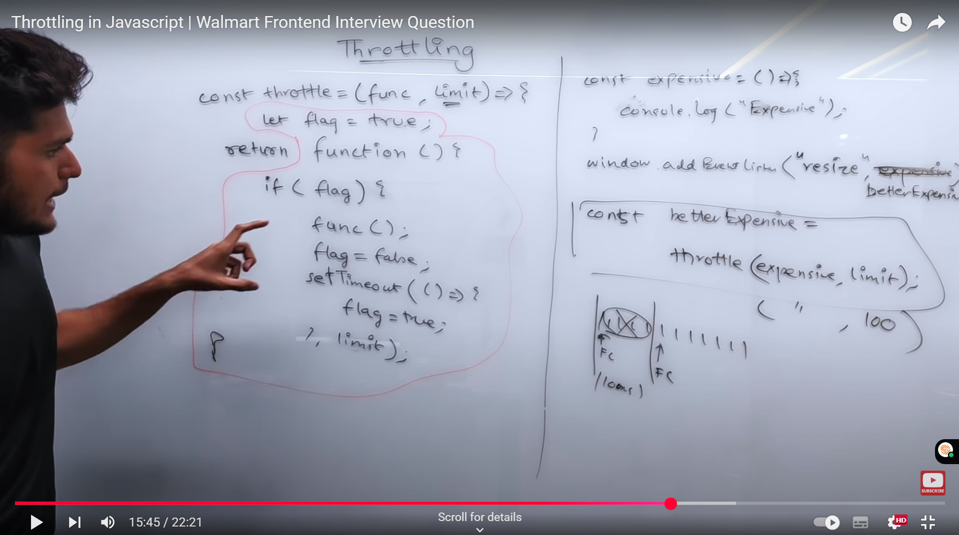

## apply method

## Polyfill for Throttling in JS 📌 What is Throttling?

**Throttling** is a programming technique used to control the rate at which a function is executed. It ensures that a function is called at most once in a specified time interval, regardless of how many times an event is triggered during that interval. This is particularly useful in scenarios where a function is triggered frequently, such as during user interactions like scrolling, resizing, or mouse movements.

## 🧠 Why is Throttling Important?

* **Performance Optimization**: Reduces the number of times a function is called, thereby improving application performance.
* **Resource Management**: Prevents unnecessary API calls or computations, saving bandwidth and processing power.
* **Enhanced User Experience**: Ensures that applications respond efficiently to user inputs without lag or unnecessary delays.

## 🛠️ How Does Throttling Work?

When an event is triggered, the throttled function executes immediately and then ignores subsequent events until the specified time interval has passed. This means that the function is guaranteed to execute at regular intervals, regardless of how many times the event is triggered.

## 🔧 Implementing a Throttle Function in JavaScript

Here's a basic implementation of a throttle function:

javascript

CopyEdit

function throttle(func, delay) {

let lastCall = 0;

return function (...args) {

const now = new Date().getTime();

if (now - lastCall >= delay) {

lastCall = now;

func.apply(this, args);

}

};

}

**Explanation**:

* func: The function to throttle.
* delay: The delay period in milliseconds.
* lastCall: Stores the timestamp of the last function call.
* now - lastCall >= delay: Checks if the specified delay has passed since the last function call.
* func.apply(this, args): Calls the function with the correct context and arguments.[Medium+1LinkedIn+1](https://medium.com/%40thefrontendfeed/throttling-in-javascript-a-complete-frontend-interview-guide-2024-4f9f4514a0f6?utm_source=chatgpt.com)

## 📋 Real-World Use Cases

1. **Scroll Events**: Limit the rate at which scroll-related functions are called.
2. **Window Resize Events**: Prevent multiple executions of resize handlers during window resizing.
3. **Mouse Move Events**: Control the frequency of mouse movement handlers.
4. **API Rate Limiting**: Ensure that API calls are made at a controlled rate.[Medium](https://medium.com/%40thefrontendfeed/throttling-in-javascript-a-complete-frontend-interview-guide-2024-4f9f4514a0f6?utm_source=chatgpt.com)

## ⚠️ Throttling vs. Debouncing

* **Throttling**: Ensures the function is executed at regular intervals, regardless of how many times the event is triggered.
* **Debouncing**: Delays the function execution until after a specified period of inactivity.

# Differences between Debouncing and Throttling

## ⚖️ Debouncing vs. Throttling

| **Feature** | **Debouncing** | **Throttling** |
| --- | --- | --- |
| Execution Timing | Executes after a specified delay of inactivity | Executes at regular intervals |
| Use Case | User stops typing, window resizing | Scrolling, mouse movements |
| Function Calls | Single execution after delay | Multiple executions at specified intervals |
| Control Mechanism | Resets timer on each event | Ignores events during the delay period |

<https://youtu.be/tJhA0DrH5co?si=EgdARpzUE48Amlgm>

## Local Storage, Session Storage and cookies **📊 Comparison Table**

| **Feature** | **sessionStorage** | **localStorage** |
| --- | --- | --- |
| Persistence | Until tab/window closed | Until manually cleared |
| Scope | Same tab/window | All tabs/windows of origin |
| Accessible by JS | Yes | Yes |
| Sent to Server | No | No |
| Use Cases | Temporary data | Persistent data |

### Common JS Design Pattern ✅ **Common JavaScript Design Patterns**

#### 1. **Module Pattern**

* **Use:** Encapsulation, creating private/public methods and variables.
* **Code Example:**

javascript

CopyEdit

const Counter = (function () {

let count = 0;

return {

increment() { count++; },

getCount() { return count; }

};

})();

* **Usage:** Building reusable and maintainable components.

#### 2. **Singleton Pattern**

* **Use:** Ensures only one instance of an object exists.
* **Code Example:**

javascript

CopyEdit

class AppState {

constructor() {

if (AppState.instance) return AppState.instance;

this.state = {};

AppState.instance = this;

}

}

* **Usage:** App-wide state management (like theme, auth).

#### 3. **Observer Pattern**

* **Use:** Implements a pub-sub system (event-driven architecture).
* **Code Example:**

javascript

CopyEdit

class EventEmitter {

constructor() { this.events = {}; }

subscribe(event, fn) {

(this.events[event] ||= []).push(fn);

}

emit(event, data) {

(this.events[event] || []).forEach(fn => fn(data));

}

}

* **Usage:** React component communication, Redux-like state updates.

#### 4. **Factory Pattern**

* **Use:** Creates objects without exposing instantiation logic.
* **Code Example:**

javascript

CopyEdit

function UserFactory(role) {

switch(role) {

case 'admin': return { role, permissions: ['*'] };

case 'user': return { role, permissions: ['read'] };

}

}

* **Usage:** Component or object instantiation based on config/type.

#### 5. **Strategy Pattern**

* **Use:** Selects an algorithm at runtime.
* **Code Example:**

javascript

CopyEdit

const strategies = {

email: () => console.log('Email validation'),

phone: () => console.log('Phone validation'),

};

function validate(type) {

strategies[type]?.();

}

* **Usage:** Form validation, payment processing flows.

#### 6. **Decorator Pattern**

* **Use:** Adds new behavior to objects without modifying them.
* **Code Example:**

javascript

CopyEdit

function addLogging(fn) {

return function(...args) {

console.log('Calling with', args);

return fn(...args);

}

}

* **Usage:** Enhancing functions or components (e.g., HOCs in React).

### 🎯 Real-World Use Cases

* **React/Redux** uses the **Observer**, **Singleton**, and **Module** patterns.
* **Next.js & Angular** use **Factory** and **Dependency Injection** patterns.
* **Reusable component libraries** often follow **Factory** and **Strategy** patterns for flexibility.

# Difference b/w Authentication & Authorization

Authentication verifies a user's identity, while authorization determines what they are allowed to do after being authenticated. In simple terms, authentication answers "who is this user?", and authorization answers "what can this user do?"  
Authorization and Authentication in React:

<https://medium.com/@ghimiresamana666/authentication-and-authorization-in-react-8fc76a496ba0>

* **Set up an Authentication Context:**

Use React's Context API to create an authentication context. This context will manage the user's authentication state and provide login and logout methods.

* **Implement Authentication Components:**

Create components for login and, optionally, logout. The login component should handle user input and authentication logic, potentially using an external authentication service or a custom backend.

* **Create Protected Routes:**

Use a routing library like react-router-dom to create protected routes. These routes will only be accessible to authenticated users. A higher-order component or a custom hook can be used to check the authentication status before rendering the route.

* **Implement Role-Based Authorization (Optional):**

If necessary, implement role-based authorization by storing user roles or permissions and checking them before granting access to specific resources or functionalities.

* **Store Authentication Tokens:**

After successful authentication, store the authentication token (e.g., JWT) securely, such as in local storage or an HTTP-only cookie.

* **Handle API Requests:**

Include the authentication token in the headers of API requests to authenticate the user on the server.

* **Implement Logout Functionality:**

Create a logout function that clears the authentication token and updates the authentication state.

* **Consider Using an Authentication Library:**

For more complex authentication scenarios, consider using an authentication library like Auth0, Okta, or Firebase Authentication.

* **Implement OAuth 2.0:**

To manually implement OAuth in React, install the react-router-dom package for client-side routing and the js-cookie package to save and retrieve access tokens. Then, set up the necessary components and functions to handle the OAuth flow, including redirecting users to the authorization server, exchanging authorization codes for access tokens, and using access tokens to access protected resources.

* **Set up client credentials:**

For setting up client credentials, go to Settings and click on "Client credentials." Generate a client credential by clicking on the relevant button. Copy the values that appear and store them securely. These values will be needed in the next step.

Here's a basic example of how to set up an authentication context and a protected route:

Code

// AuthContext.js  
import React, { createContext, useState, useContext } from 'react';  
  
const AuthContext = createContext(null);  
  
export const AuthProvider = ({ children }) => {  
 const [user, setUser] = useState(null);  
  
 const login = (userData) => {  
 setUser(userData);  
 // Store token in local storage or cookie  
 };  
  
 const logout = () => {  
 setUser(null);  
 // Remove token from local storage or cookie  
 };  
  
 return (  
 <AuthContext.Provider value={{ user, login, logout }}>  
 {children}  
 </AuthContext.Provider>  
 );  
};  
  
export const useAuth = () => {  
 return useContext(AuthContext);  
};  
  
// ProtectedRoute.js  
import React from 'react';  
import { Route, Navigate } from 'react-router-dom';  
import { useAuth } from './AuthContext';  
  
const ProtectedRoute = ({ children }) => {  
 const { user } = useAuth();  
 return user ? children : <Navigate to="/login" />;  
};  
  
// App.js  
import React from 'react';  
import { BrowserRouter as Router, Route, Routes } from 'react-router-dom';  
import { AuthProvider } from './AuthContext';  
import Login from './Login';  
import Home from './Home';  
import Dashboard from './Dashboard';  
import ProtectedRoute from './ProtectedRoute';  
  
const App = () => {  
 return (  
 <AuthProvider>  
 <Router>  
 <Routes>  
 <Route path="/login" element={<Login />} />  
 <Route path="/" element={<Home />} />  
 <Route  
 path="/dashboard"  
 element={  
 <ProtectedRoute>  
 <Dashboard />  
 </ProtectedRoute>  
 }  
 />  
 </Routes>  
 </Router>  
 </AuthProvider>  
 );  
};

# Async / await:

**ALWAYS RETURNS A PROMISE**

async/await is a way to handle asynchronous operations in programming, making them look and behave more like synchronous code. It simplifies asynchronous code by providing a more readable syntax for working with promises, which are objects used to represent the eventual completion or failure of an asynchronous operation.

How it works:

* async:

This keyword is used before a function to indicate that it is an asynchronous function. An async function implicitly returns a promise.

* await:

This keyword is used inside an async function to pause the execution of the function until a promise completes. The await keyword can only be used inside async functions.

* **Promises:**

async/await works with promises. When an await statement is encountered, the function execution pauses, and the program continues when the promise resolves (or rejects).

Benefits of using async/await:

* **Readability:**

async/await makes asynchronous code easier to read and understand because it resembles synchronous code.

* **Error handling:**

async/await allows for using try/catch blocks to handle errors within asynchronous code, making it easier to manage potential issues.

* **Simplified code:**

It reduces the need for callbacks and nested then statements, making the code cleaner and easier to maintain.

Example (JavaScript):

JavaScript

async function fetchData() {  
 try {  
 const response = await fetch('https://example.com/data');  
 const data = await response.json();  
 console.log(data);  
 } catch (error) {  
 console.error('Error:', error);  
 }  
}  
  
fetchData();  
  
NAMASTE JAVASCRIPT:

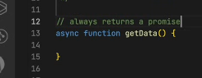

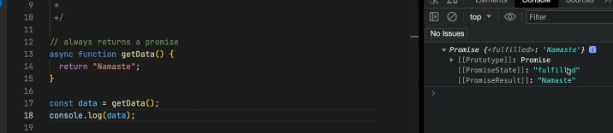

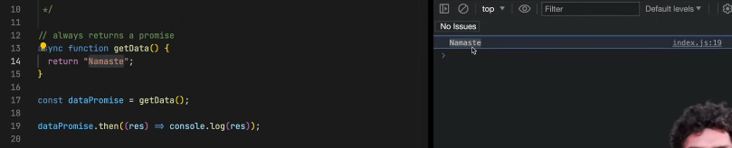

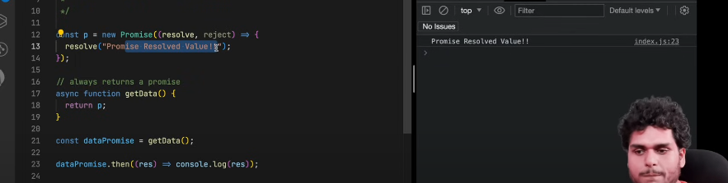

# Design Patterns with example:

<https://youtu.be/YMAwgRwjEOQ?si=46nGhnNMPUlLril5>

The Open/Closed Principle (OCP), a key concept in software engineering, dictates that a software entity (like a class, module, or function) should be open for extension, meaning new functionalities can be added, but closed for modification, meaning the existing, working code should not be changed

## ✅ 1. **Decorator Pattern – Add Features Without Changing Original Code**

### 💡 Purpose:

Ek object ke behavior ko modify ya extend karna bina uski original class ko change kiye.

### 🔧 Example:

Ek notification system hai. Usko log bhi karna hai aur format bhi, lekin original class ko touch nahi karna.

javascript

CopyEdit

class Notification {

send(message) {

console.log("Sending:", message);

}

}

class LoggingDecorator {

constructor(notification) {

this.notification = notification;

}

send(message) {

console.log("Logging message...");

this.notification.send(message);

}

}

const basic = new Notification();

const logged = new LoggingDecorator(basic);

logged.send("Hello!");

## ✅ 2. **Strategy Pattern – Switch Between Different Algorithms or Methods**

### 💡 Purpose:

Alag-alag strategies ko use karna bina main logic ko badle.

### 🔧 Example:

Agar ek payment app hai, jisme user card se bhi pay kar sakta hai, aur PayPal se bhi – to har payment ek strategy hogi.

javascript

CopyEdit

class CardPayment {

pay(amount) {

console.log(`Paid ${amount} with card`);

}

}

class PayPalPayment {

pay(amount) {

console.log(`Paid ${amount} via PayPal`);

}

}

class PaymentProcessor {

constructor(strategy) {

this.strategy = strategy;

}

pay(amount) {

this.strategy.pay(amount);

}

}

const card = new PaymentProcessor(new CardPayment());

card.pay(100); // Paid 100 with card

## ✅ 3. **Observer Pattern – Notify All Listeners When Something Changes**

### 💡 Purpose:

Jab ek object ka state change ho, to sab "subscribed" ya "listening" objects ko notify karo.

### 🔧 Example:

Instagram – jab koi post karta hai, followers ko update milta hai.

javascript

CopyEdit

class Subject {

constructor() {

this.observers = [];

}

subscribe(observer) {

this.observers.push(observer);

}

notify(message) {

this.observers.forEach(obs => obs.update(message));

}

}

class Follower {

constructor(name) {

this.name = name;

}

update(message) {

console.log(`${this.name} received: ${message}`);

}

}

const user = new Subject();

const f1 = new Follower("Ali");

const f2 = new Follower("Sara");

user.subscribe(f1);

user.subscribe(f2);

user.notify("New post uploaded!");

## ✅ 4. **Module Pattern – Group and Protect Related Code**

### 💡 Purpose:

Functions aur variables ko **encapsulate** karo taake wo globally accessible na hoon (i.e., privacy + organization).

### 🔧 Example:

Ek calculator app banani hai jisme kuch private logic ho aur kuch public methods.

javascript

CopyEdit

const CalculatorModule = (function () {

let secret = 42; // private

function add(a, b) {

return a + b;

}

return {

add: add,

getSecret: () => secret

};

})();

console.log(CalculatorModule.add(2, 3)); // 5

console.log(CalculatorModule.secret); // undefined

## ✅ 5. **Factory Pattern – Create Objects Without** new **Keyword Logic Everywhere**

### 💡 Purpose:

Alag-alag type ke objects banani hoon but new keyword na ghoomayein har jaga.

### 🔧 Example:

Ek pet app jisme Dog aur Cat dono hain – factory use karke object banayein.

javascript

CopyEdit

class Dog {

speak() {

console.log("Woof!");

}

}

class Cat {

speak() {

console.log("Meow!");

}

}

class AnimalFactory {

static createAnimal(type) {

if (type === "dog") return new Dog();

if (type === "cat") return new Cat();

}

}

const pet1 = AnimalFactory.createAnimal("dog");

pet1.speak(); // Woof!

## 🔍 **Summary: Difference in One Line Each**

| **Pattern** | **One-Liner** |
| --- | --- |
| **Decorator** | Add extra behavior to an object without changing it. |
| **Strategy** | Switch between different algorithms or actions at runtime. |
| **Observer** | One-to-many subscription — when one changes, notify all. |
| **Module** | Organize and protect your code (encapsulation). |
| **Factory** | Create objects based on conditions without using new directly. |

# ASYNCHRONOUS PROGRAMMING

<https://youtu.be/d3jXofmQm44?si=n4MompV-lUa-R9p3>

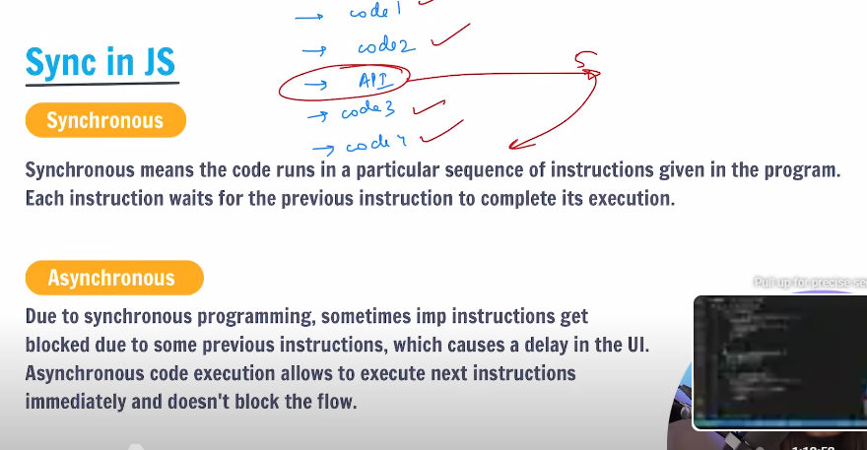

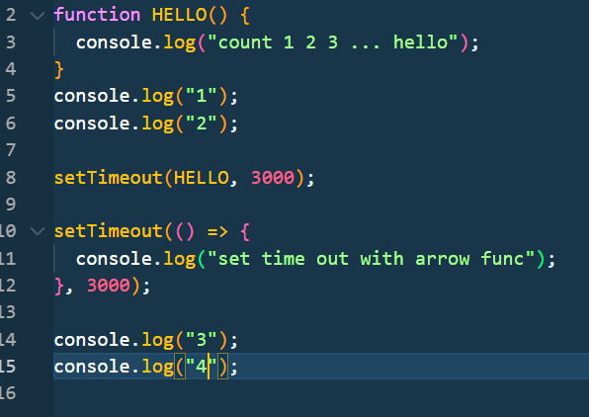

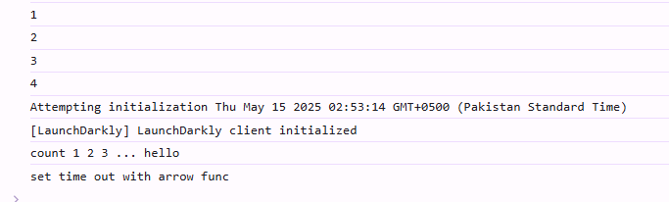

# Callback Hell

Take e.g of taking data from database

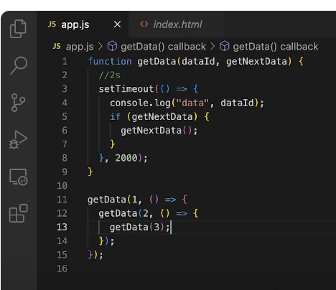

Ham chahe hain pehla data aaye phir 2 sec baad doosra data aaye phir 2 sec baad teesra aaye upto so on……….

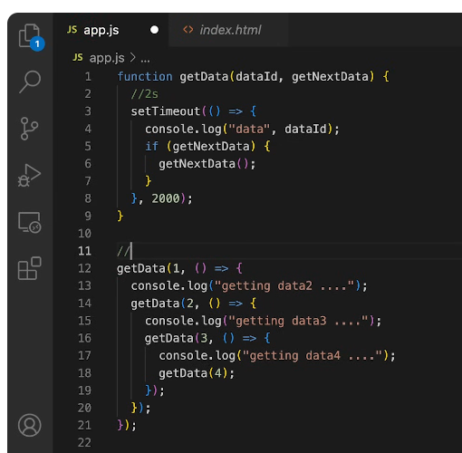

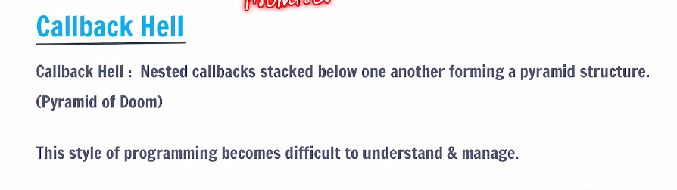

# Solution: promises

#### What Are Promises in JavaScript?

Promises are objects used for asynchronous operations. They represent the eventual completion or failure of an asynchronous operation and allow chaining and handling of success or error cases.

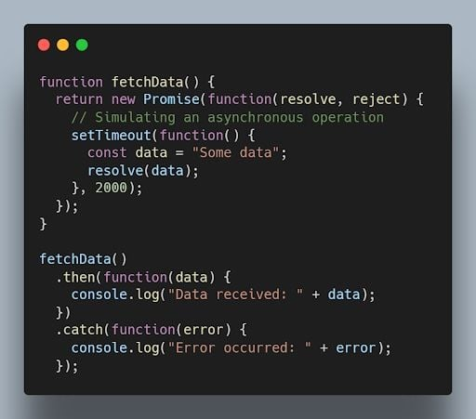

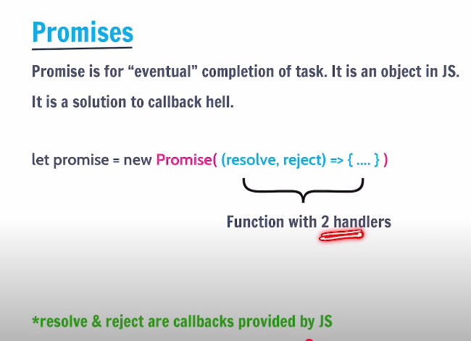

Resolve and reject are also call backs

3 states of promise:

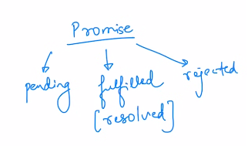

Take an online order from Amazon, ya tou order receive hojayega kuch time baad means fulfilled hojayea promise ya reject hojayega aur paise wapis miljaynge hamare.

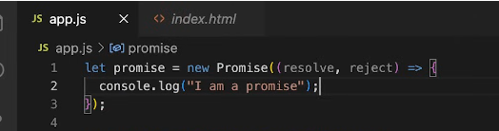

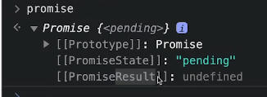

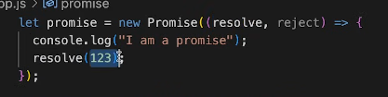

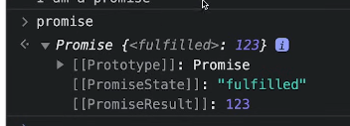

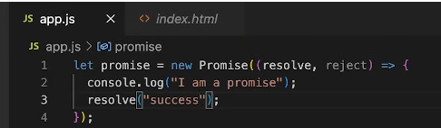

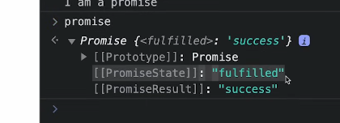

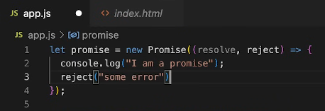

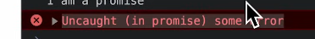

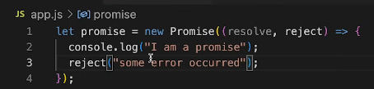

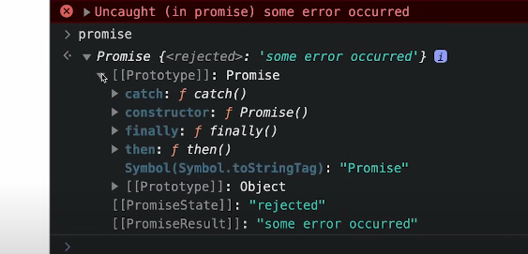

Lets take an example to get data from API:

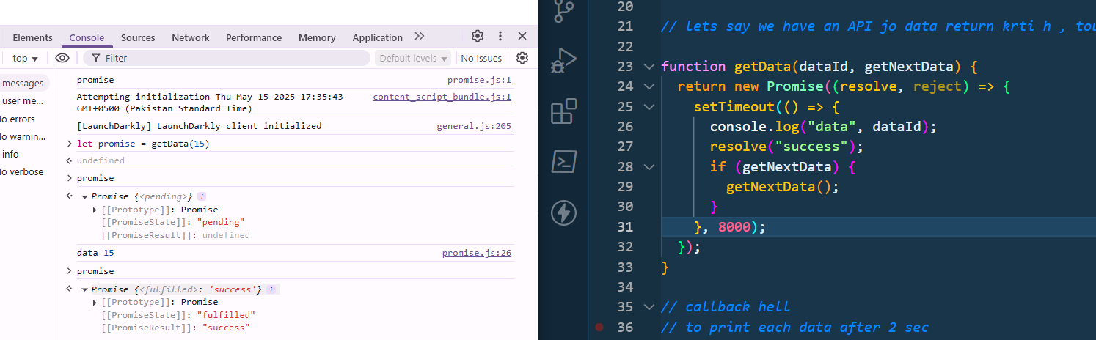

Yahn kia horaha hm aik getData ka function call kr rahe from API ab ye api time lagati ha data lane me but ye hame aik promise return krti hain immediately k ma wada kr raha hun 8 sec baad tumhe data return krdoonga tou hum iska wada hi rakhlenge means promise hi save karalete hain, jab tak data nhi aaya promise pending ha jaise console karake dekha upper(yani jb tk ye setTime execute nhi hota tab tak data pending ha) aur jaise hi isne data console krwaya tou hamne next line resolve ki likhi wi ha with a success msg tou state hamari khud update hojayegi fulfill and msg success ka print hojayega

General programming me promise ham khud create nhi krte hame return hoke milta ha,

## How to handle promise?

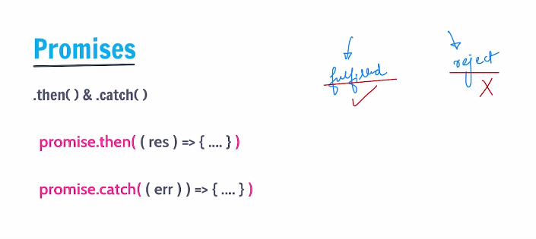

.then ka fuc Tabhi execute hoga jb promise fulfilled hoga

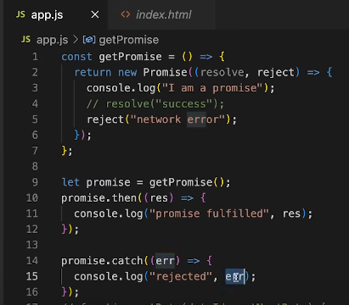

Lets say aik func a getPromise jo prmise return krta ha phir hamne promise ko call kia .then jab chaleg jab promise fulfil hoga  
aur catch jab chalega jab reject hoga

res and err are buitlin param aur inme wo value pass hoti ha jo hamne , msg pass kye the fulfill ya reject k case me

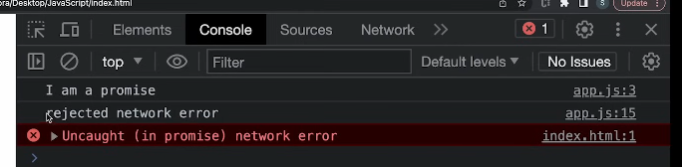

## setTimeOut:

#### What Is the Purpose of the setTimeout() Function in JavaScript?

The setTimeout() function is [used to delay the execution](https://builtin.com/software-engineering-perspectives/javascript-sleep) of a function or the evaluation of an expression after a specified amount of time in milliseconds.

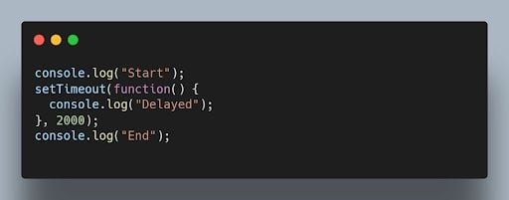JavaScript setTimeout() function code. | Image: Akshay Kumar

Output after two seconds:

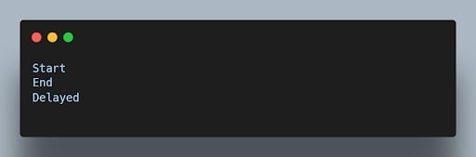

## Promise chain:

Jo kam ham call back se kr rahe the wo promise se bhi krsakte hain with lesser code 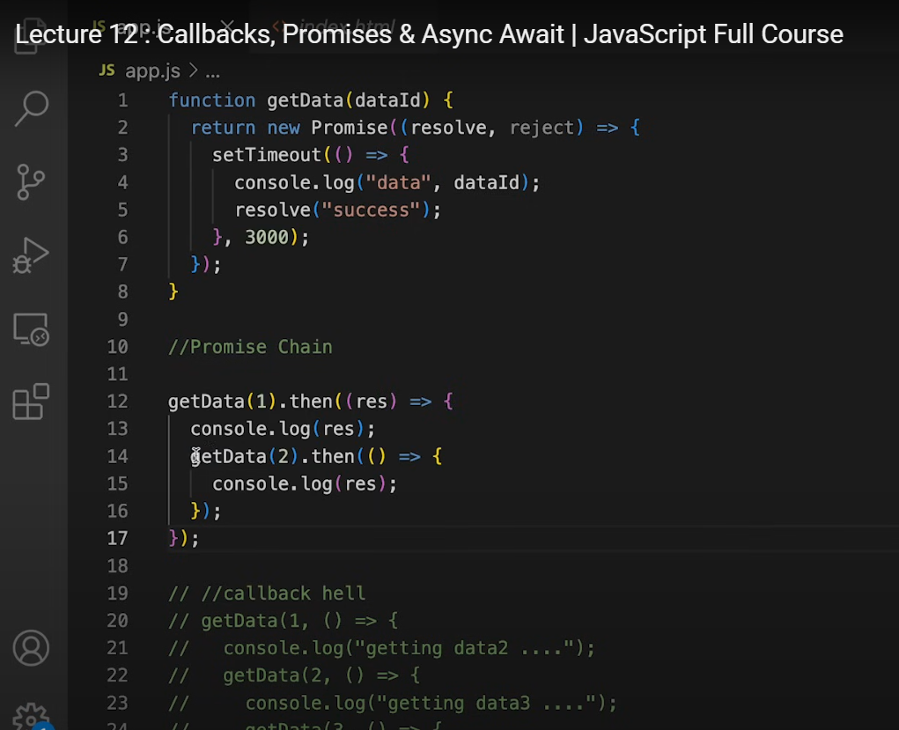

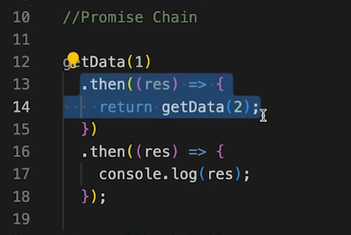

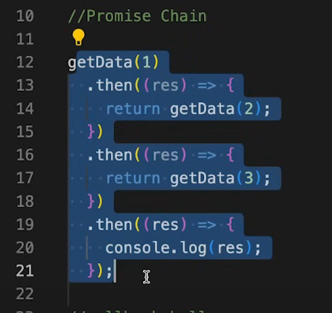  
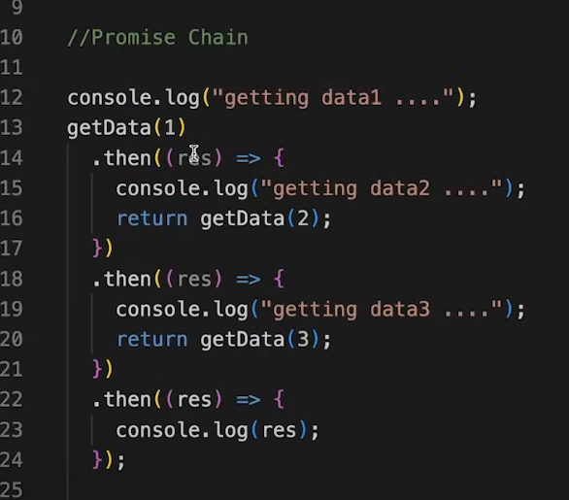  
still jab yahan bhi line of codes hongi lets say console ki line aagai everytime tou ye code bhi messy hojayega. Promise chain is also difficult to understand.  
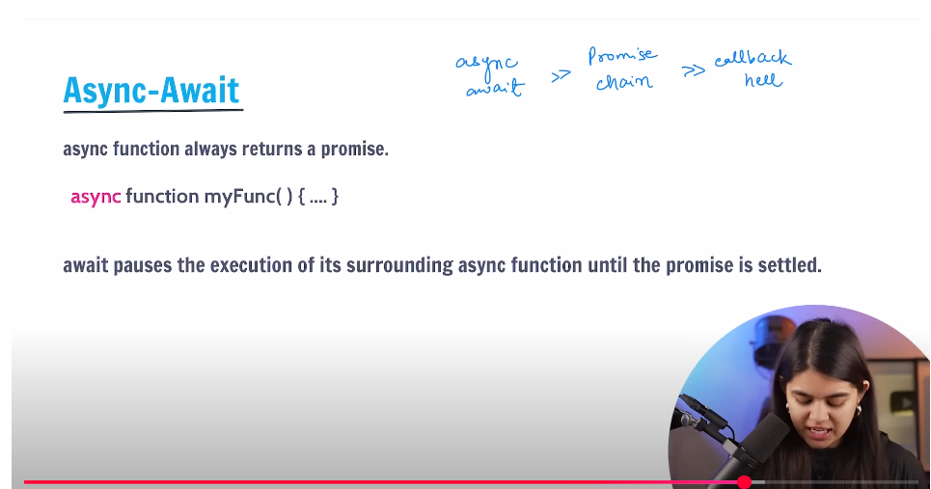

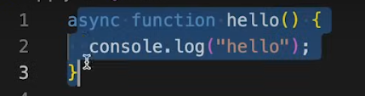

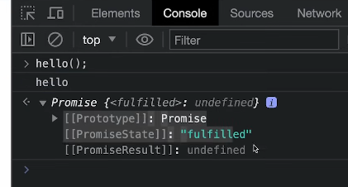  
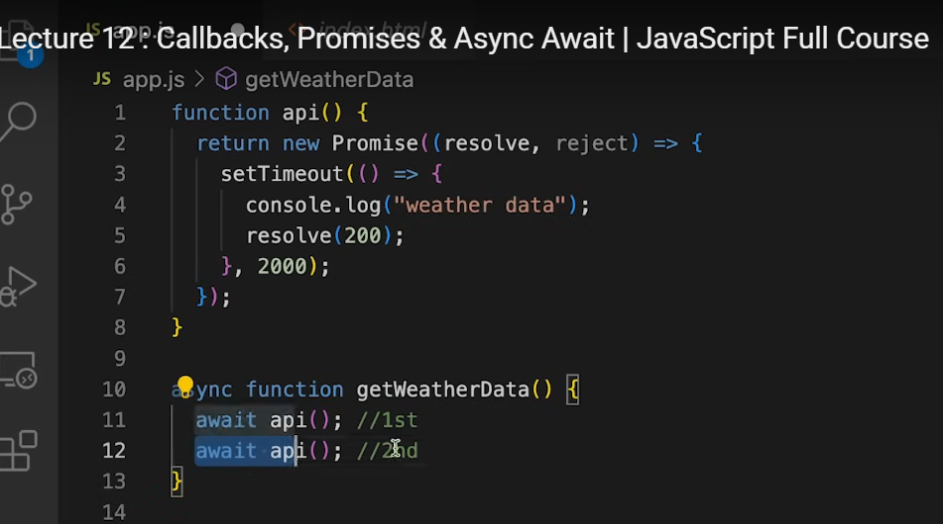  
hamari main probem statement ye thi k aisa kia kren let say k aik data print ho phir 2 sec ka pause aaye phir 2nd data print ho phir 2 sec ka delay aaye phir 3rd…. iso ham pehle call back then promise chain k through achieve kr rahe the  
e.g Instagram pe pehle username check ho agr exist krta ho phir hi password cck hoga

**Await :to wait; jab tk ye kam na hojaye aage nhi brhna**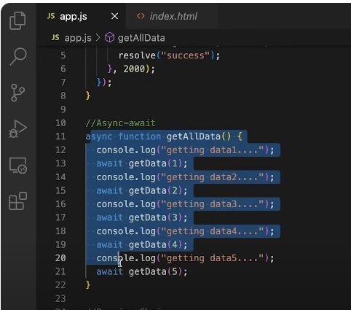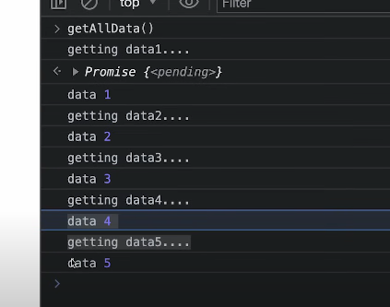

**Note:** jab bhi hm async await use krte hain, hame is code ko aik function k ander daalna parta ha aur pir us func ko call krna parta ha 🡪 to avoid this unnecessary call we use IIFE  
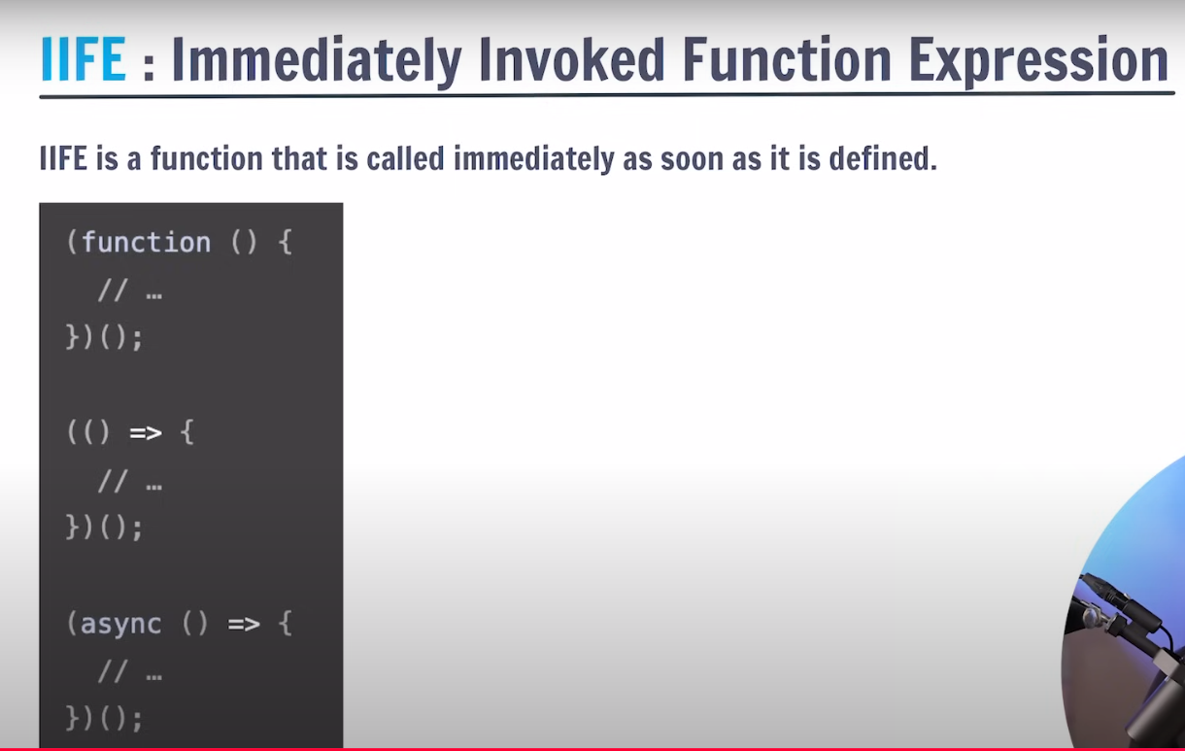

IIFE function hote hain unka koi name nhi hota, aur wo function aik hi bar use hote hain, one time likhe jate hain aur jahana likhe jate hain wahin execute hojate hain  
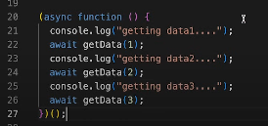  
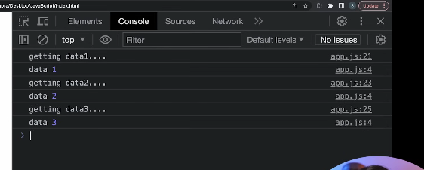  
  
for api calls 🡪 use IIFE  
It is also known as a self-executing anonymous function.  
[**https://developer.mozilla.org/en-US/docs/Glossary/IIFE**](https://developer.mozilla.org/en-US/docs/Glossary/IIFE)

# Async/await:

#### What Is the Purpose of the async and await Keywords in JavaScript?

The async and await keywords are used for handling asynchronous operations in a more synchronous-like manner. The async keyword is used to define an asynchronous function, and the await keyword is used to pause the execution of an async function until a promise is fulfilled or rejected.

Example:

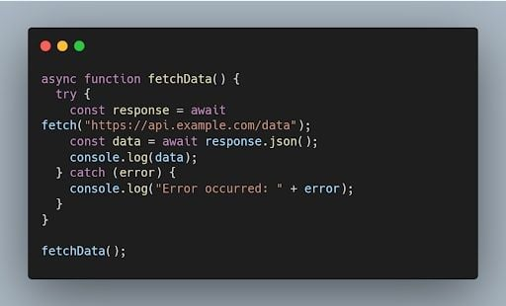

# Generator Function:

#### What Is a Generator Function in JavaScript?

A generator function is a special type of function that can be paused and resumed during its execution. It allows generating a sequence of values over time, using the yield keyword.

Example:

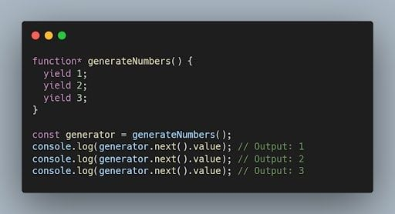

# Event Bubbling:

#### Explain the Concept of Event Bubbling in JavaScript.

Event bubbling is the process where an event triggers on a nested element, and then the same event is propagated to its parent elements in the document object model (DOM) tree. It starts from the innermost element and goes up to the document root.

Example:

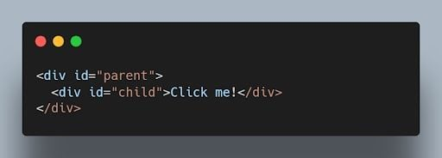JavaScript code using event bubbling. | Image: Akshay Kumar

When you click on the child element, both the child and parent event handlers will be triggered, and the output will be:

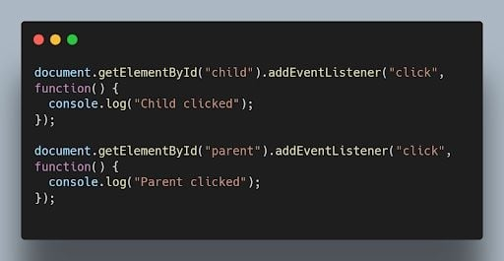

# Fetch API

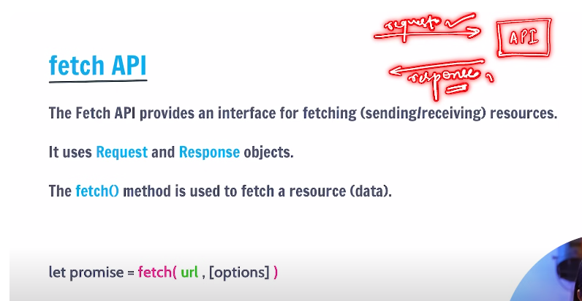

FETCH returns a promise.

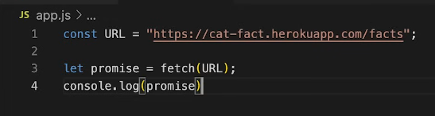



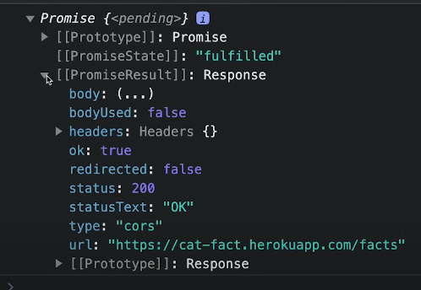  
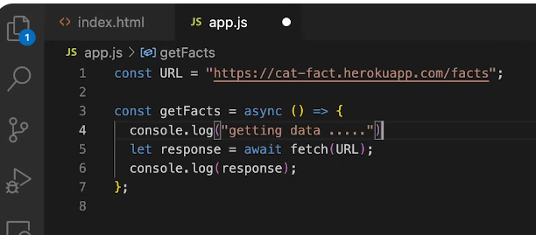  
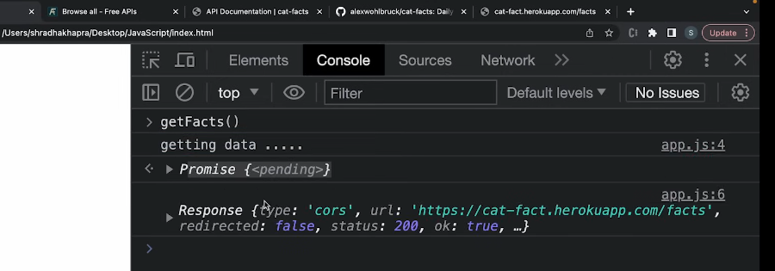  
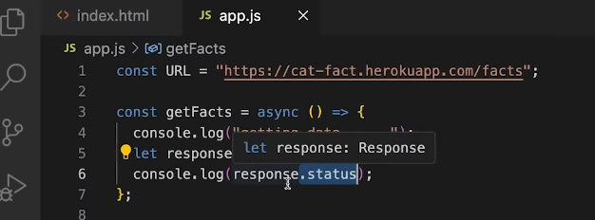

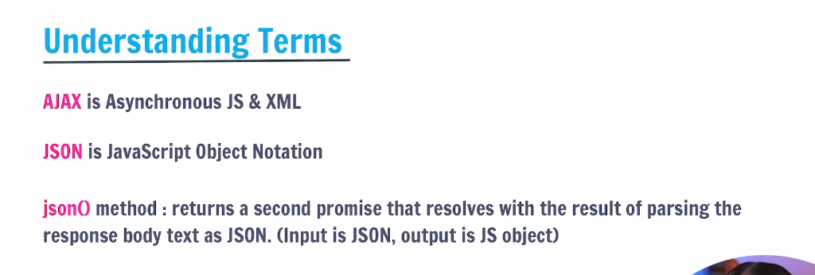  
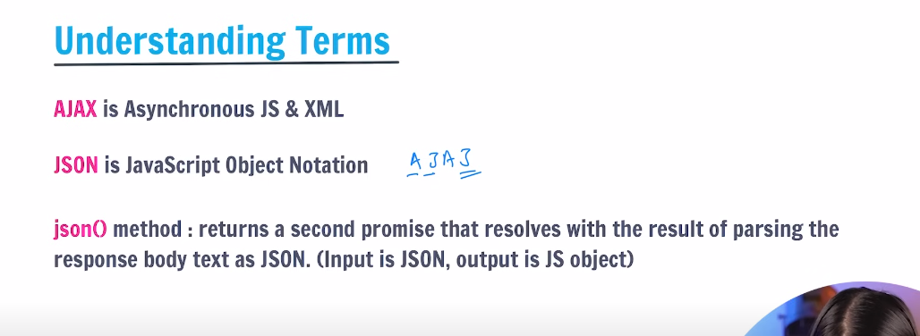  
AJAJ: Asynchronous JavaScript and JSON   
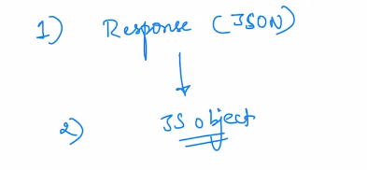  
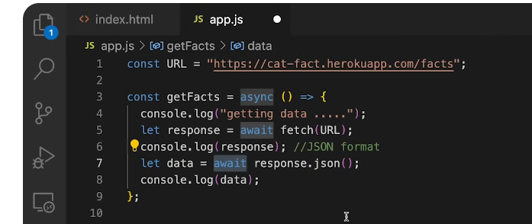  
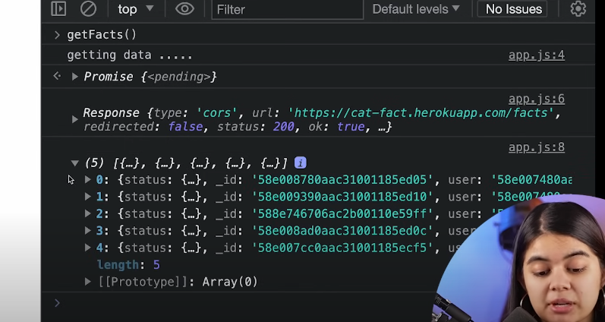  
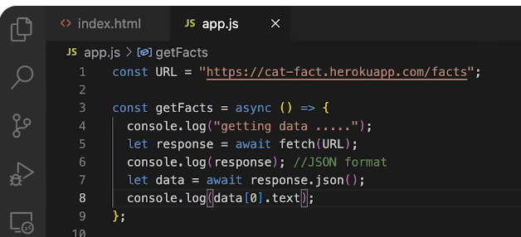  
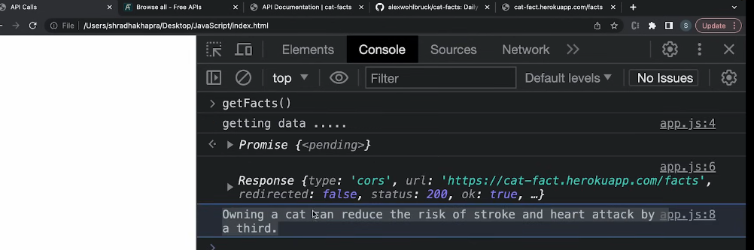  
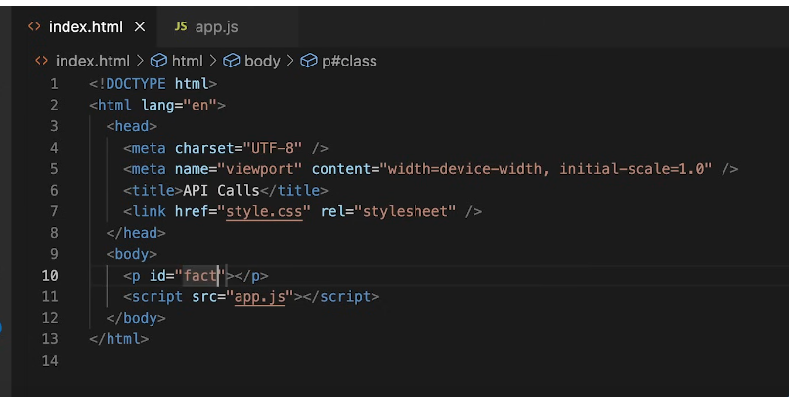  
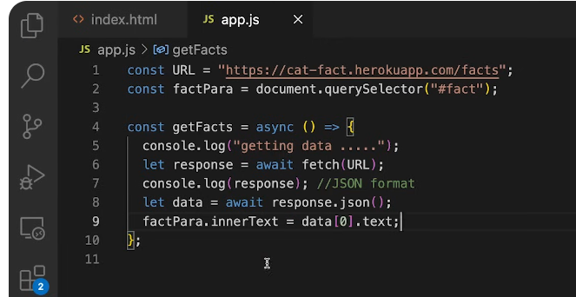  
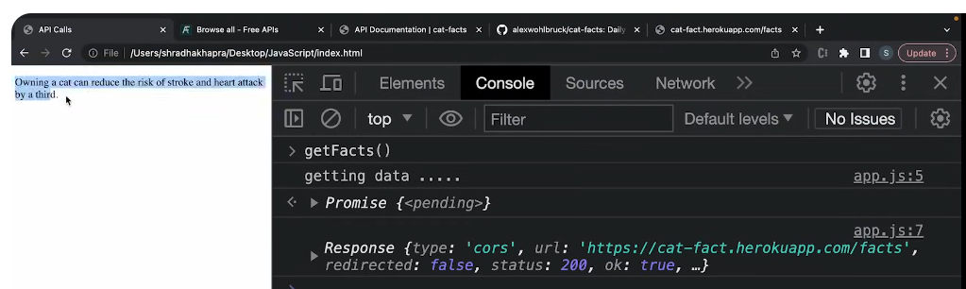  
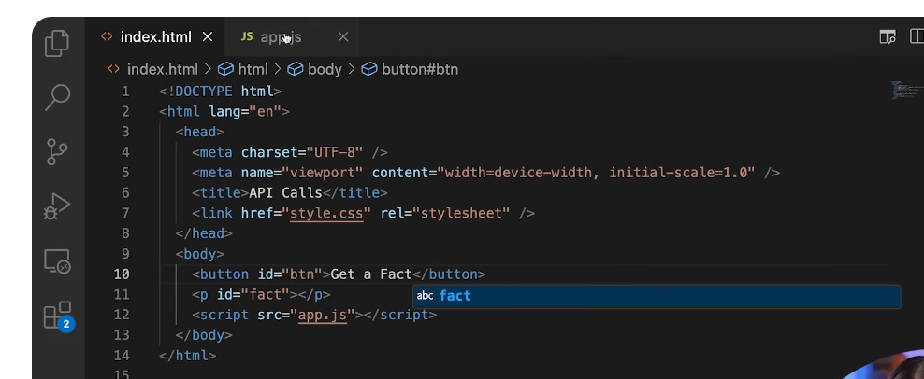  
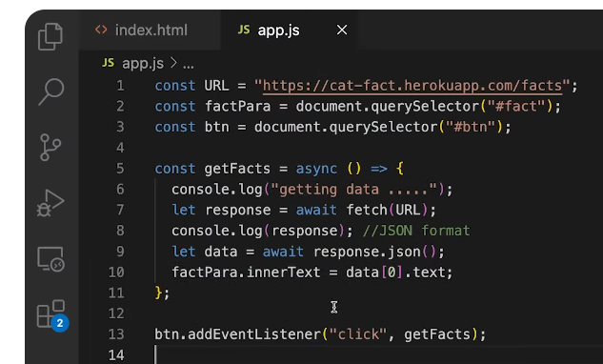  
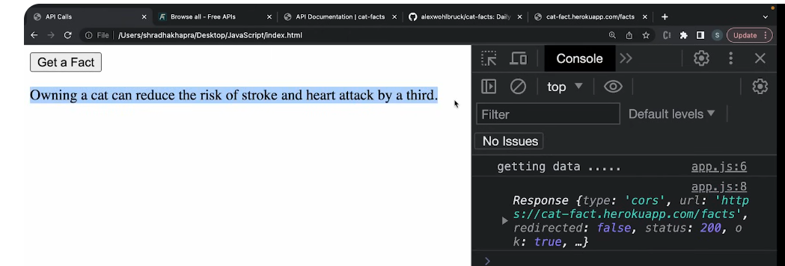  
YE Kam promise chain se bhi hosakta tha like this:  
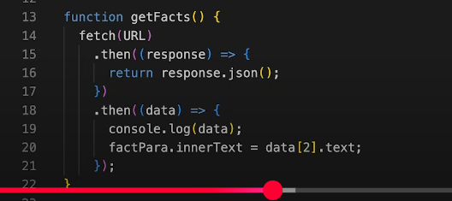  
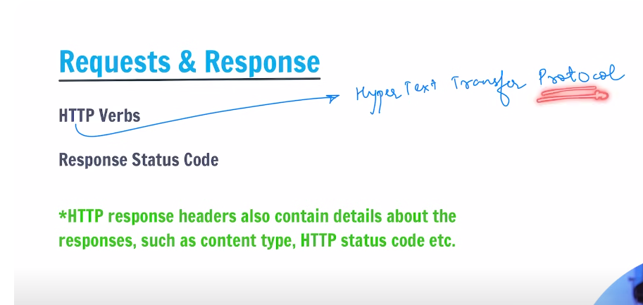

## http methods/verbs

<https://developer.mozilla.org/en-US/docs/Web/HTTP/Reference/Methods>

# Prototype, prototype chain: everything in JS s nothing but an object

Whether you write an obj , arr or function it is,down the prototype chain, ending being an object  
  
inheritace:

And protoype chian endup being null  
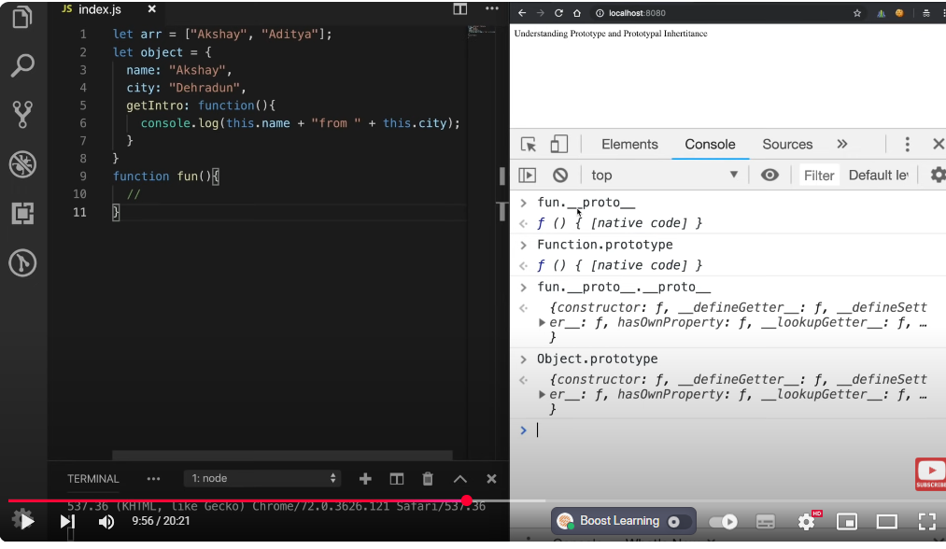

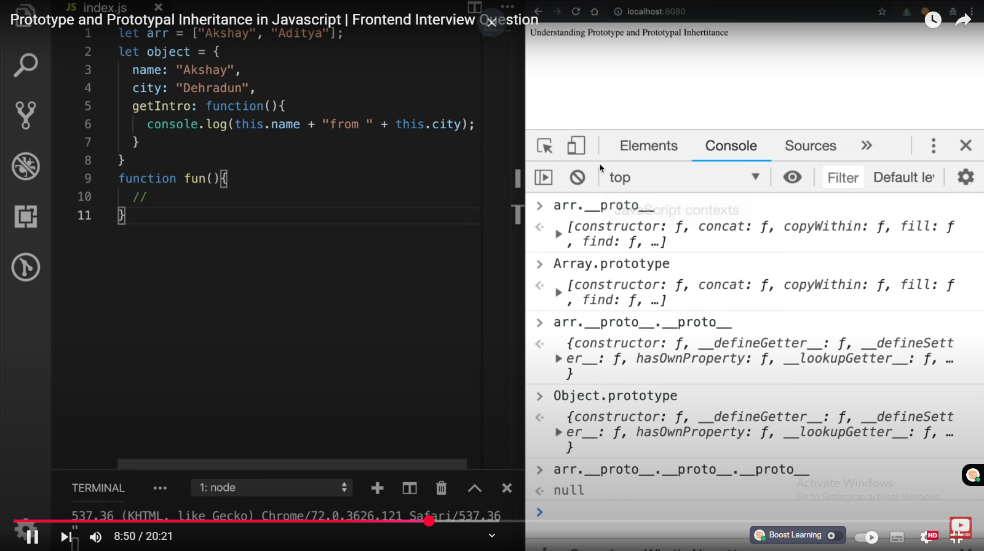

## Example:

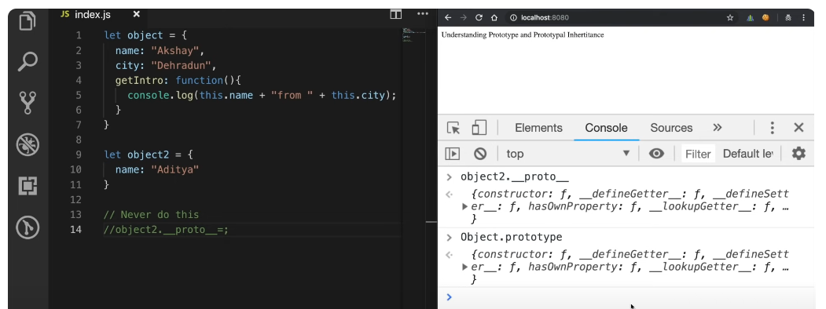

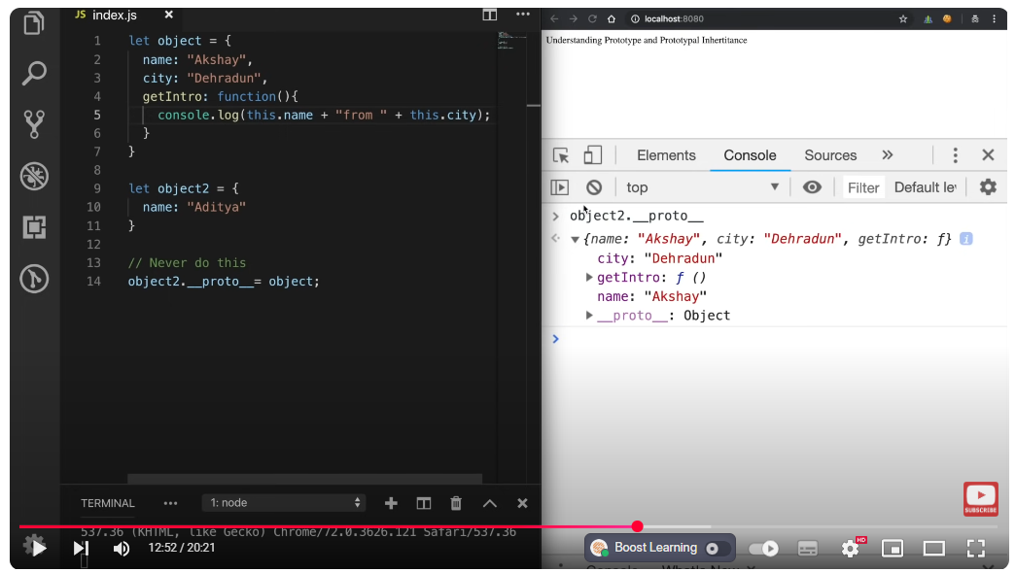

Object2 inherits from object

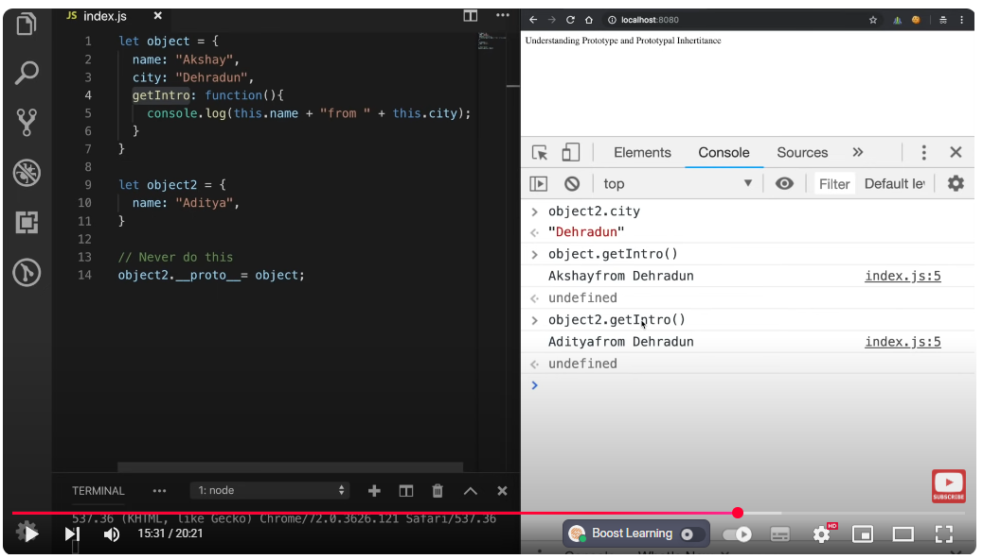

See here first this.name, its find name property in local memory and returns then it tries to find city property nd when it didn’t find it, it goes to its prototype chain and found it   
prototypal inheritance is where object2 is inheriting properties and methods from proto which is pointing to object

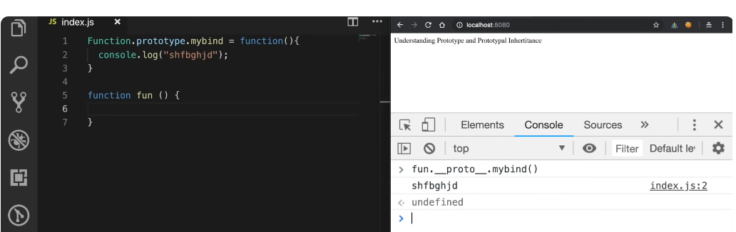

Setting mybind to prototype of Function will give all the functions access to mybind() method

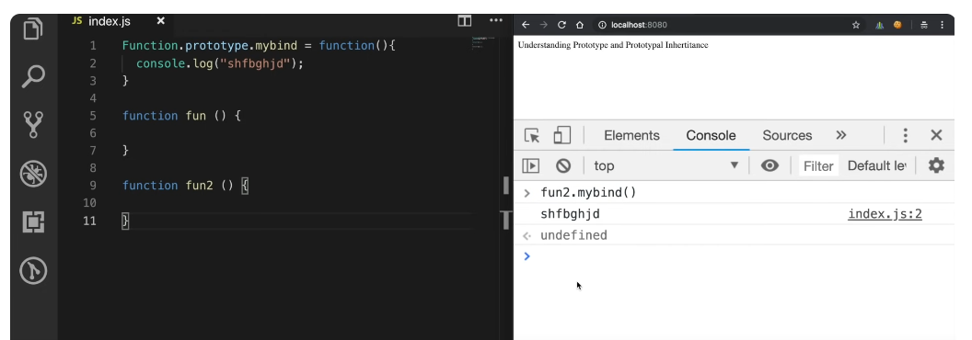

Difference between prototype and instance properties in JavaScript?

## **What is an Instance Property?**

An **instance property** is a **property or method that belongs to the object itself**, not its prototype.

### 📌 Example:

js

CopyEdit

function Person(name) {

this.name = name; // instance property

this.sayHi = function () { // instance method

console.log("Hi, I'm " + this.name);

};

}

const p1 = new Person("Ali");

console.log(p1.name); // Ali

p1.sayHi(); // Hi, I'm Ali

➡️ Here, name and sayHi are defined **inside the constructor** using this, so they are **copied separately to every object**.

## 🧬 **What is a Prototype Property?**

A **prototype property** is a **shared property or method** defined on the **constructor's prototype**, not the object itself.

### 📌 Example:

js

CopyEdit

function Person(name) {

this.name = name; // instance property

}

Person.prototype.sayHi = function () { // prototype method

console.log("Hi, I'm " + this.name);

};

const p1 = new Person("Ali");

const p2 = new Person("Sara");

p1.sayHi(); // Hi, I'm Ali

p2.sayHi(); // Hi, I'm Sara

➡️ Now sayHi is **shared** between all instances of Person. It is not copied for each object.

## 🔍 🔍 **Main Differences:**

| **Feature** | **Instance Property** | **Prototype Property** |
| --- | --- | --- |
| Location | Inside constructor (via this) | On the constructor's .prototype |
| Shared? | ❌ No – each object has its own | ✅ Yes – shared by all instances |
| Memory efficient? | ❌ No – duplicates per object | ✅ Yes – one shared method |
| Best for? | Unique data per object | Common behavior across objects |

JS Objects:

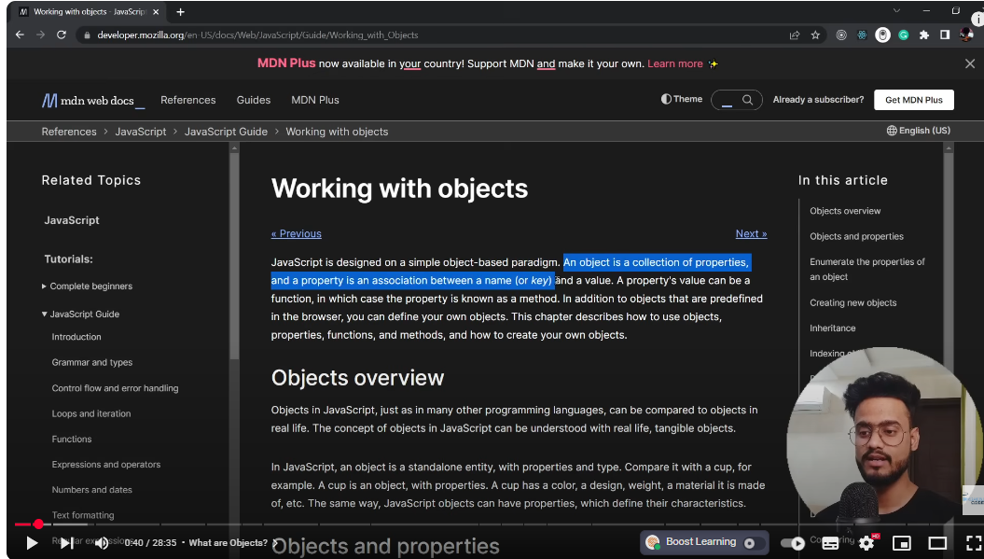

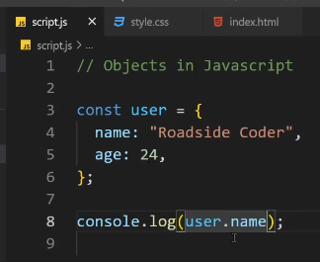

## Modify a property:

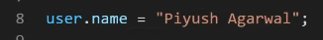

## To delete a property:

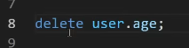

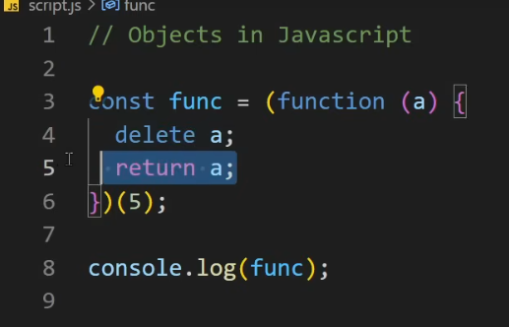

Ans will be 5; many people think that delete will delete a and return null or udefined bbut this is not the case b/c a is local variable , **delete keyword** can delete a property of an object but it can’t delete local variable inside func , this example is an IIFE

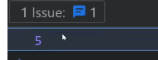

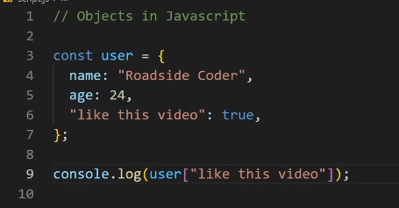

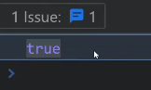

## Iteration through object:

## If we have two same keys then the later one will replace/overwrite the first one:

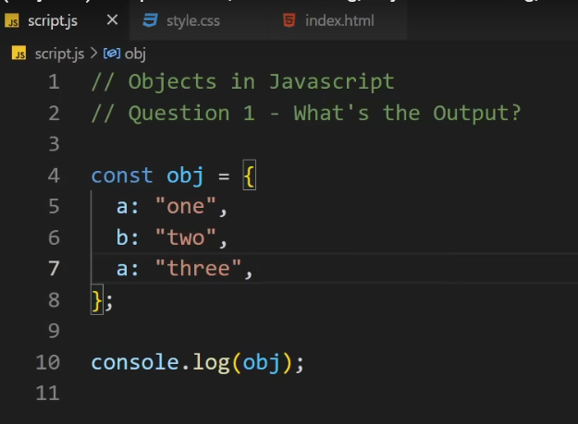

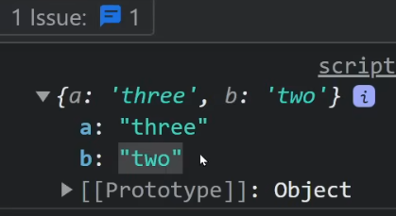

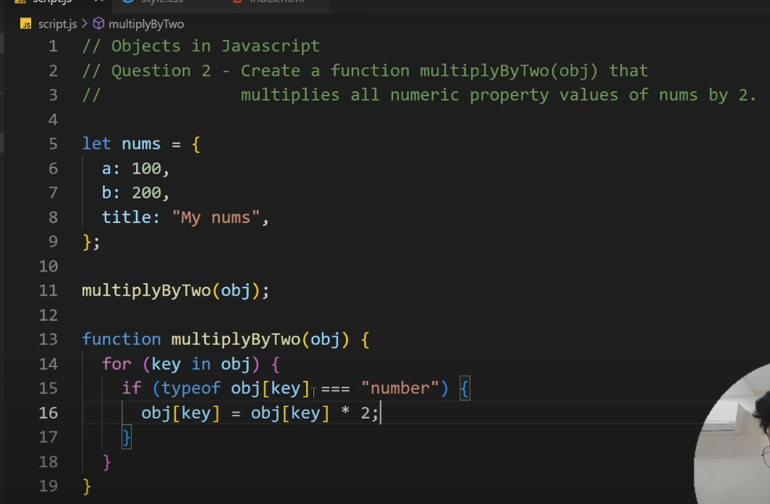

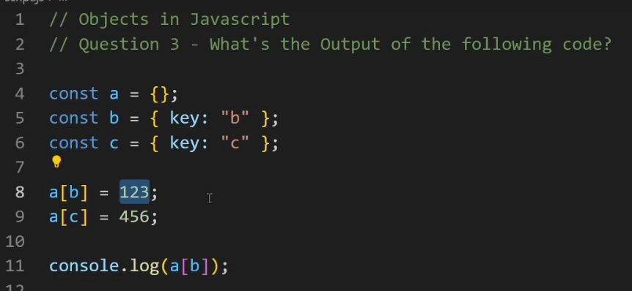

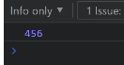  
why?

Lets print



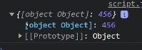

b is an object , it can not assign as key unless it’s a string so when it try to convert it into string this will save as object object

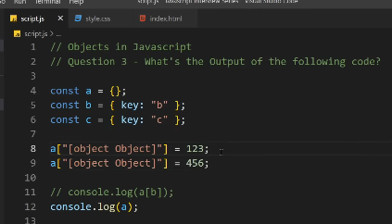

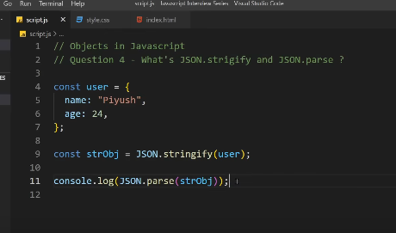

JSON.stringify(obj) 🡪 to convert object into string

JSON.parse(strObj) 🡪 to convert stringifyObj back to object

Where you can use these things?

useCase : storing in our local storage

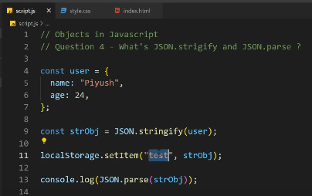

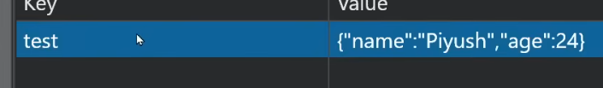

If we assign object directly without converting into string forcefully:

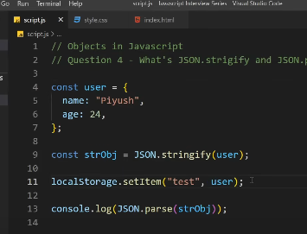

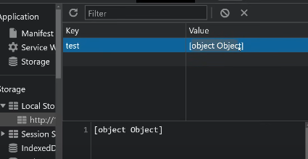

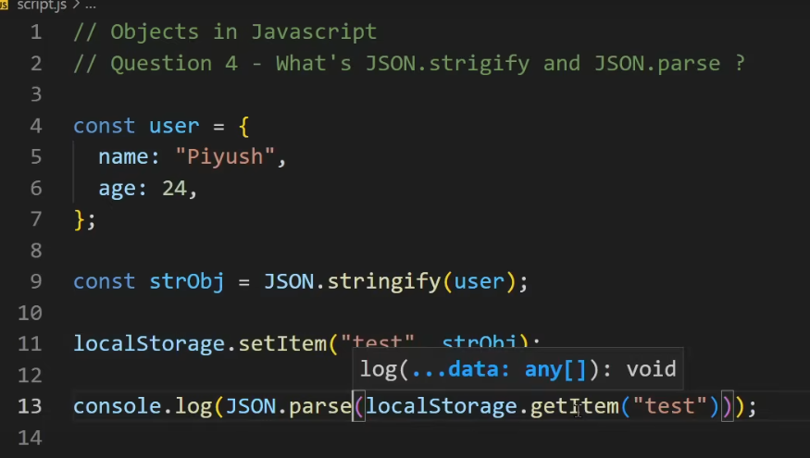

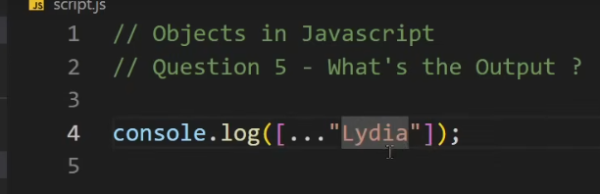

Spread operator : it spreads all the values of an array etc  
here string is given so o/p will be:

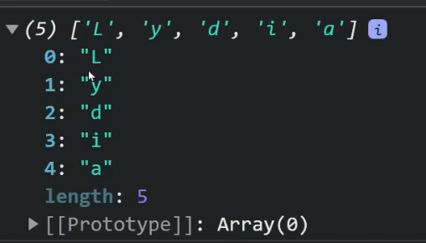

## Spread operator:

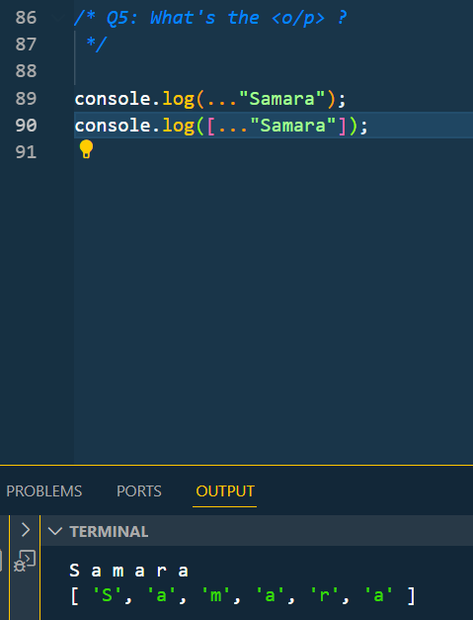

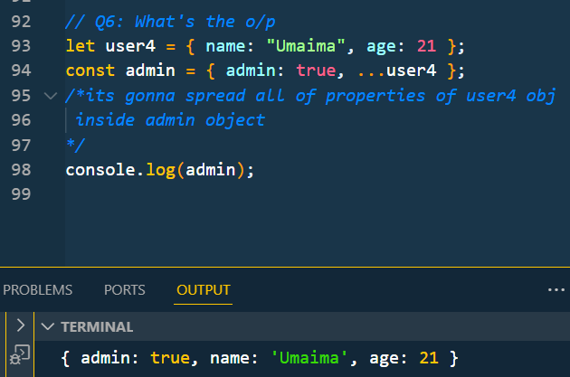

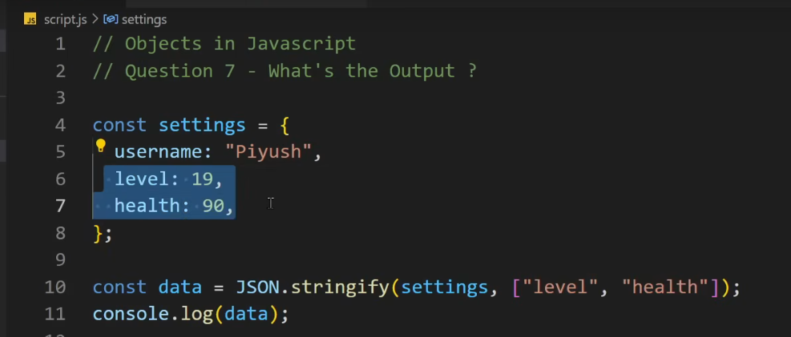

This will only stringify only level and health property

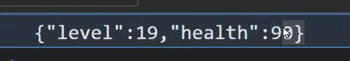

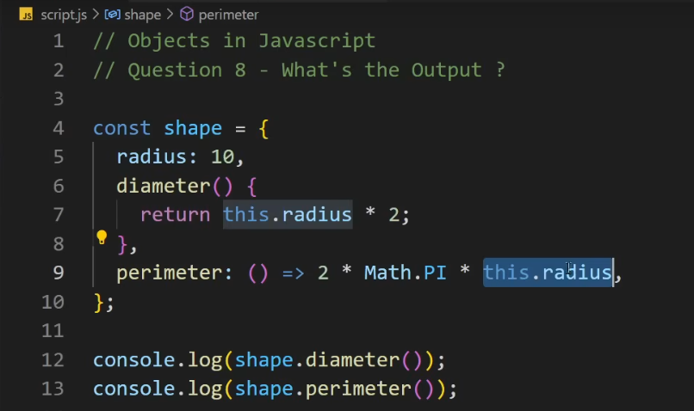

when you call this function

it's gonna reference to this object

right here but when you call the arrow

function it's gonna reference to the

window object

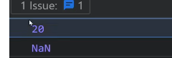

## De-structuring in Objects:

